**EVENT MANAGEMENT AND RESOURCING PLATFORM**

**(EVENZA)**

By Madushanka H.W.C

(IM/2016/046)

A report submitted in partial fulfillment of the requirements for the degree of Bachelor of Science (Honours) in Management and Information Technology (B.Sc. MIT)

**Name of the Supervisor: Dr. Dilani Wickramarachchi**

Department of Industrial Management

University of Kelaniya

Sri Lanka

2020

## DECLARATION

I hereby certify that this project and the all the artifacts associated with it is my own work and it has not been submitted before nor is currently being submitted for any other degree programme.

|  |  |  |
| --- | --- | --- |
| Full name of the student: | Hewa Witharana Chiran Madushanka | |
| Student No: | IM/2016/046 |  |
| Signature of the student: | ………………………….. | Date: 24-02-2020 |
| Name of the supervisor(s): | Dr. Dilani Wickramarachchi |  |
| Signature of the supervisor: | ……………………….. | Date: 24-02-2020 |

## ACKNOWLEDGEMENT

I express my sincere gratitude to my Project Supervisor, Dr. Dilani Wickramarachchi for the continuous support and for being the pillar of strength in succeeding the completion of the event management and resourcing platform (Evenza).

I thank my Project Coordinator Mr.Janaka Senanayake for the immense helping hand given throughout. I would also like to express my gratitude to Mr. Pasindu De Silva (Biz Lead and coordinator – Ideamart for Dialog Axiata PLC) for providing me with the required information and for the support given.

I convey my heartiest gratitude to every individual who helped me in making this project a success.

## ABSTRACT

Event management is the application to manage and development of festivals, events, celebrations and conferences. Proposed work involves study of identifying the target of budget, cost, and analysis. Pre event analysis and ensuring a return on investment have become significant drivers for the event industry. Lack of a platform for event related service providers to promote their business to the exact customer base has become also a significant issue with the industry.

The proposed system is an online event management and resourcing platform that serves the functionality of an event manager as well as providing access to event related resources by connecting relevant service providers to the customers .The core uniqueness is that proposed system provides a solution for planning and management of an event as well as finding necessary resources (services and products) within the same platform. The project also provides most of the basic functionality required for an event. It consists of the current background of the problems we face while planning for upcoming events and how planners can tackle these matters through this proposed system. It also entails building a fully functional system that would help achieve a well-organized, timely and within the budget event.

This web and mobile based platform can be integrated with venue services as hotels, clubs, auditoriums and other event related service providers as coordinators, choreographers, caters, photographers, renters, dress makers etc. as resources. The user gets all the resources at a single place instead of wondering round for these. This system is effective and saves time and cost for the user.

## TABLE OF CONTENTS

DECLARATION i

ACKNOWLEDGEMENT ii

ABSTRACT iii

TABLE OF CONTENTS iv

LIST OF FIGURES viii

LIST OF TABLES xi

ABBREVIATIONS xii

1 INTRODUCTION 1

1.1 Event Management and Resourcing in Sri Lanka 1

1.2 Introduction to “Evenza” online Event Management and Resourcing Platform 3

1.3 Problem Definition 4

1.4 Current Business Process 5

1.5 Aims and Objectives 6

1.6 Scope of the project 7

1.7 Tools and Project Feasibility 8

1.7.1 Technical Feasibility 8

1.7.2 Economical Feasibility 8

1.7.3 Operational Feasibility 8

1.7.4 Organizational Feasibility 8

1.8 Organization of the Report 9

1.9 Summary 9

2 SYSTEM ANALYSIS 10

2.1 Requirement Analysis 10

2.2 Use Case Diagram for the Current System 11

2.3 Activity Diagrams for the Current System 14

2.3.1 Activity Diagram for creating an event plan 14

2.3.2 Activity Diagram for finding required service providers 15

2.3.3 Activity Diagram for finding required product suppliers 16

2.3.4 Activity Diagram for booking a service 17

2.3.5 Activity Diagram for create a visit appointment for a venue service 18

2.3.6 Activity Diagram for purchase products for the event 19

2.3.7 Activity Diagram for inviting and managing event participants 20

2.4 System Requirement Analysis 21

2.4.1 Functional Requirements 21

2.4.2 Non-functional Requirements 22

2.4.3 Functional Requirement explanation 23

2.5 Business System Options 27

2.5.1 Business system option identification 27

2.5.2 BSO1- Web based event management and resourcing system with Progressive mobile web application (PWA) 28

2.5.3 BS02 – Web based system with android and iOS based native mobile applications 30

2.5.4 BSO3 - Web based application which utilize an existing event planning platform using its API (Ex: - eventray, openevent) 32

2.6 Evaluation of BSOs 34

2.6.1 Functional requirements Vs. BSOs 34

2.6.2 Non-functional requirements Vs. BSOs 36

2.6.3 Selected BSO with a sound justification 36

2.7 Summary 37

3 SYSTEM DESIGN 38

3.1 Use Case Diagram for the Proposed System 38

3.1.1 UC92 Use Case for update user profile. 40

3.1.2 UC110 Use Case for create an event plan 40

3.1.5 UC120 Use Case for search and sort products or services 41

3.1.7 UC140 Use Case for add products and services 42

3.1.9 UC160 Use Case for place a visit appointment for a service 43

3.1.11 UC180 Use Case for send invitations to the ‘closed type’ event invitees 44

3.1.13 UC200 Use Case for generate reports 45

3.1.14 UC210 Use Case for collect commission and subscription fee 45

3.1.15 UC170 Use Case for rate and review services/ products 46

3.2 Use Case Descriptions for the Proposed System 47

3.2.1 UC92 Use case description for update user profile 47

3.2.2 UC110 Use case description for create an event plan 48

3.2.3 UC120 Use case description for search and sort services or products 49

3.2.4 UC130 Use case description for create a business profile 50

3.2.5 UC140 Use case description for add services or products to the business profile 51

3.2.6 UC150 Use case description for place a booking for a service 52

3.2.8 UC170 Use case description for place an order for a required product 54

3.2.9 UC180 Use case description for send invitations to the closed type event invitees 56

3.2.10 UC190 Use case description for get random participants registered to the open type events 57

3.2.11 UC200 Use case description for generate reports 58

3.2.12 UC210 Use case description for collect commission and subscription fee 59

3.2.13 UC220 Use case description for rate and review services and products 60

3.3 Activity Diagrams for the Proposed System 61

3.3.1 Activity diagram for sign up to the system 61

3.3.2 Activity diagram for log in to the system 62

3.3.3 Activity diagram for update Merchant’s user profile 63

3.3.4 Activity diagram for generate event plan for available event category 64

3.3.5 Activity diagram for and generate event plan for new event category 65

3.3.6 Activity diagram for creating business profile 66

3.3.7 Activity diagram for add and modify products and services 67

3.3.8 Activity diagram for search and filter products and services 68

3.3.9 Activity diagram for place a booking for a service 69

3.3.10 Activity diagram for place a visit appointment for a venue service 70

3.3.11 Activity diagram for place an order for a required product 71

3.3.12 Activity diagram for send invitations to invitees (closed type events) 71

3.3.13 Activity diagram for get participants registered (open type events) 73

3.3.14 Activity diagram for generating reports 74

3.3.15 Activity diagram for collect commission by admin 75

3.3.16 Activity diagram for manage users by admin 76

3.3.17 Activity diagram for chat with chatbot 77

3.4 Sequence Diagrams for the Proposed System 78

3.4.1 Sequence diagram for sign up to the system 78

3.4.2 Sequence diagram for log in to the system 79

3.4.4 Sequence diagram for create business profile 79

3.4.5 Sequence diagram for create event plan 81

3.4.6 Sequence diagram for place a booking for a service 81

3.4.7 Sequence diagram for place a visit appointment for venue service 82

3.4.8 Sequence diagram for order a product 83

3.5 Class Diagram for Proposed System 84

3.6 Database Design 86

3.6.1 Entity – Relationship model 86

3.6.2 Normalized database diagram 87

3.7 GUI Design 88

3.7.1 Welcome page GUI 89

3.7.3 System Sign up GUIs (Merchant’s sign up) 90

3.7.5 GUI of events overview 92

3.7.6 GUIs for creating an event plan 92

3.7.7 GUI of Merchant’s business profile 94

3.7.8 GUI of adding services to the business profile 94

3.7.9 GUI of adding products to the business profile by a product supplier 95

3.7.10 GUI of Service overview and booking 95

3.7.11 GUI of payment page 96

3.7.12 GUI of managing closed type event invitees 96

3.7.13 GUI of creating registration form for open type event participants 97

3.7.14 GUI of generating reports 97

3.7.15 GUI of Bookings overview of a customer 98

3.7.16 GUIs of mobile interface - Getting started page 98

3.7.17 GUIs of mobile interface - Service list 99

3.7.18 GUIs of mobile interface - sidebar navigation 99

3.7.19 GUIs of mobile interface - chat with chatbot 100

3.7.20 GUIs of mobile interface - Receive Notifications 100

3.8 System Reports 101

3.9 Summery 101

4 CONCLUTION 102

4.1 Limitations and Drawbacks 102

4.2 Future Modification, Improvements and Extensions 103

4.3 Summary 103

REFERENCES 104

## LIST OF FIGURES

Figure 1.1 Scope of the Project 7

Figure 2.1 UC10 overall use case diagram for current business process 12

Figure 2.2 Activity Diagram for creating an event plan 14

Figure 2.3 Activity Diagram for finding required service providers 15

Figure 2.4 Activity Diagram for finding required product suppliers 16

Figure 2.5 Activity Diagram for create a booking for a service 17

Figure 2.6 Activity Diagram for create a visit appointment for a venue service 18

Figure 2.7 Activity Diagram for purchase required products for the event 19

Figure 2.8 Activity Diagram for inviting and managing event participants 20

Figure 3.1 UC20 Overall use case for the proposed system 39

Figure 3.2 UC92 Use Case for update user profile 40

Figure 3.3 UC110 Use Case for create event plan 40

Figure 3.4 UC120 Use Case for search and sort products or services 41

Figure 3.5 UC130 Use Case for create business profile 41

Figure 3.6 UC140 Use Case for add products and services 42

Figure 3.7 UC150 Use Case for place a booking for a service 42

Figure 3.8 UC160 Use Case for place a visit appointment for a service 43

Figure 3.9 UC170 Use Case for place an order for a required product 43

Figure 3.10 UC180 Use Case for send invitations to the closed type event invitees 44

Figure 3.11 UC190 Use Case for get random participants registered to the open type events 44

Figure 3.12 UC200 UC200 Use Case Diagram for generate reports 45

Figure 3.13 UC210 Use Case for collect commission and subscription fee 45

Figure 3.14 UC170 Use Case for rate and review services/ products 46

Figure 3.15 Activity diagram for sign up to the system 61

Figure 3.16 Activity diagram for log in to the system 62

Figure 3.17 Activity diagram for update Merchant’s user profile 63

Figure 3.18 Activity diagram for generate event plan for available event category 64

Figure 3.19 Activity diagram for and generate event plan for new event category 65

Figure 3.20 Activity diagram for creating business profile 66

Figure 3.21 Activity diagram for add and modify products and services 67

Figure 3.22 Activity diagram for search and filter products and services 68

Figure 3.23 Activity diagram for place a booking for a service 69

Figure 3.24 Activity diagram for place a visit appointment for a venue service 70

Figure 3.25 Activity diagram for place an order for a required product 71

Figure 3.26 Activity diagram for send invitations to invitees (closed type events) 72

Figure 3.27 Activity diagram for get participants registered (open type events) 73

Figure 3.28 Activity diagram for generating reports 74

Figure 3.29 Activity diagram for collect commission by admin 75

Figure 3.30 Activity diagram for manage users by admin 76

Figure 3.31 Activity diagram for chat with chatbot 77

Figure 3.32 Sequence diagram for sign up to the system 78

Figure 3.33 Sequence diagram for log in to the system 79

Figure 3.34 Sequence diagram for create business profile 80

Figure 3.35 Sequence diagram for create event plan 81

Figure 3.36 Sequence diagram for place a booking for a service 82

Figure 3.37 Sequence diagram for place a visit appointment for venue service 83

Figure 3.38 Sequence diagram for order a product 84

Figure 3.39 Class Diagram for the proposed system 85

Figure 3.40 Entity Relationship diagram for the proposed system 86

Figure 3.41 Normalized database design for the proposed system 87

Figure 3.42 Welcome page GUI 89

Figure 3.43 System Sign in GUI 89

Figure 3.44 System Sign up GUIs (Merchant’s sign up) 01 90

Figure 3.45 System Sign up GUIs (Merchant’s sign up) 02 90

Figure 3.46 System Sign up GUIs (Merchant’s sign up) 03 91

Figure 3.47 GUI of user dashboard 91

Figure 3.48 GUI of events overview 92

Figure 3.49 GUIs for creating an event plan 01 92

Figure 3.50 GUIs for creating an event plan 02 93

Figure 3.51 GUIs for creating an event plan 03 93

Figure 3.52 GUI of Merchant’s business profile 94

Figure 3.53 GUI of adding services to the business profile 94

Figure 3.54 GUI of adding products to the business profile by a product supplier 95

Figure 3.55 GUI of Service overview and booking 95

Figure 3.56 GUI of payment page 96

Figure 3.57 GUI of managing closed type event invitees 96

Figure 3.58 GUI of creating registration form for open type event participants 97

Figure 3.59 GUI of generating reports 97

Figure 3.60 GUI of Bookings overview of a customer 98

Figure 3.61 GUIs of mobile interface - Getting started page 98

Figure 3.62 GUIs of mobile interface - Service list 99

Figure 3.63 GUIs of mobile interface - sidebar navigation 99

Figure 3.64 GUIs of mobile interface - chat with chatbot 100

Figure 3.65 GUIs of mobile interface - Receive Notifications 100

## LIST OF TABLES

Table 2.1 Functional Requirements 21

Table 2.2 Non - functional requirements 22

Table 2.3 Planned cost - BSO1 29

Table 2.4 Planned cost - BSO2 31

Table 2.5 planned cost - BSO3 33

Table 2.6 Functional requirements vs. BSOs 34

Table 2.7 Non-functional requirements vs. BSOs 36

Table 2.8 BSO Justification 37

Table 3.1 UC92 Use case description for update user profile 47

Table 3.2 UC110 Use case description for create an event plan 48

Table 3.3 UC120 Use case description for search and sort services or products 49

Table 3.4 UC130 Use case description for create a business profile 50

Table 3.5 UC140 Use case description for add services or products to the business profile 51

Table 3.6 UC150 Use case description for place a booking for a service 52

Table 3.7 UC160 Use case description for place a visit appointment for a venue service 53

Table 3.8 UC170 Use case description for place an order for a required product 54

Table 3.9 UC180 Use case description for send invitations to closed type event invitees 56

Table 3.10 UC190 Use case description for get random participants registered to the open type events 57

Table 3.11 UC200 Use case description for generate reports 58

Table 3.12 UC210 Use case description for collect commission and subscription fee by system administrator 59

Table 3.13 UC220 Use case description for rate and review services and products 60

## ABBREVIATIONS

* GUI – Graphical User Interface
* SME – Small and Medium Scale Businesses
* Evenza – Online event management and resourcing platform.
* SRS – System Requirement Specification
* BSO – Business System Options

CHAPTER 1

## 1 INTRODUCTION

This chapter outlines the introduction of the business process of event management and resourcing, nature of the business, the current business process and issues. Furthermore, it analyses the objectives and aims of the proposed system, scope and boundaries and the organization of the dissertation.

# 1.1 Event Management and Resourcing in Sri Lanka

Event organization and management has become one of the largest contests in Sri Lanka. In a social aspect every and each of the religious gatherings, social gathering from a scale from islandwide to a single-family unit, and in a business aspect almost all of business entities are planning, organizing and managing several events. So, the event management industry has become a rapidly growing industry with increasing demand which is lack of enough technical support for its exponential development.

There are a several event planning and management organizations are currently operating in Sri Lanka. Some of them a large-scale organization where others are SMEs and startups. According to the World Bank statistics 42.845% of Total-employed in Sri Lanka were self-employed. Sri Lanka has more than 500,000 SMEs, each employing three to five persons on average. A considerable number of these SMEs are into event management industry. There are several service individuals and firms which do their business in event related resourcing. Starting form event planners and coordinators, catering services, cab services, photographers and videographers, renting services, handicraft designers, graphic designers, dress makers, decorators and dressing saloons etc. Event related product manufacturing and reselling is identified as another considerable industry related to the event management which consist of specific product suppliers as souvenirs, photo framing, food products etc.

Event some of event computer base event management platforms are available internationally, event management services in Sri Lanka are mostly operated manually or semi-autonomous. People tend to plan events on their own finding required service suppliers and product suppliers on their own. In most cases managing large scale event, they hire event planners and event management firms or individuals. They also do their management operations manually with the aid of some automated tools like planners and schedulers. One of the major event which is planned through those event planner firms are wedding ceremonies, conferences and corporate meetups. Within the market research, I’ve identified several event planning and management firms as listed below which are still do their operations manually with minimum support of technology.

* Vibes Events
* Beyond boundaries Global (Pvt) Ltd.
* Colombo Conferences
* 3N Events
* CEC Events
* Imagine Entertainments
* AI Events
* Showtown entertainment
* Magical Moments (Pvt) Ltd

I also identified some major event participant management platforms for participant registration and management. Several platforms are already operates online within the International as well as Sri Lankan contest.

* Open Events
* Eventray by APACHE
* Block Events (By Dialog Axiata PLC)
* Eventbrite
* Meetups.com
* RSVP.lk

# 1.2 Introduction to “Evenza” online Event Management and Resourcing Platform

Event refers to an occurrence happening at a determinable time and place. It is also something significant or notable that usually happens a planned occasion or activity. Event planning is, therefore, the process of managing an occurrence or happening such as a party, tradeshow, ceremony, team building activity, or convention. Event planning entails budgeting, setting up timelines, selecting and booking the event sites, acquiring permits, planning for food, coordinating transport, coming up with a theme among others.

Event planning consists of coordinating every detail of meetings and convention, from the speakers and venue to organization of printed materials and audio-visual equipment. It starts with determining the objective that the sponsoring organization wants to achieve. Organizers choose a public address, entertainment, content and arrange the program to present the organization's information in the most efficient way. The organizers are responsible for selecting, prospective attendees and how to get them to the meeting.

Therefore, Event Planning is an uphill and demanding task. Planners must multi-task, face numerous deadlines and orchestrate the activities of many diverse groups of people. Organizers may need to travel extensively to attend meetings and to visit prospective sites and meet suppliers. Working durations can be irregularly wrong and work for more than 40 hours per week is common especially when the event is approaching.

Thinking of the hustles and baffles involved when one must go through when planning for an upcoming event, I have come up with the“Evenza” is a online event planning, management and resourcing platform which addresses all the services required regard to event management including its participant management which will be introduced to the Sri Lankan event industry for the first time. The platform mainly connects the event planners or the customers with the event resources as service providers and product suppliers directly through one platform. The uniqueness of the platform is that it is capable of providing an auto generated and fully customizable event plan according to each event and the user is allowed to tackle the plan set reminders and most importantly find and book required services and order necessary products at the very first stage throughout the same system with no hesitate.

The platform basically handles the job of an event planner so the end user (customer) can plan their events without the support of an event planner or an event planning and management organization can use this as a tool for their growth.

A successful event is the aim of every event planner. An extraordinary event is always admired and talked. Therefore, if one wants his or her event to get remembered one must do it plan it and manage it in a different manner. The system must go through a series of steps as indicated earlier. However, some challenges such as time and budgetary constraints get experienced.

“Evenza” will cut off time wastage, energy, and money that might be used unnecessarily to move from one point to another looking for suitable items and services. All that is required is for the event planner or the customer to log in then select an event of concern to him or her such as a wedding or a birthday etc. The generated event plan gets directed to pages of shops or suppliers offering the required items or services. He or she will then select what should go into his or her event. All the provided service and product suggestions are allocated according to the event budgets and other parameters provided by the event planner or the customer.

# 1.3 Problem Definition

Event planning is an uphill task to many people. As much as one would wish to have a perfect occasion, several factors that are likely to hamper the process of event planning. One of these factors include; might be Shrinky budgets. Anyone dreaming of a successful event should allocate adequate funds to have it sail through, but with the tough economic times, it’s become a challenge to utilize the limited resources. Time constraints is also another major factor. Planning for an occasion needs a lot of time. Time wastage is because of consultations with different suppliers who offer various goods and services. Poor planning skills also will lead to a substandard event. This kind of poor planning is mainly brought about by the lack of exposure. When the planner is not well vast with event organizing, he or she tends to make numerous mistakes that may lead to a poorly planned event.

Even if the manual planning and resourcing process goes well, it is a high cost process as contacting and booking event resources are still operated manually. Transport cost as well as the consumption of time has become a huge drawback of the current process.

The currently available event planning and resourcing process is fully or partially manual. Support of computerized systems are only used in event task planners and scheduler software which are used by event planners. When it comes to resourcing there is no platform to provide event resourcing features as well as the participant management feature within the same platform.

Lack of a proper marketplace for event related service providers and product suppliers which is focused on their customers is another major problem found. Once such marketplace is provided, they will be capable of direct target marketing as well as increasing their sales and revenue.

# 1.4 Current Business Process

Current business process of the event planning and resourcing is operated manually and semi-autonomous with the aid of some currently available tools. An event planner or the customer by himself first identify the event to be planned and its type and gather a set of requirements. Then they need to create a event plan manually on a paper or a event scheduler or task planner tool with identified requirements. Then required services and products should be identified and completion date for each task should be identified and set manually. Once the task date is set reminders can be added with the support of available tools.

Then the planner or the customer need to identify relevant product and service providers. The methods they use, can be identified as the available databases in the event planning organizations, recommendations, social media and newspaper advertisements. Then they gather contact details of relevant service provides and they may need to manually contact those service providers to make reservations and bookings. These methods may differ as some service providers has enabled web or social medial booking services while some are operating completely manually. The payments process is also differed from one reservation to another. This leads to poor maintainability of the event budget according to specific event tasks.

# 1.5 Aims and Objectives

Proposed system, “Evenza” is an online event management and resourcing platform. This system as a platform where event planners or the customers by themselves could directly connect with the service provider or the product supplier for event related products and services resourcing,

The general objectives of system are to:

1. Enable user plan and management events online.
2. Enable resourcing event related services and products in one platform.
3. Enable event plan tackle and reminders for a smooth planning process.
4. Enable participant registration, invitation and management.
5. Provide a marketplace for event related service providers and product suppliers.
6. Provide progress evaluation and business supportive reports.

The specific objectives of the System are to:

1. Enable those planning for events to do so easily, effectively and efficiently.
2. Give customers an attractive, logical planning and resourcing experience.
3. Give service providers and suppliers a platform to advertise their goods and services online.
4. Enable event planners to monitor what they have ordered online and tackle their event plan.
5. Save time and other valuable resources for those planning for events.

# 1.6 Scope of the project

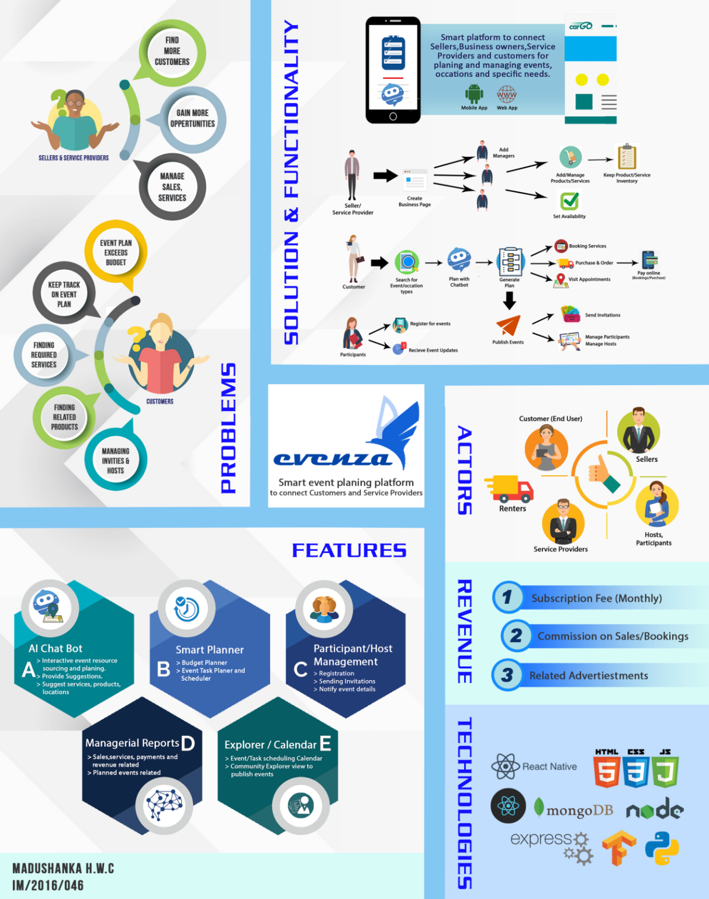Proposed system is a platform based on resourcing event related service providers and product suppliers. The system is a web-based system which provides mobile interfaces for quick interaction with its users. Payments are collected through the system with aid of a payment gateway. Only an initial amount of each service cost or the payment quote will be charged through the system. Ordered product delivery is explicit of the system and will depend on the relevant delivery service provider assigned by the product supplier. The overall scope of the project is depicted by the figure 1.1 below.

Figure 1. Scope of the Project

# 1.7 Tools and Project Feasibility

### 1.7.1 Technical Feasibility

The system is planned to run on a cloud-based server (Web hosting) with the support of node js and express js and the front end will be developed using an interactive framework, Angular 8 and the database will be relational SQL database developed with MySql. The system will be designed to support concurrent access and smooth processing with the support of recent frameworks coding styles and patterns which enables easy maintenance and consistency.

### 1.7.2 Economical Feasibility

Because of new system implements with existing hardware sources and using opensource software’s there will be no huge cost for deploying and running system. just only some minor neglectable costs. But with time faculty must bear up considerable cost in system maintenance

### 1.7.3 Operational Feasibility

Since the workload becomes less with the automating of event management process time consumption and the resource wastage on planning and finding required services will be reduced completely. And user Interfaces are very simple and interactive where event a user with basic IT knowledge can manipulate system easily.

notifications make their tasks efficient and remind them of their responsibilities in return providing operational benefits with reduction of cost and time used.

### 1.7.4 Organizational Feasibility

As an event management organization, the proposed system addressed in simplifying the tasks and process of a general event planner. So, the system can be widely used in such organizations in order to simplify their day to day tasks. Introducing the system through familiar technology will minimize the impact of change that the organizational employees have to prepare for.

# 1.8 Organization of the Report

This thesis covers the system analysis and design segments of the proposed system for the online event management and resourcing platform “Evenza”.

Chapter 1 introduces the current business process, problems and the objectives of the proposed system. It clearly defines the scope and the boundaries.

Chapter 2 presents the clear analysis of the existing system and the requirement analysis of the system. It further analyses the available business system options (BSOs) and defines the best option to proceed with.

Chapter 3 is the depiction of the furtherance of the project after the requirement analysis and specification. This will provide a better understanding of the system behavior and the interactions with the diagrams used. One diagram will lead to another to explain the functionality, entries and their relationships. By the end of the chapter, database design will show the tables which will be used in the system and Graphical User Interfaces will further elaborate its performance.

Chapter 4 is the conclusion of the report.The chapter will conclude the system analysis and design phases with a discussion of provided functionalities of thee system , benefits, drawbacks and the challenges ahead in development with suggestions.

# 1.9 Summary

In Chapter 1, the nature of the business process and the current functionality of the manual process of event organization, resourcing and management were identified. Then the problems and issues were defined, through which the objectives were emphasized. Furthermore, clear boundaries and scope for the system were defined.

CHAPTER 2

## 2 SYSTEM ANALYSIS

This chapter briefly analyses the current functionality of the existing business process and functional and nonfunctional requirements that are going to implement with the proposed system. It describes the requirement gathering techniques, how data are analyzed and the requirement definitions. Then going into much deeper, it discusses what are the Business System Options (BSO) available for the proposed system and finally it decides the best BSO to design the system.

# 2.1 Requirement Analysis

Gathering and analysis of requirements of the current business process of event management and resourcing is a must to develop a system with more usability and satisfaction. The requirement gathering was done by conducting interviews with event resourcing organizations as ‘Sarasi hotels- Matara’, ‘Evuni Saloon - Matara’, ‘Veura Photography’ etc. Over-the-phone interview was also conducted with Mr.Pasindu de Silva, (Biz lead - Ideamart for Dialog Axiata PLC) on technical and IT event management and resourcing in Sri Lanka. A background research was conducted on currently available event management organizations like ‘Magical Moments wedding planners’, ‘The Wedding Planner’ mobile application, ‘Block Events’ , ‘Meetup.com’, ‘RSVP.lk’, ‘OpenEvents’ and ‘eventray’ from APACHE and also with already established event management and coordinating organizations like 3N Events, Vibes events, Beyond Boundaries Pvt. Ltd, Imagine Entertainment and Showtown entertainment.

# 2.2 Use Case Diagram for the Current System

The functionality of existing business process of event planning, management and resourcing is handled manually and semi-autonomous approach with the aid of some currently available event task scheduling tools and participant management platforms. An exact boundary for the manual process cannot be clearly identified as it is open for all users who involve in this process under different levels. Therefore, the consistency of the process is very poor.

Figure 2.1 shows the overall scope of the existing process which carries out by an event planner (a firm/person required to organize an event) manually with use of available tools.

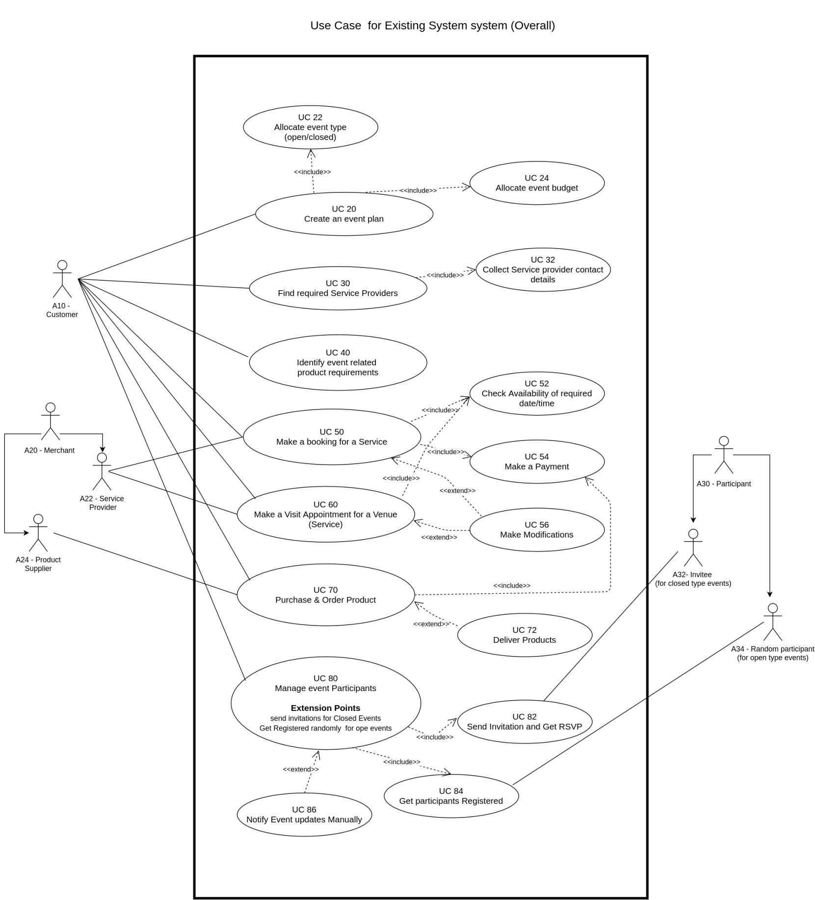

Figure 2.1 UC10 overall use case diagram for current business process

Figure 2.1 illustrates how the users interact with current business processes such as planning events and allocating budget according to the plan, purchasing required products, scheduling visit appointments, booking venue and services, get participants registered and manage registered participants. Current process is operated manually, and resources are gathered over external contacts and recommendations. Creating event plans, tracking plan and participant management are also operated manually with aid of a set of already available tools by different sources as listed below.

* Event planners and reminder applications (Tasks should be set manually, need to place reminders on added tasks)
* Online participant management platforms (Get participants registered to the event)
* With the support of an event planner or an event coordinator. (Or an event planning/organizing firm)

The user A10 - Customer has two different roles the customer(organizer) by themselves or a hired event planner. If the customer wants to plan and resource an event, can proceed directly according to the use case. If the customer hires an event planner or a coordinator to plan the event, then the event planner or coordinator will become the A10 -Customer to the system and they are required to go through the process according to the given use case. Event related service and product suppliers involved in the system are considered as the user ‘A20 -Merchant’. Event participants who explicitly connected to the system are identified as the user ‘A30 - Participant’.

# 2.3 Activity Diagrams for the Current System

### 2.3.1 Activity Diagram for creating an event plan

Figure 2.2 illustrates the activity diagram for creating an event plan. The activity is done by the customer (event planner). The current process is partially manual and achieved through the aid of different resources.

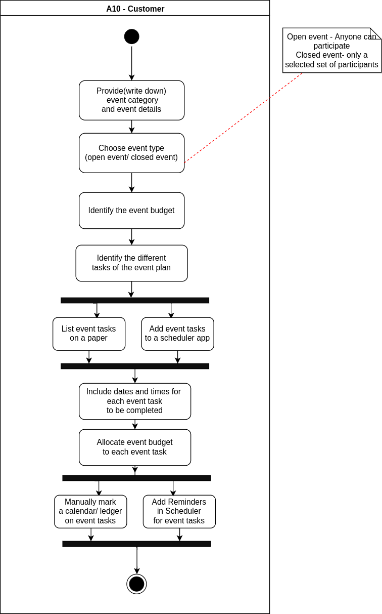

Figure 2.2 Activity Diagram for creating an event plan

### 2.3.2 Activity Diagram for finding required service providers

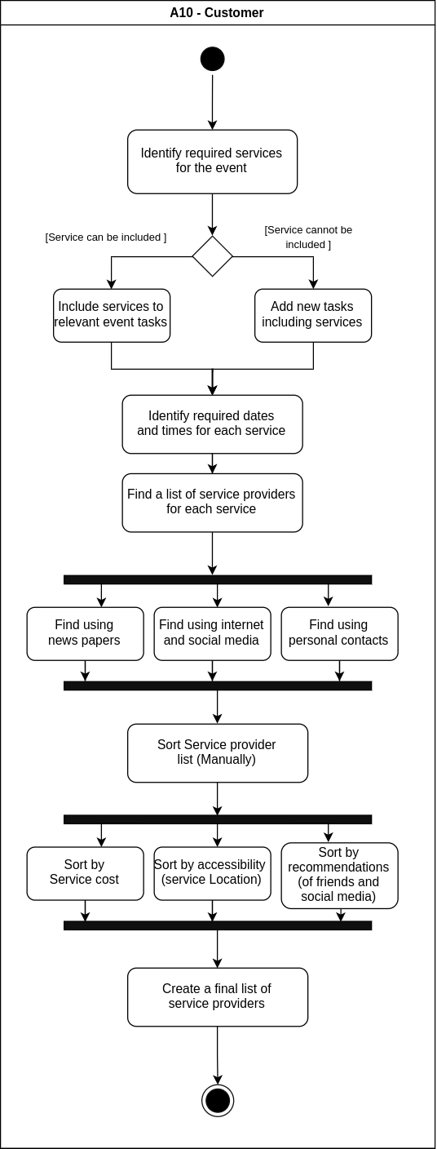Figure 2.3 illustrates the activity diagram for finding required service providers. The activity is done by the customer (event planner).

Figure 2.3 Activity Diagram for finding required service providers

### 2.3.3 Activity Diagram for finding required product suppliers

Figure 2.4 illustrates the activity diagram for finding required product suppliers. The activity is done by the customer (event planner). As illustrated the required products are first identified and then the suitable product suppliers are found.

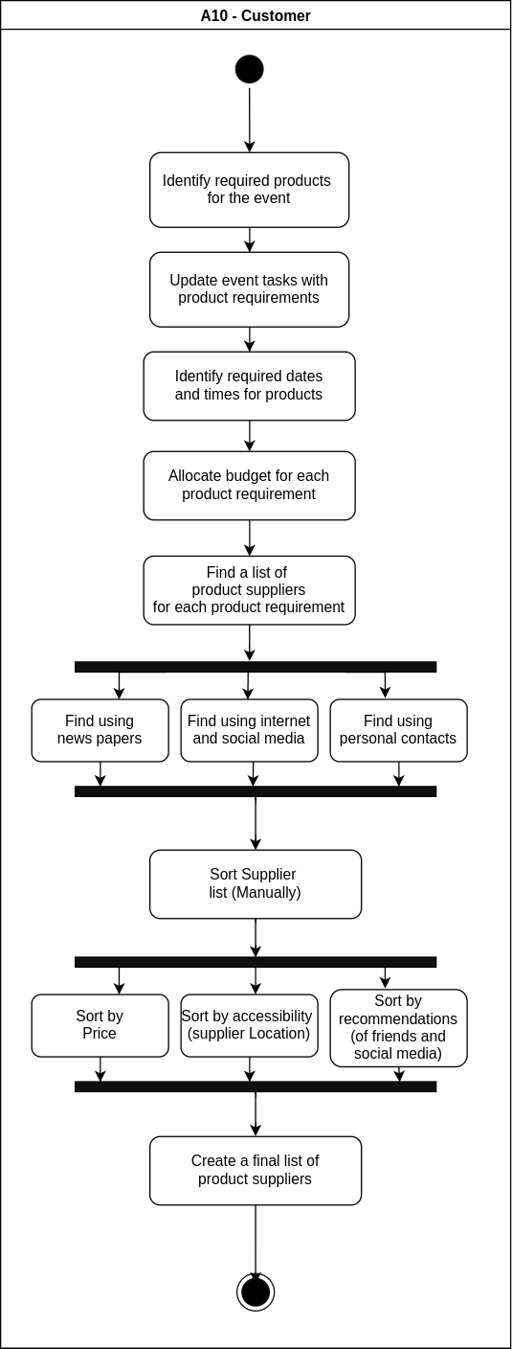

Figure 2.4 Activity Diagram for Finding required product suppliers

### 2.3.4 Activity Diagram for booking a service

Figure 2.5 illustrates the activity diagram for booking an event related service. The activity is done by the customer (event planner). Service can be either a venue or other service which is booked for a specific date and a time duration at the event day or prior to the event.

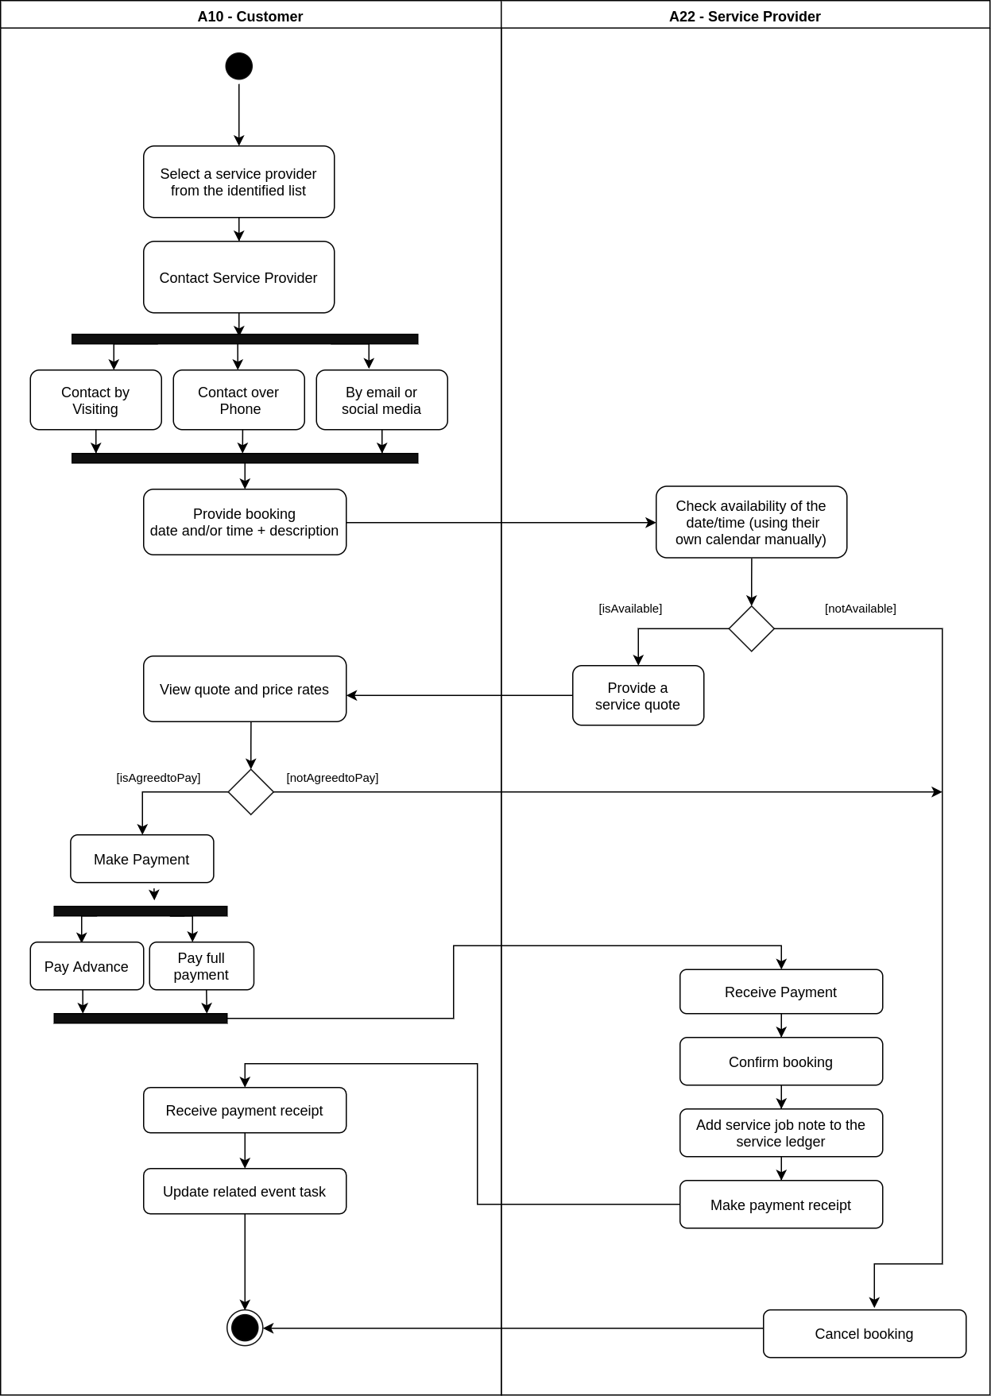

Figure 2.5 Activity Diagram for booking a service

### 2.3.5 Activity Diagram for create a visit appointment for a venue service

Figure 2.6 illustrates the activity diagram for creating a visit appointment for a venue service. The activity is done by the customer (event planner). This activity is identified when the customer needs to visit the venue (auditorium, reception hall etc..) before proceeding a booking.

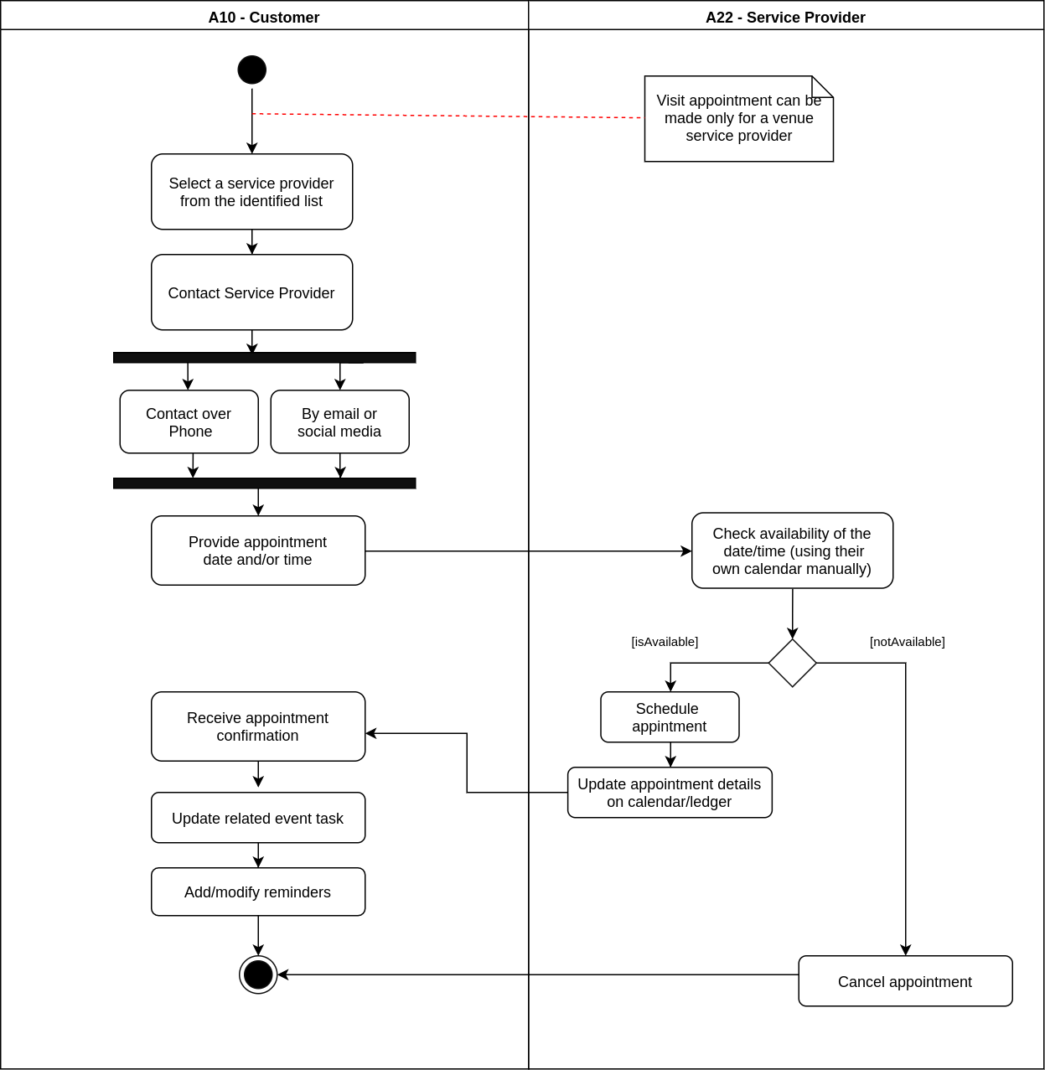

Figure 2.6 Activity Diagram for create a visit appointment for a venue service

### 2.3.6 Activity Diagram for purchase products for the event

Figure 2.7 illustrates the activity diagram for purchasing required products for the event. The activity is done by the customer (event planner). Some products can be ordered online but most of the product suppliers do offline business.

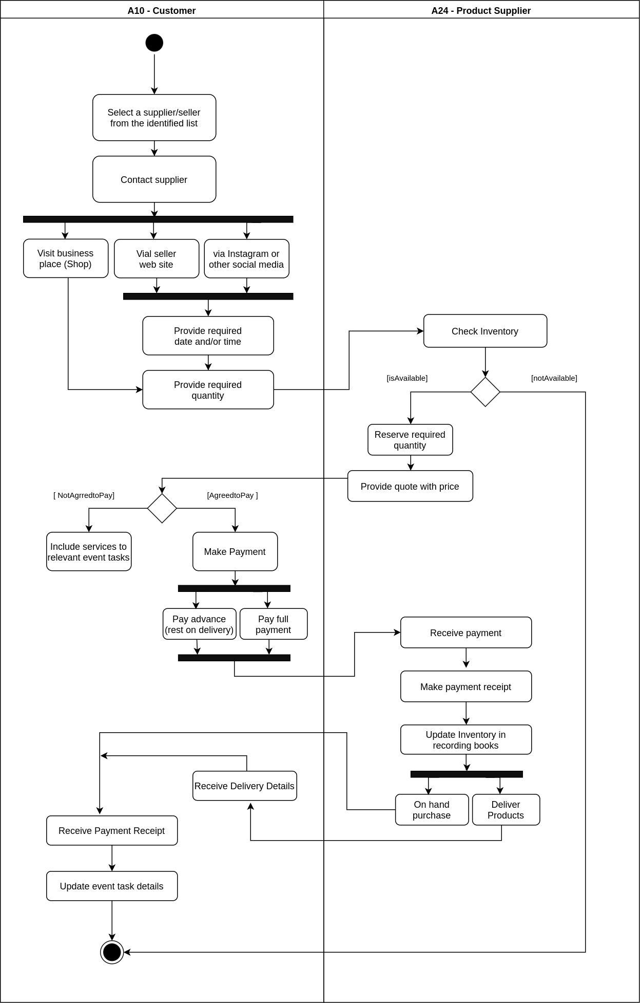

Figure 2.7 Activity Diagram for purchase required products for the event

### 2.3.7 Activity Diagram for inviting and managing event participants

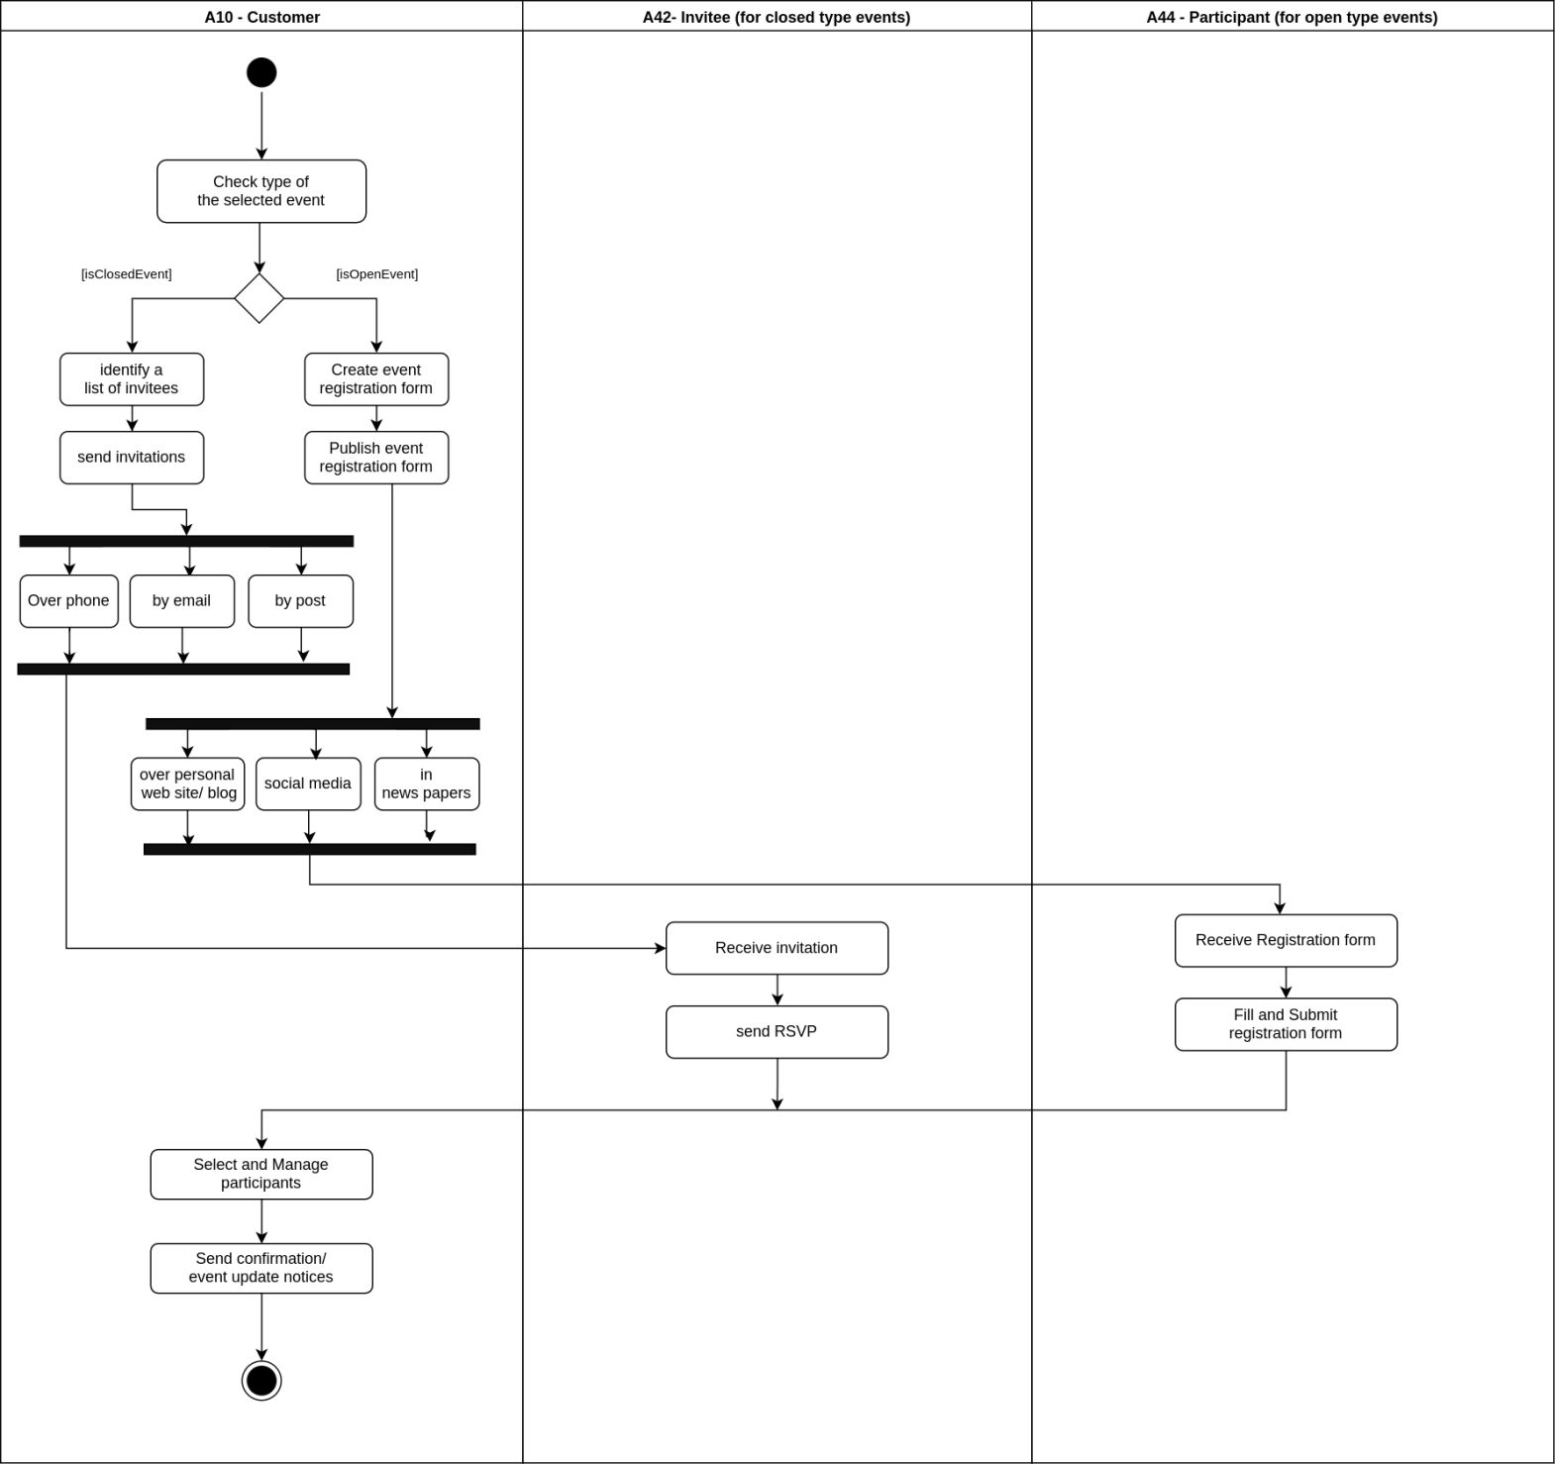Figure 2.8 illustrates the activity diagram for inviting and managing registered participants for an event. The activity is done by the customer (event planner)

Figure 2.8 Activity Diagram for inviting and managing event participants

# 2.4 System Requirement Analysis

System requirements analysis phase aims at providing a full description of the problem based on the concepts defined in the problem domain. This section would brief the reader of the functional and non-functional requirements identified in the system analysis phase and those were identified as mandatory requirements with the wording ‘shall’ and non-mandatory requirements with the wording ‘should’.

### 2.4.1 Functional Requirements

The table 2.1 will illustrate the functional requirements of the system.

Table 2.1 Functional requirements

|  |  |
| --- | --- |
| ID | Requirement |
| 1 | Shall be able to create and manage user accounts. |
| 2 | Shall be able to login to the system. |
| 3 | Shall be able to create business profiles (by service providers) |
| 4 | Shall be able to manage products/services (by service providers) |
| 5 | Shall be able to provide a set of event types to select. |
| 6 | Shall be able to get event details for selected event type from customers. |
| 7 | Shall be able to generate an event plan for selected event type. |
| 8 | Shall be able to search for products/services under specific event plan segments. |
| 9 | Shall be able to book/request appointments for services (by customers) |
| 10 | Shall be able to order products (by customers) |
| 11 | Shall be able to send cancellation/ modification requests for bookings/appointments (by customers) |
| 12 | Shall be able to respond for bookings/appointments (by service providers) |
| 13 | Shall be able to provide appointment/booking calendar for service providers. |
| 14 | Shall be able to record booking and purchase history. |
| 15 | Shall be able to show notifications related to event plan. |
| 16 | Shall be able to record event plan details. |
| 17 | Shall be able to get customer feedback. |
| 18 | Shall be able to generate reports. |
| 19 | Shall be able to send invitations to event participants. |
| 20 | Shall be able to send event related notifications to participants. |
| 21 | Should be able to get participants registered to the relevant event. |
| 22 | Shall be able to backup data. |
| 23 | Should be able to manage registered users. |
| 24 | Should be able to receive payments (subscription fee and commission). |

The functional requirements described in table 2.1 are what the system should be able to do in order to satisfy its main objectives. Mainly these describe what are the tasks or functions which the system can perform after initial implementation.

### 2.4.2 Non-functional Requirements

Non-functional requirements describe the behavior of the system other than the main functionality of it. Hence, they cover the requirements which are not included in section 2.4.1. The table 2.2 will show the non-functional requirements identified.

Table 2.2 Non - functional requirements

|  |  |
| --- | --- |
| ID | Requirement |
| 1 | Shall be able to provide web interface. |
| 2 | Shall be able to provide mobile interface. |
| 3 | Shall be able to facilitate concurrent access. |
| 4 | Should be able to provide chatbot service to get event details and generate event plans. |
| 5 | Should be able to have a user-friendly attractive interface. |
| 6 | Should be able to share created events through social media. |
| 7 | Should be able to have quicker response time. |
| 8 | Should be able to provide support documentation and accessibility features. |
| 9 | Should be able to use the existing resources efficiently. |

The non-functional requirements in table 2.2 describe the usability, reliability, performance, maintainability and other similar aspects of the system. These set of requirements may not be directly related to the main functionality, but they are of extreme importance to the proper functioning of the system.

### 2.4.3 Functional Requirement explanation

This section explains the functionalities that are going to be computerized in the proposed system. All requirements are organized to provide a full review of the system and to describe them in order.

|  |  |  |  |
| --- | --- | --- | --- |
| 1. Shall be able to create and manage user accounts. | | | |
|  | | * Shall be able to facilitate customer account creation and management. | |
|  | | * Shall be able to facilitate business owner/service provider account creation and management. | |
|  | | * Shall be able to facilitate administrator account creation and management. | |
| 2. Shall be able to login to the system | | | |
|  | | * Shall be able to facilitate different access levels for each account type. | |
|  | | * Shall be able to reset passwords. | |
| 3. Shall be able to create business profiles (by service providers) | | | |
|  | | Shall be able to add details, business location and photos to the business profile | |
|  | | Shall be able to create business profiles in two main types (service providers (venue and other services) and sellers(products)) | |
|  | | Shall be able to manage details in the business profile | |
| 4. Shall be able to manage products/services (by service providers) | | | |
|  | | * Shall be able to add new products/ services | |
|  | | * Shall be able to modify products/ services | |
|  | | * Shall be able to manage service availability status | |
|  | | * Shall be able to manage remaining product inventory | |

|  |  |
| --- | --- |
| 1. Shall be able to provide a set of event types to select | |
| 6. Shall be able to get event details for selected event type from customers | |
|  | * Shall be able to get event details |
|  | * Shall be able to get planned event location |
|  | * Shall be able to get planned event budget |
| 7. Shall be able to generate an event plan for selected event type | |
|  | * Shall be able to generate plans for provided event types |
|  | * Shall be able to create new event types and plans |
|  | * Shall be able to allocate given budget for each plan segment |
|  | * Shall be able to manage and customize event plan segments |
| 8. Shall be able to search for products/services under specific event plan segments | |
|  | * Shall be able to provide services/products list on their availability |
|  | * Shall be able to filter services/products on budget and given details |
|  | * Shall be able to view user ratings and reviews |
|  | * Should be able to filter services/products on event location |
| 9. Shall be able to book/request appointments for services (by customers) | |
|  | * Shall be able to request visit appointments for venue providers |
|  | * Shall be able to send booking requests for services |
|  | * Shall be able to pay online for confirmed bookings |
| 10. Shall be able to order products (by customers) | |
|  | * Shall be able to pay online for products |

|  |  |  |  |  |
| --- | --- | --- | --- | --- |
| 1. Shall be able to send cancellation/ modification requests for bookings/appointments (by customers) | | | | |
| 12. Shall be able to respond for bookings/appointments (by service providers) | | | | |
|  | | | * Shall able to receive service booking/visit appointment requests | |
|  | | | * Shall be able respond to booking/appointment requests | |
|  | | | * Shall be able to modify bookings/appointments | |
| 13. Shall be able to provide appointment/booking calendar for service providers | | | | |
|  | | * Shall be able to add bookings/appointments to the calendar | | |
|  | | * Shall be able to consider booking availability on calendar when listing search results | | |
|  | | * Should be able to update calendar with other bookings explicit to the system | | |
| 14. Shall be able to record booking and purchase history | | | | |
|  | * Shall be able to record service bookings | | | |
|  | * Shall be able to record visit appointments | | | |
|  | * Shall be able to record product purchase history | | | |
| 15. Shall be able to show notifications related to event plan | | | | |
|  | | | * Shall be able to receive reminders | |
|  | | | * Shall be able to receive event related notifications | |
| 1. Shall be able to record event plan details | | | | |
| 17. Shall be able to get customer feedback | | | | |
|  | | | | * Shall be able to rate and review services/products |
|  | | | | * Shall be able to rate and review service providers |

|  |  |  |
| --- | --- | --- |
| 18. Shall be able to generate reports | | |
|  | * Shall be able generate sales reports | |
|  | * Shall be able to generate payment records | |
|  | * Shall be able to generate related performance measurement reports | |
| 19. Shall be able to send invitations to event participants | | |
|  | | * Shall be able to send invitations via emails |
|  | | * Shall be able to view no. of participants |
|  | | * Should be able to view RSVP responds |
| 20. Shall be able to send event related notifications to participants | | |
|  | | * Shall be able to send event related notification via email |
|  | | * Should be able to send event reminders via email |
| 21. Should be able to get participants registered to the relevant event | | |
|  | | * Should be able to send registration forms |
|  | | * Should be able to view registered participant details |
| 1. Shall be able to backup data | | |
| 1. Should be able to manage registered users | | |
| 24. Should be able to receive payments (subscription fee and commission) | | |

# 2.5 Business System Options

The project needs to be focused on satisfying the identified requirements and future requirements that can be emerged in future. According the above requirement analysis and specification the system should mainly satisfy the customer’s need to plan the relevant event according to the budget, find required venue, service providers and book services, order goods, keep a track on the event plan and get event participants registered.

In this section BSOs are presented and at the end they are evaluated to select the best option. Each BSO is consisted of overlapping features as well as exclusive features. Since each BSO is focused on different aspects, each BSO requires different set of software combinations. Evaluation of the BSOs are done by comparing them against the functional and non-functional requirements of the system.

### 2.5.1 Business system option identification

BSO1 – Web based event management system with Progressive mobile web application (PWA)

BS02 – Web based system with android and iOS based native mobile applications

BS03 - Web based application which utilize an existing event planning platform using its API (ex: - eventray, openevent)

### 2.5.2 BSO1- Web based event management and resourcing system with Progressive mobile web application (PWA)

2.5.2.1 Description

This BSO is concerned of developing a web-based event management and resourcing platform with all the features and develop it further to a progressive web application (PWA) with significant access to mobile devices as well (geo location, auto-update etc.). The system is platform independent and can be accessed anytime anywhere along with using any mobile device or desktop environment which has an internet access.

2.5.2.2 Functionality

Users can create their profiles and are provided more secure login. Customers can select an event type an generate a customizable event plan and select between suggested resources (service providers and sellers). Merchants gain an easy and convenient way of managing their business pages and add services/products. Once an event is created user is be able to manage its participants easily. Database including user data are stored in a cloud-based hosting service for concurrent reliable access. System provides highly interactive and common interface in both web and mobile devices.

2.5.2.3 Benefits

* Can be accessed anywhere through internet.
* Can be accessed even by using a smart phone or tablet computer with the feel of a native mobile application at anywhere anytime.
* Provide more interactive user interface which makes users comfortable with.
* Platform independent. (web, android mobile, IOS mobile)
* Accessible to mobile device features as location access etc. with the same platform.
* Provide generic interface for both web and mobile platforms.
* Data transfer with backend is gone through a proper validation and use of API.

2.5.2.4 Issues

* Rely on good internet connection.
* Security issues.

2.5.2.5 Planned Cost

Table 2.3 Planned cost - BSO1

|  |  |
| --- | --- |
| Description | Cost(Rs) |
| Software (web based) development | 100000 |
| Mobile interface development | 40000 |
| Web domain | 4000 |
| Hosting and other cloud services | 6000 |
| Purchase of development tools | 2000 |
| Sub Total | **152000** |

2.5.2.6 Justification

This BSO satisfy all the functional requirements and non-functional requirements of the proposed system. Since this is an online solution this gives flexibility for both customer and merchant as it can be accessed from anytime and anywhere. Cost is comparatively low, and the development time is minimum. Both web application and a mobile application can be provided to the user for wider use of the system. And this BSO also supplies more interactive interfaces.

### 2.5.3 BS02 – Web based system with android and iOS based native mobile applications

2.5.3.1 Description

This BSO is focused on implementing a web-based system with native mobile applications for event management and resourcing which is to be developed for both android and iOS platforms. This BSO supplies a native mobile application of the proposed system and can be accessed from anywhere anytime along with good internet connection.

2.5.3.2 Functionality

Both customers and the merchants need to create user accounts and access to the system using a web browser or a mobile device with relevant login credentials. A natively developed mobile application is more advanced but the interfaces are limited to a small space and the multi-functionality may be difficult. Users may have to install an integrated application either from the ‘Google play store’ or ‘Apple app store’ to use the system and it will reserve more space on the device.

2.5.3.3 Benefits

* Can be access from anywhere through internet even while travelling.
* Easy navigation through the system.
* Direct access to device features.
* More interactive.

2.5.3.4 Issues

* High development and deployment cost due to building a separated native mobile application for both android and iOS platforms.
* Users must have a proper mobile device to access the application (ex: Suitable android OS and memory for a smooth run of the application).
* Devices with lower android versions may not able to access the application.
* Takes additional space on mobile devices.

2.5.3.5 Planned Cost

Table 2.4 Planned cost - BSO2

|  |  |
| --- | --- |
| Description | Cost (Rs) |
| Web application development | 100000 |
| Mobile application development | 80000 |
| Play Store and App Store payments(deploying) | 7000 |
| Hosting and other cloud services | 6000 |
| Purchase of development tools | 3000 |
| Sub Total | **196000** |

2.5.3.6 Justification

This BSO satisfied the functional requirements and many non-functional requirements of the proposed system. But there are a few drawbacks with this BSO. The mobile application has limited access for devices for previous android versions, and the additional space reserved on the device, limited interfaces may not capable of providing all the information and mufti-functionality. High development and deployment cost as well as the increased development time are other drawbacks.

### 2.5.4 BSO3 - Web based application which utilize an existing event planning platform using its API (Ex: - eventray, openevent)

2.5.4.1 Description

In this BSO developing a web-based application integrated with the support of an already available event management API (Ex: - open-source platforms like eventray, openevent by APACHE) is concerned. A community can be developed as a part of this implementation and data mining techniques can be further used for more productive event plan generation and suggesting. But the system may require separate APIs from different platforms for event management and resourcing features separately as the currently available platforms does not provide both services together. Some required functionalities may not be able to provide using currently available APIs.

2.5.4.2 Functionality

All users must create profiles and user data are stored and managed in the relevant event management platform as part of it. The provided API services are used. Other functionalities are same as the previous BSOs.

2.5.4.3 Benefits

* Enables wide data availability for data mining purposes
* Quick response time
* High concurrent access
* Easy data storage and management
* Cloud storage facilities

2.5.4.4 Issues

* Incompatibility
* Data security and privacy concerns
* Need to use different APIs with separated data sources
* Inability to provide some functionalities.

2.5.4.5 Planned Cost

Table 2.5 planned cost - BSO3

|  |  |
| --- | --- |
| Description | Cost (Rs) |
| Web based development | 100000 |
| Purchase of API Services | 70000 |
| Hosting and other cloud services | 5000 |
| Purchase of development tools | 3000 |
| Sub Total | **178000** |

2.5.4.6 Justification

Though this BSO is easy to implement and more secure way. But the main objective of this system is to provide a vendor-based platform to connect customer with merchants who provide event related resources. No currently available platform provides event resourcing, event management and participant management together through their APIs. There this BSO is not be the most appropriate one.

# 2.6 Evaluation of BSOs

Evaluation of the BSOs were done by comparing them first with the functional and non-functional requirements. Then the pros and cons of the BSOs were considered. Ultimately the best option could be one of the BSOs. Looking at the three BSOs, it seems that all of them cover almost all the requirements mentioned in the requirements catalogue. But there are some differences when taking the other constraints into consideration. The figure 2.6 shows the comparison of the each BSO with the requirements.

### 2.6.1 Functional requirements Vs. BSOs

Table 2.6 illustrates the comparison of the three BSO with the functional requirements. According the above comparison, all the functional Requirements are satisfied by the BSO1, BSO2 and BSO3.

Table 2.6 Functional requirements vs. BSOs

|  |  |  |  |  |
| --- | --- | --- | --- | --- |
| ID | Requirement | BSO1 | BSO2 | BSO3 |
| 1 | Shall be able to create and manage user accounts. | X | X | X |
| 2 | Shall be able to login to the system. | X | X | X |
| 3 | Shall be able to create business profiles. | X | X | X |
| 4 | Shall be able to manage products/services (by service providers) | X | X | X |
| 5 | Shall be able to provide a set of event types to select. | X | X | X |
| 6 | Shall be able to get event details for selected event type from customers. | X | X | X |
| 7 | Shall be able to generate an event plan for selected event type. | X | X | X |
| 8 | Shall be able to search for products/services under specific event plan segments. | X | X | X |
| 9 | Shall be able to book/request appointments for services | X | X | X |
| 10 | Shall be able to order products | X | X | X |
| 11 | Shall be able to send cancellation/ modification requests for bookings/appointments | X | X | X |
| 12 | Shall be able to respond for bookings/appointments | X | X | X |
| 13 | Shall be able to provide appointment/booking calendar for service providers. | X | X | X |
| 14 | Shall be able to record booking and purchase history. | X | X | X |
| 15 | Shall be able to show notifications related to event plan. | X | X | X |
| 16 | Shall be able to record event plan details. | X | X | X |
| 17 | Shall be able to get customer feedback. | X | X | X |
| 18 | Shall be able to generate reports. | X | X | X |
| 19 | Shall be able to send invitations to event participants. | X | X | X |
| 20 | Shall be able to send event related notifications to participants. | X | X | X |
| 21 | Should be able to get participants registered to the relevant event. | X | X | X |
| 22 | Shall be able to backup data. | X | X | X |
| 23 | Should be able to manage registered users. | X | X | X |
| 24 | Should be able to receive payments (subscription fee and commission). | X | X | X |

### 2.6.2 Non-functional requirements Vs. BSOs

Table 2.7 illustrates the comparison of the three BSOs with the non-functional requirements. According the above comparison, all the non-functional requirements are satisfied by the BSO1. BSO2 and BSO3 are satisfying only a few non-functional requirements.

Table 2.7 Non-functional requirements vs. BSOs

|  |  |  |  |  |
| --- | --- | --- | --- | --- |
| ID | Requirement | BSO1 | BSO2 | BSO3 |
| 1 | Shall be able to provide web interface. | X | X | X |
| 2 | Shall be able to provide mobile interface. | X | X | X |
| 3 | Shall be able to facilitate concurrent access. | X | X | X |
| 4 | Should be able to provide chatbot service to get event details and generate event plans. | X | X |  |
| 5 | Should be able to have a user-friendly attractive interface. | X | X |  |
| 6 | Should be able to share created events through social media. | X | X | X |
| 7 | Should be able to have quicker response time. | X |  |  |
| 8 | Should be able to provide support documentation and accessibility features. | X |  |  |
| 9 | Should be able to use the existing resources efficiently. | X |  |  |

### 2.6.3 Selected BSO with a sound justification

Selected BSO is BSO1- ‘Web based event management and resourcing system with progressive mobile web application (PWA)’ as it satisfies all the functional and non-functional requirements. It can provide more interactive and convenience use of the system while giving a more security and keeping customers and merchants connected as well as implementing a platform for easy management of events and its participants. It also provides the most affordable solution among all the stated BSOs with the minimum cost of Rs.152 000/- while providing more features. It can generate managerial reports related to merchants and included a chatbot to make the use of system more convenience.

Table 2.8 BSO Justification

|  |  |  |  |
| --- | --- | --- | --- |
|  | **BSO 1** | **BSO 2** | **BSO 3** |
| Initial cost | Low | High | Medium |
| Security risk | Medium | Medium | High |
| Functional Requirements | High | High | High |
| Non - functional Requirements | High | Medium | Low |
| Variable cost | Medium | Medium | Medium |

# 2.7 Summary

This chapter analyzed the existing features of the current business process and thus specified the functional and non-functional requirements that are about to be implemented in the proposed system. This evaluated three BSOs and finally selected ‘Web based event management and resourcing system with a progressive mobile web application (PWA)’ as the most appropriate Business System Option.

CHAPTER 3

## 3 SYSTEM DESIGN

This chapter mainly covers the design of the system. It describes the continuation of the project after the requirement analysis and specification. It gives a better understanding of the system functionalities, it’s actors and behaviors and interactions with the diagrams used. One diagram leads to another with explaining the exact the functionality, entities and their relationships.

# 3.1 Use Case Diagram for the Proposed System

Use case provides a structured view of the system functionality. These diagrams are used to gather the requirements of a system, including internal and external requirements. These requirements are mostly design requirements. When a system is analyzed to gather its functionality, use cases are prepared and actors of the system are identified. This process is very important since the next phase of the System Development Life Cycle (SDLC) is the system designing phase. Here the use cases are the different tasks the users do in order to interact with the system. Actors are the users who will be interacting with the system.

The figure 3.1 illustrates the overall use case diagram for the proposed system. Event planners (or the customer) is denoted as ‘A-10 Customer’ and the merchant who provide event related services and products are denoted as ‘A-20 Merchant’ in two types ‘A22- service Provider’ and ‘A-24 Product Supplier’. Events are categorized into two types as ‘Open events’ which, any random participant who satisfies given set of requirements through a registration, can be participated and ‘Closed type’ events that only an identified set of guests are invited through an email. Participants are also categorized regarding the above event categorization as ‘A42- Invitee’ for closed type events and ‘A44- Random participant’ for open type events.   
Any product can be purchased, and any service can be booked while a visit appointment can be appointed only for ‘venue’ type services.

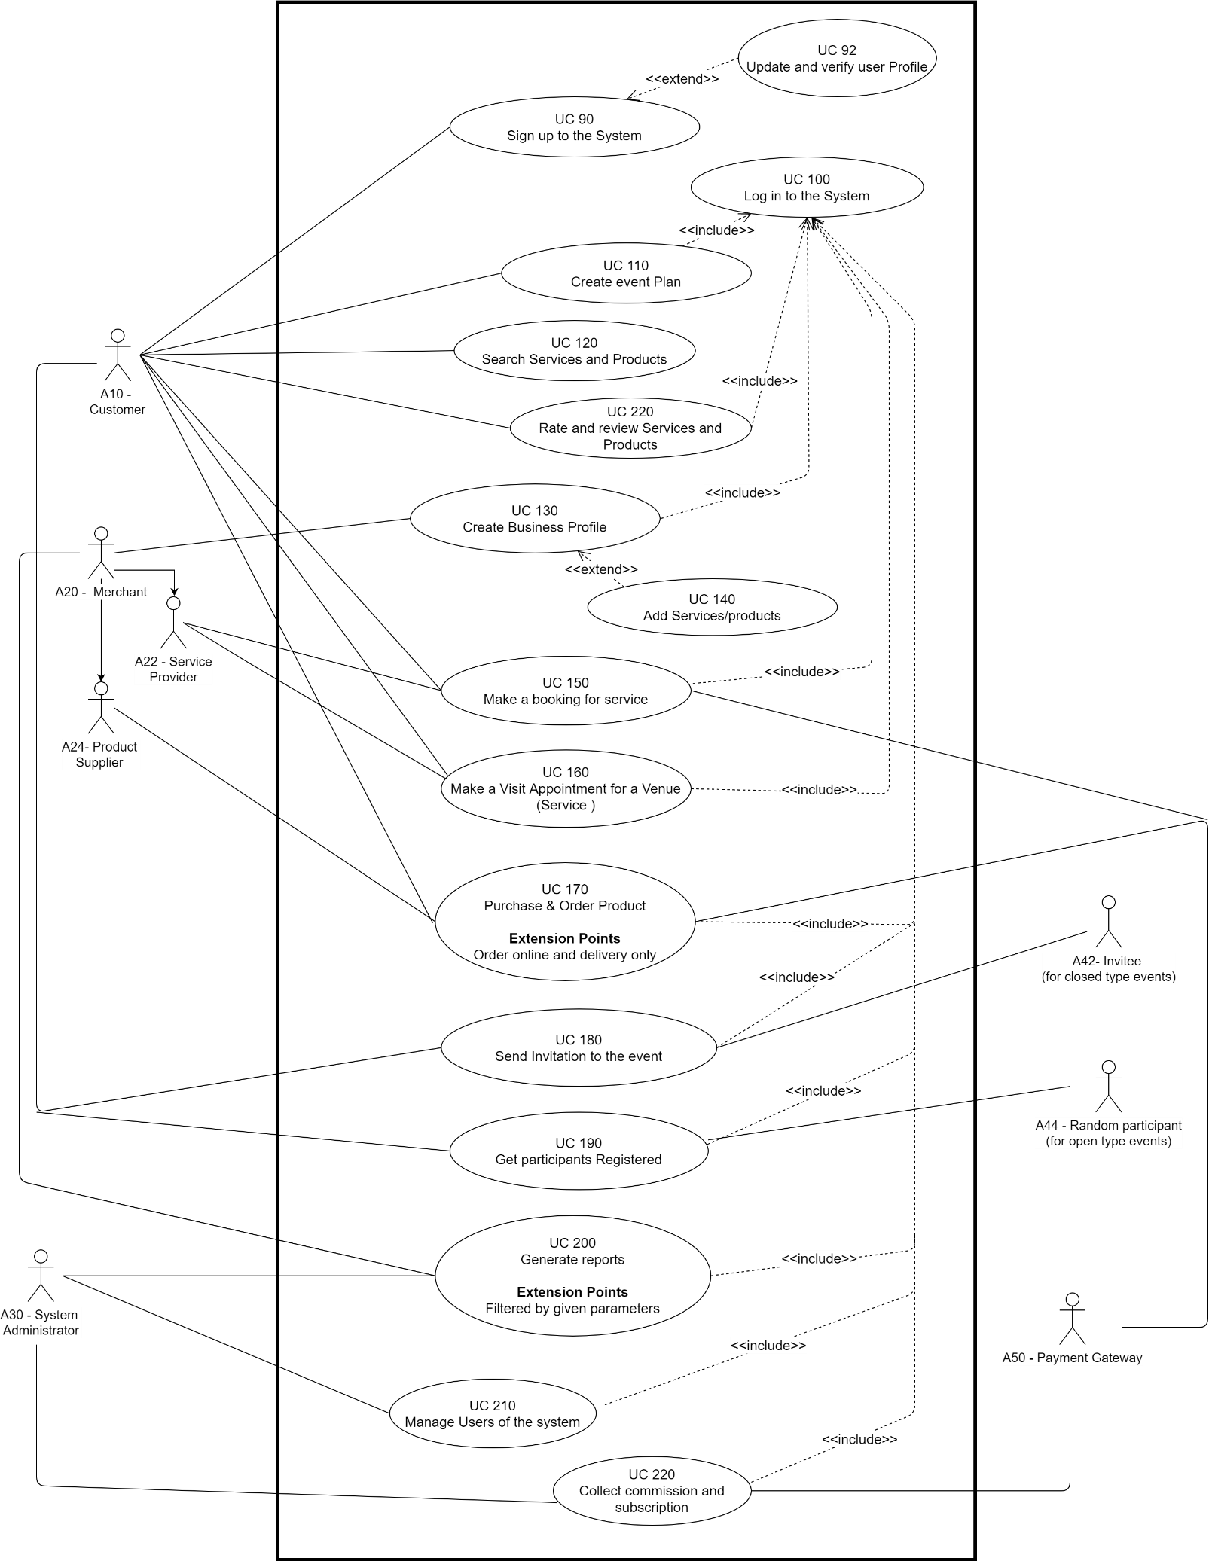

Figure 3. UC20 Overall use case for the proposed system

### 3.1.1 UC92 Use Case for update user profile Figure 3.2 illustrates the use case diagram for update user profile. The activities are done by both customer and Merchant.

Figure 3.2 UC92 Use Case for update user profile

### 3.1.2 UC110 Use Case for create an event plan

Figure 3.3 illustrates the use case diagram for creating an event plan using the system. The activities are done by the customer.

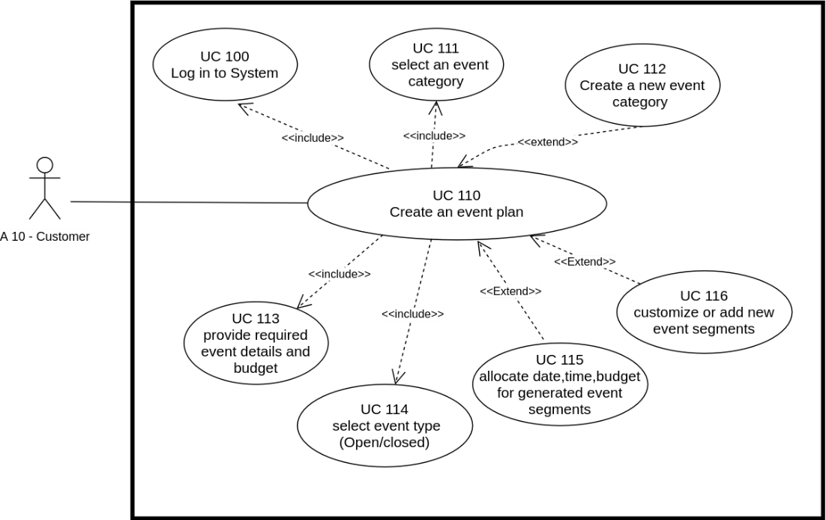  
  
  
  
  
  
  
  
  
  
  
  
  
  
  
  
  
  
  
  
  
Figure 3.3 UC110 Use Case for create event plan

### 3.1.5 UC120 Use Case for search and sort products or services

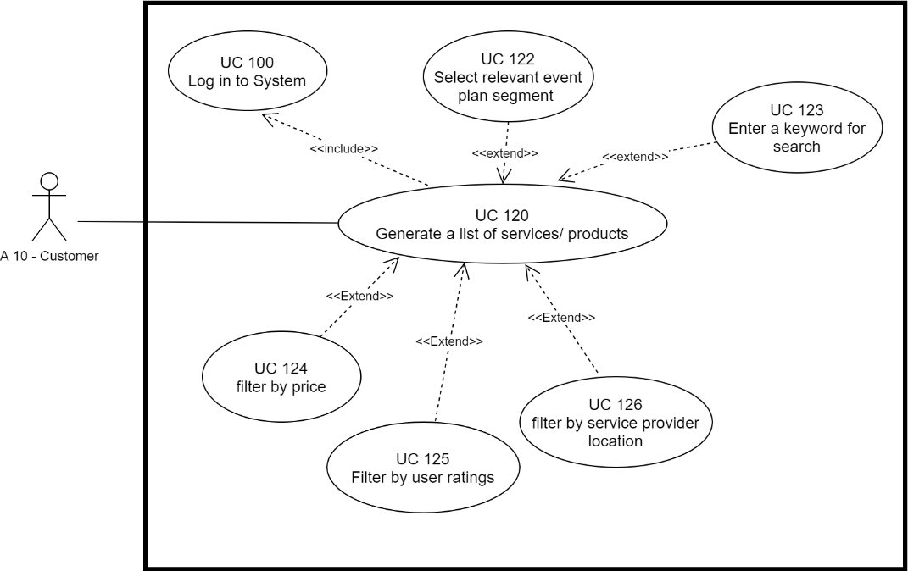Figure 3.4 illustrates the use case diagram for search and sort event related products and services. The activities are done by the customer.

Figure 3.4 UC120 Use Case for search and sort products or services

**3.1.6 UC130 Use Case for create business profile**

Figure 3.5 illustrates the use case diagram for create business profile. The activities are done by the merchant.

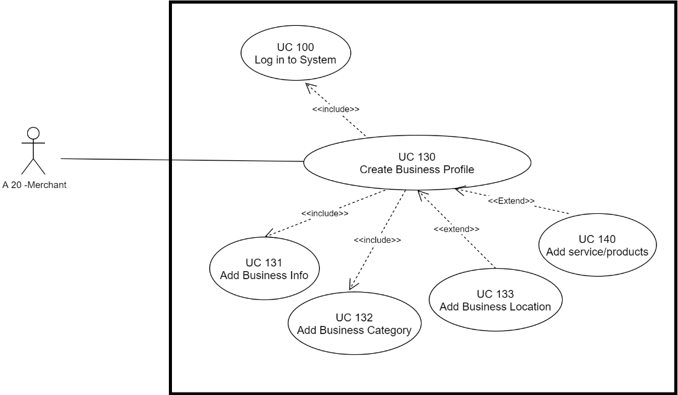

Figure 3.5 UC130 Use Case for create business profile

### 3.1.7 UC140 Use Case for add products and services

Figure 3.6 illustrates the use case diagram for add services and products to the business page.

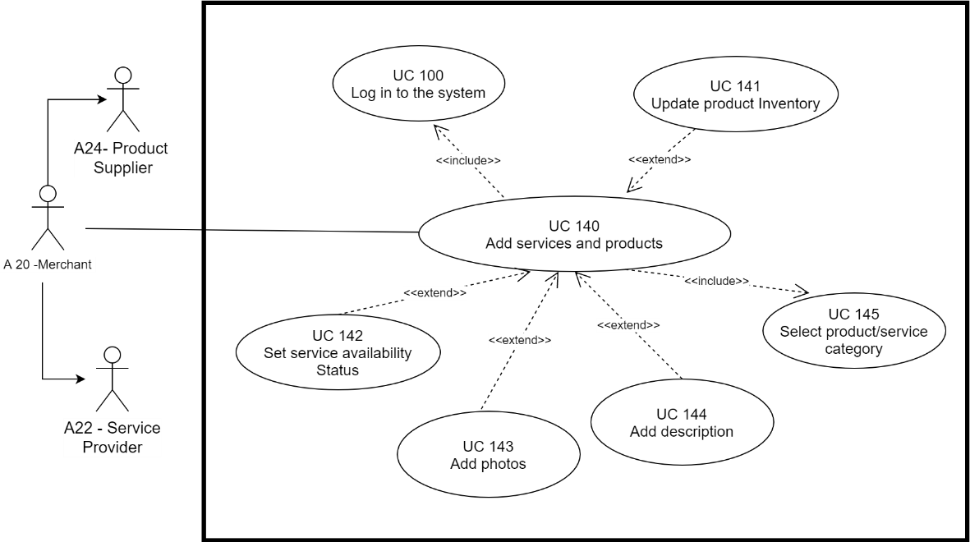

Figure 3.6 UC140 Use Case for add products and services

**3.1.8 UC150 Use Case for place a booking for a service**

Figure 3.7 illustrates the use case diagram for placing a booking for a service.

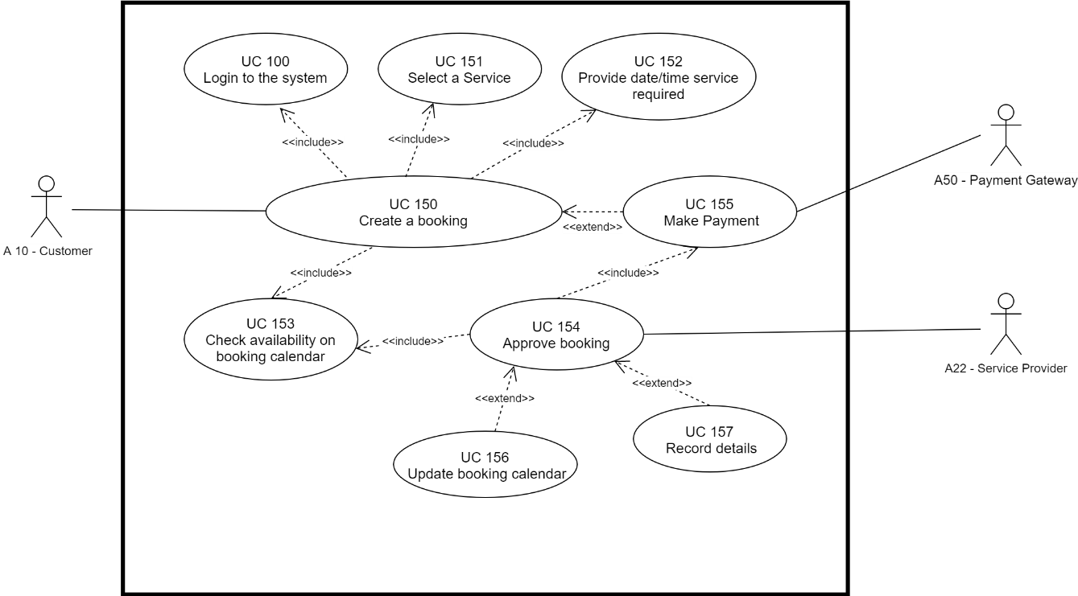

Figure 3.7 UC150 Use Case for place a booking for a service

### 3.1.9 UC160 Use Case for place a visit appointment for a service

Figure 3.8 illustrates the use case diagram for place a visit appointment for a venue.

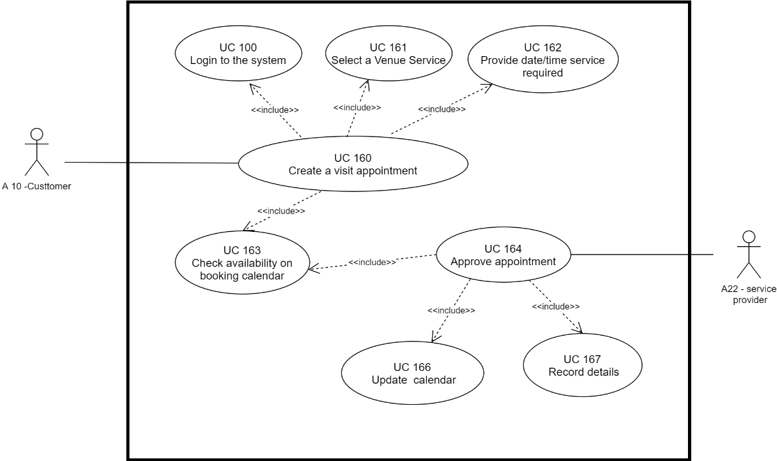

Figure 3.8 UC160 Use Case for place a visit appointment for a service

**3.1.10 UC170 Use Case for place an order for a required product**

Figure 3.9 illustrates the use case diagram for place an order for a event related product. Payment can be made online.

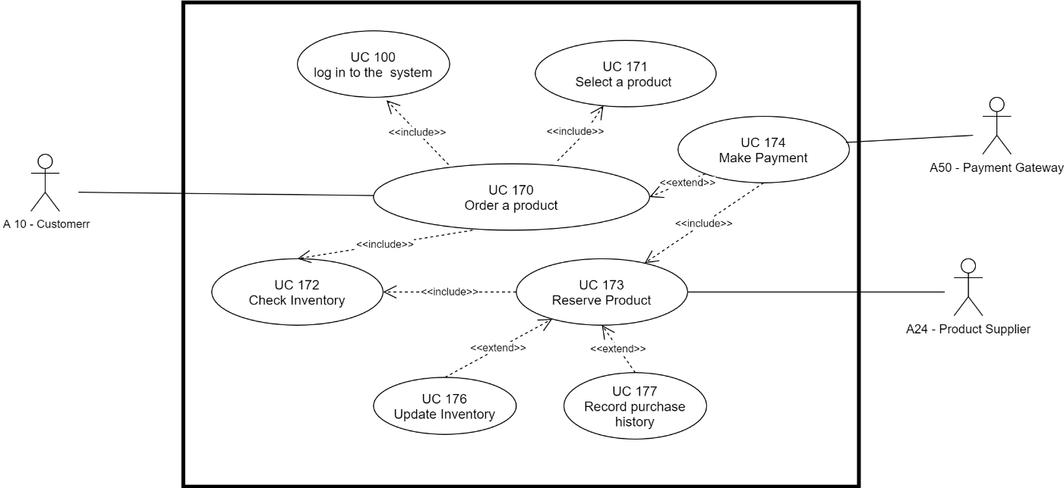

Figure 3.9 UC170 Use Case for place an order for a required product

### 3.1.11 UC180 Use Case for send invitations to the ‘closed type’ event invitees

Figure 3.10 illustrates the use case diagram for send invitations to the ‘closed type’ event participants.

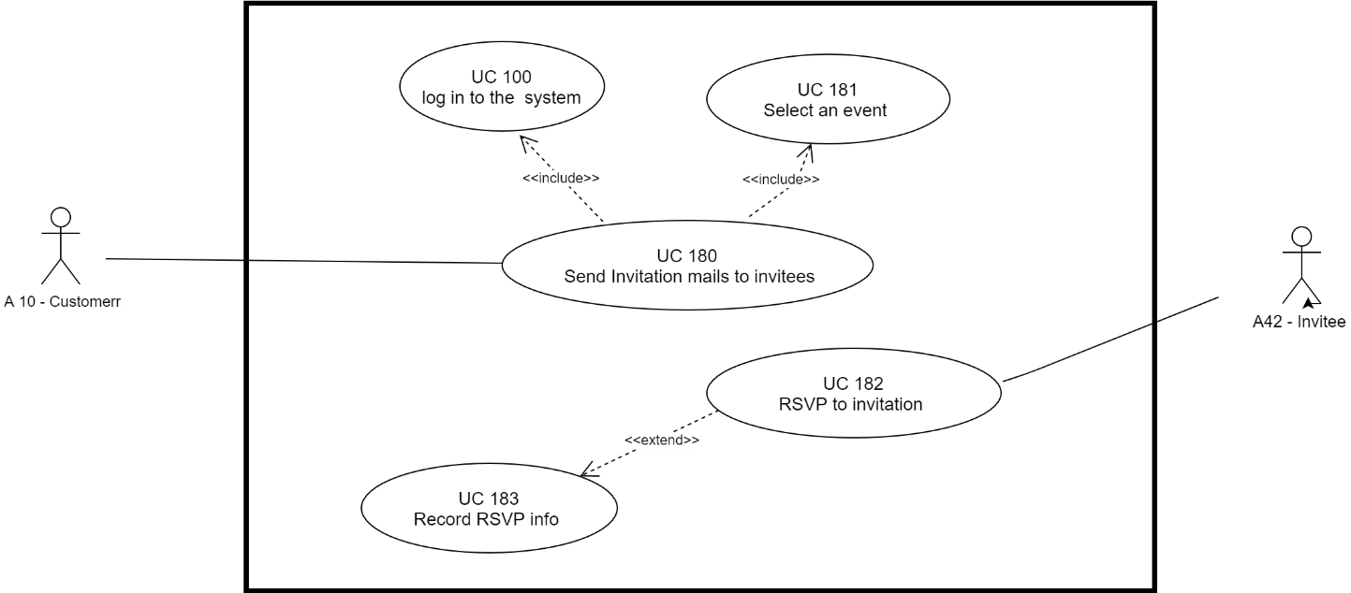

Figure 3.10 UC180 Use Case for send invitations to the closed type event invitees

**3.1.12 UC190 Use Case for get participants registered for the ‘open type’ events**

Figure 3.11 illustrates the use case diagram for get participants registered for ‘open type’ events through registration.

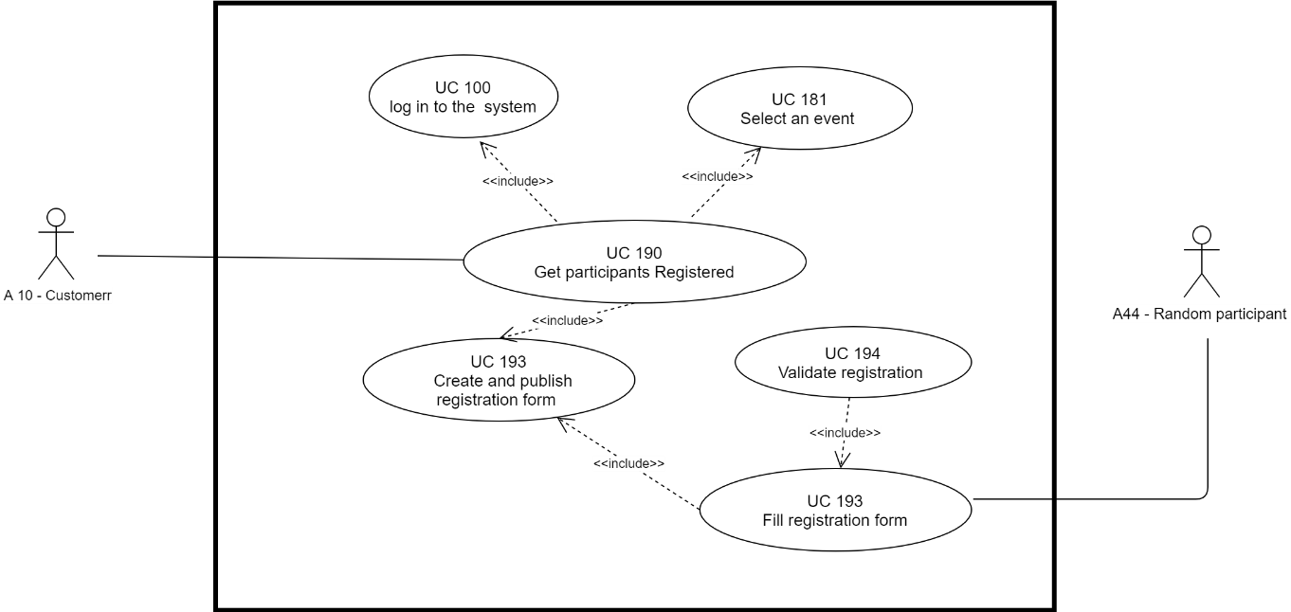

Figure 3.11 UC190 Use Case for get random participants registered to the open type events

### 3.1.13 UC200 Use Case for generate reports

Figure 3.12 illustrates the use case diagram for generate reports.

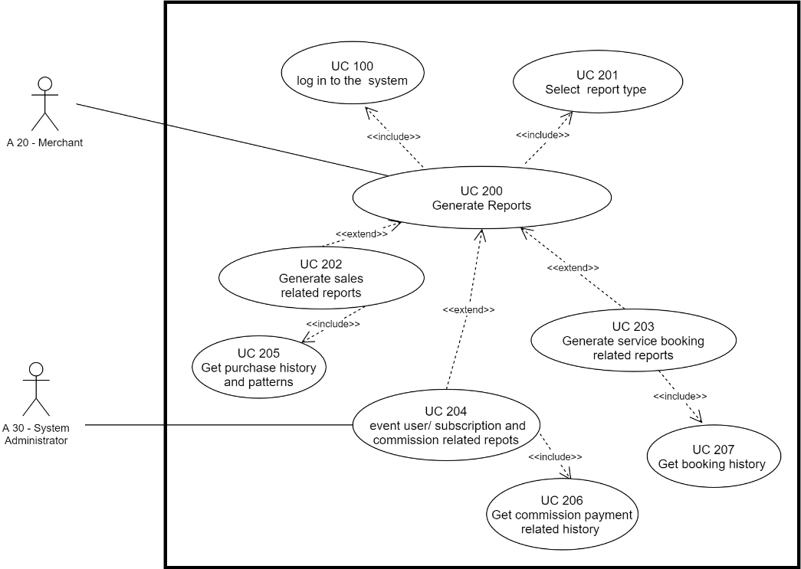

Figure 3.12 UC200 Use Case Diagram for generate reports

### 3.1.14 UC210 Use Case for collect commission and subscription fee by System Administrator

Figure 3.13 illustrates the use case diagram for collect commission and subscription fee by System Administrator.

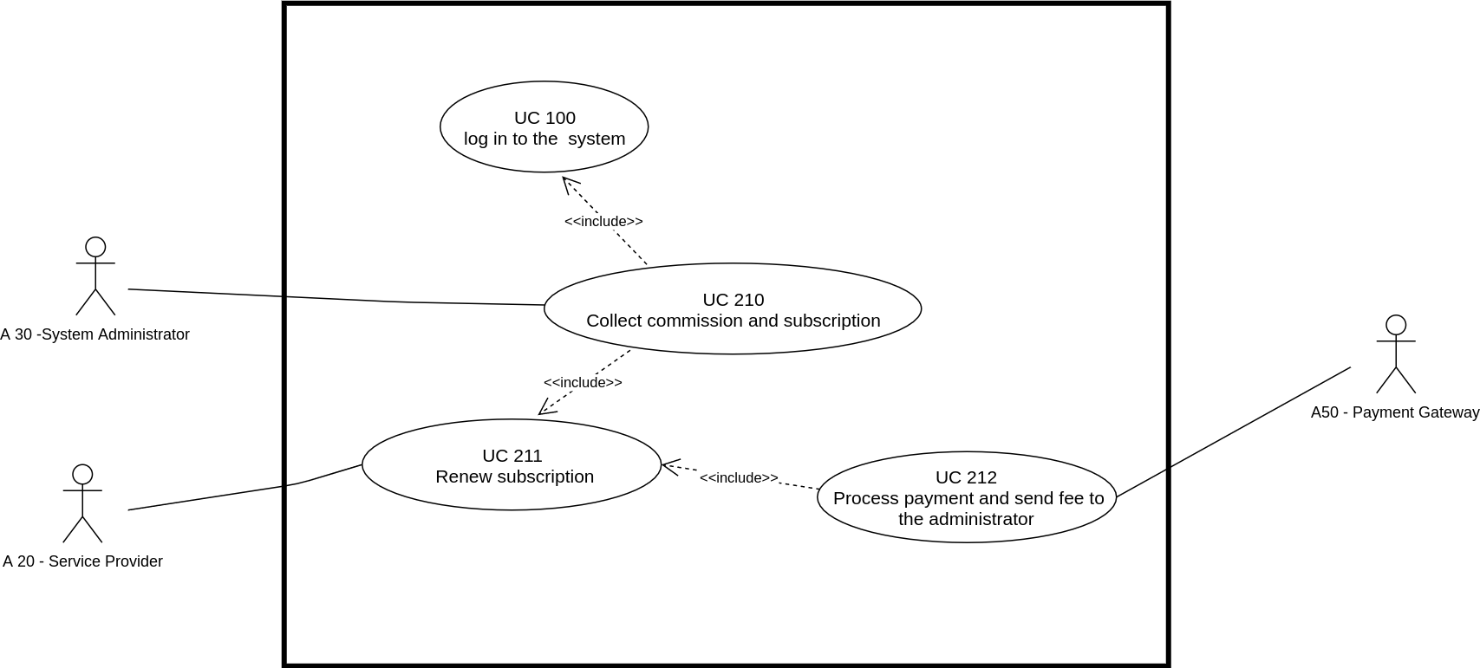

Figure 3.13 UC210 Use Case for collect commission and subscription fee by System Administrator

### 3.1.15 UC220 Use Case for rate and review services/ products

Figure 3.14 illustrates the use case diagram for rate and review service and products by the customer.

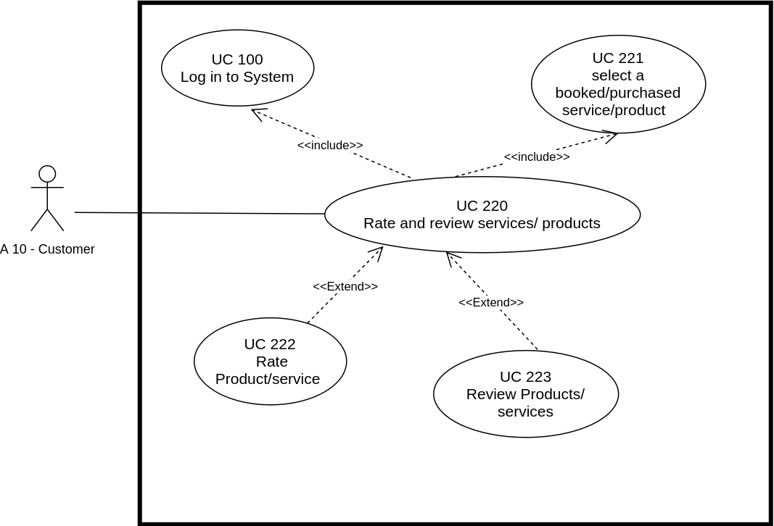

Figure 3.14 UC170 Use Case for rate and review services/ products

# 3.2 Use Case Descriptions for the Proposed System

### 3.2.1 UC92 Use case description for update user profile

Table 3.1 UC92 Use case description for update user profile

|  |  |
| --- | --- |
| Use Case | UC92 - Update user profile |
| Use Case Description | This use case describes how the user can update details in their user profile. |
| Actors | A 10 - Customer, A20 -Merchant |
| Pre-conditions | User should have logged in to the system. |
| Basic Flow | 1.Navigate to ‘User Profile’  2.Update profile info  3.Add a profile picture  4. Check user type  [if a merchant]   4.1 confirm identity verification if not confirmed yet  5.User may change the password  [if password change required]  5.1 Type old password  5.2 Type new password |
| Alternative Flow/ Exceptions | 1. Entered data may not be validated and given error. 2. Uploaded picture may be larger than the given size limit. |
| Post-conditions | Successfully logged in to the system and given desired access level |

### 3.2.2 UC110 Use case description for create an event plan

Table 3.2 UC110 Use case description for create an event plan

|  |  |
| --- | --- |
| Use Case | UC110 - Create an event plan |
| Use Case Description | This use case describes how the user can create a new event plan for already available event type or newly created event type. |
| Actors | A 10 - Customer |
| Pre-conditions | User should have logged in to the system. |
| Basic Flow | 1.Navigate to ‘Event’.  2.Select ‘Create new Event’.  3.Select event category.  [if category not available] 3.1 Create a new event category.  4. Select event type (Open event/closed event)  5. Input required event details.  6. Validate given details  [if valid]   6.1 generate event plan with a set of plan segments  [if not valid]   6.2 Show error. request to try again. |
| Alternative Flow/ Exceptions | 1.Entered data may not be validated and given error. |
| Post-conditions | Creates an event plan with set of segments. |

### 3.2.3 UC120 Use case description for search and sort services or products

Table 3.3 UC120 Use case description for search and sort services or products

|  |  |
| --- | --- |
| Use Case | UC120 - Search and sort services or products |
| Use Case Description | This use case describes how the user can search for specific services and/or products for the event. |
| Actors | A 10 - Customer |
| Pre-conditions | 1.User should have logged in the system.  2.Merchant should have added products or services to the system. 3.User should have created an event plan or navigated to the general search area. |
| Basic Flow | 1.User click on ‘Search’ and type a keyword or select an event plan segment which is a type of ‘Service’ or ‘Product’  2.System generates list of suggested services or products according to provided filters 3.User filter results by price, user ratings, service provider location and other given filters. |
| Alternative Flow/ Exceptions | 1.Entered keyword may not match with any available resources.  2.Event plan may have not yet generated. In that case user first need to generate an event plan according to the event. |
| Post-conditions | The most suitable services products are suggested. User will view and book/purchase services and/or products. |

### 3.2.4 UC130 Use case description for create a business profile

Table 3.4 UC130 Use case description for create a business profile

|  |  |
| --- | --- |
| Use Case | UC130 - Create a business profile |
| Use Case Description | This use case describes how the merchant can create a business profile. |
| Actors | A20 -Merchant |
| Pre-conditions | Merchant should have logged in to the system. Merchant should have completed the identity verification in their user profile. |
| Basic Flow | 1.User click on ‘Create Business Profile’  2.Check for Identity Verification  [if verified] create a blank business profile.  [if not verified] Show an error. Request to verify first.   1. Update business title, type, category and description. 2. Update business location, address and contact details. 3. Upload photos related to the business. 4. Upload any available certification and earn a badge after verification of uploaded certification. 5. UC 140 - Add products or services to the business profile. 6. Validate profile details   [if valid] 8.1 Update business profile details.  [if not valid] 8.2 Show an error. |
| Alternative Flow/ Exceptions | 1.Details my have not provided correctly  2.Identity verification may have not completed |
| Post-conditions | A business profile is created and published. |

### 3.2.5 UC140 Use case description for add services or products to the business profile

Table 3.5 UC140 Use case description for add services or products to the business profile

|  |  |
| --- | --- |
| Use Case | UC140 - Add services or products to the business profile |
| Use Case Description | This use case describes how the user merchant can add products or services to the business profile, to be shown to the customers for booking / purchasing. |
| Actors | A20 -Merchant |
| Pre-conditions | Merchant should have logged in to the system.  Merchant should have created and published a business profile. |
| Basic Flow | 1.User click on ‘Add service / Add product’  2.Select service or product category  3.Input title, description and other details.  4. Add photos of the service or product.  5.Set product/service state  [if a service] 5.1 Set service availability  [if a product] 5.1 Set product inventory  6.Validate provided details  [if valid]   6.1 Created and update service or product  6.2 Add service or product to the business profile  [if not valid] 6.3 Show an error |
| Alternative Flow/ Exceptions |  |
| Post-conditions | Successfully added service or product to the business profile. User will receive a confirmation message. |

### 3.2.6 UC150 Use case description for place a booking for a service

Table 3.6 UC150 Use case description for place a booking for a service

|  |  |
| --- | --- |
| Use Case | UC150 - Place a booking for a service |
| Use Case Description | This use case describes how the user can place a booking for a selected service. |
| Actors | A10 - Customer, A22 - Service Provider, A50 -Payment gateway |
| Pre-conditions | Customer should have logged in to the system.  An event plan should be generated and selected. |
| Basic Flow | 1.User select relevant event plan segment for a service.  2.A suggested list according to the availability, event location and allocated budget, will be generated.  3.User can change the required date, time and filter again.  4.User can sort list with provided filters.  5.Select a suitable service in the list.  6.Select ‘Book Service’  [if date is available]  [if can be directly booked]  6.1.1 check calendar availability and reserve booking.  6.1.2 generate payment quote and send to the customer.  [if cannot be directly booked]  6.1.3 A booking request will be sent to the service provider.  6.1.4 Booking confirmed by the service provider.  6.1.5Payment quote will be generated.  [if date in unavailable]   * 1. Show error and request another selection.   7.User make payment through the payment gateway. (An initial amount of the total booking)  8.Booking will be confirmed, and payment receipt will be generated.  9.Booking calendar will be updated, and history will be recorded. |
| Alternative Flow/ Exceptions | 1.If event plan segments relevant to required services are not generated, use can add a new plan segment and book a service.  2.User can directly search for a service and book it. |
| Post-conditions | A booking successfully created. Payment quote for booking reservation and the payment receipt once the payment is made will be sent to the customer. |

**3.2.7 UC160 Use case description for place a visit appointment for a venue service**

Table 3.7 UC160 Use case description for place a visit appointment for a venue service

|  |  |
| --- | --- |
| Use Case | UC160 - Place a visit appointment for a venue service |
| Use Case Description | This use case describes how the user place a visit appointment for a service under ‘venue’ category prior to pay and booking. |
| Actors | A10 - Customer, A22- Service Provider |
| Pre-conditions | Customer should have logged in to the system. |
| Basic Flow | 1. User select relevant service under ‘venue’ category. 2. Select ‘Create a visit appointment’ 3. User can provide/modify the required date, time for the visit appointment.   [if date is available]  3.1 check calendar availability and reserve appointment.  3.2 send appointment request to service provider.  [if date in unavailable]  3.3 Show error and request another date/time.  4. A reservation note sent to the customer.  5. Booking calendar will be updated.  5. Appointment history will be recorded. |
| Alternative Flow/ Exceptions | 1.If event plan segments relevant to required services are not generated, use can add a new plan segment for a venue service.  2.User can directly search for a service and create a visit appointment. |
| Post-conditions | A visit appointment is successfully scheduled.  A reservation note will be sent to the customer. |

### 3.2.8 UC170 Use case description for place an order for a required product

Table 3.8 UC170 Use case description for place an order for a required product

|  |  |
| --- | --- |
| Use Case | UC170 - Place an order for a required product |
| Use Case Description | This use case describes how the user place an order for a required product |
| Actors | A10 - Customer, A24 - Product Supplier, A50 - Payment gateway |
| Pre-conditions | Customer should have logged in to the system. |
| Basic Flow | 1. User select relevant product from the list. 2. View product details and price.   3. User select ‘order now’  4. User provide required quantity.  5. Check for the availability in inventory    [if required quantity is available]  5.1 reserve the quantity.  3.2 send payment quote to the user.  [if not unavailable]  3.3 Show error and request another selection.  4. User make payment through the payment gateway. (including delivery charges if required)  5. Request will be sent to the product supplier.  6. Payment receipt will be generated and sent to the customer.  7. Inventory will be updated.  8. Order history will be recorded.  9. Products are overhanded to the delivery (explicit from the system)  10. Delivery service details and a delivery ID will be sent to the user. |
| Alternative Flow/ Exceptions | 1.If event plan segments relevant to required products are not generated, use can add a new plan segment for a product category.  2.User can directly search for a product and place an order.  3. Delivery is explicit from the system and only the details will be provided. Delivery tracking will depend on the delivery service hired by the product supplier. |
| Post-conditions | A product order is successfully created.  A reservation note will be sent to the customer. |

### 3.2.9 UC180 Use case description for send invitations to the closed type event invitees

Table 3.9 UC180 Use case description for send invitations to the closed type event invitees

|  |  |
| --- | --- |
| Use Case | UC180 - Send invitations to closed type event invitees |
| Use Case Description | This use case describes how the user send invitations for a closed type event to a set of selected invitees. |
| Actors | A10 - Customer, A42 - Invitee |
| Pre-conditions | Customer should have logged in to the system.  Customer should have created a closed type event.  The event should have been in ‘published’ state. |
| Basic Flow | 1. User select an event of closed type. 2. select ‘Participants’. 2. View already confirmed invitees and number of guests. 3. select ‘Create Invitation’ 4. Create invitation content and save draft. 5. select ‘Add new Participant’ 6. Input participant email. 7. send invitation.   9. Invitee receive and confirm invitation.  [if confirmed]  9.1 update the participant list.  9.2 send upcoming event related notifications to the invitee. |
| Alternative Flow/ Exceptions | 1.Once the event is in published invitation can be share over social media if the email of the invitee is not available. |
| Post-conditions | An invitation for an event is created.  Participant is added to the event. |

### 3.2.10 UC190 Use case description for get random participants registered to the open type events

Table 3.10 UC190 Use case description for get random participants registered to the open type events

|  |  |
| --- | --- |
| Use Case | UC190 - Get random participants registered to the open type events. |
| Use Case Description | This use case describes how the user get random participants registered to an open type event. |
| Actors | A10 - Customer, A44 - Random Participant |
| Pre-conditions | Customer should have logged in to the system.  Customer should have created an open type event.  The event should have be in ‘published’ state. |
| Basic Flow | 1. User select an event of open type. 2. select ‘Participants’.   3. View already confirmed participants and number of guests.  4. select ‘Create Registration form’  5. Create registration form and get the form link.  6. select ‘Add new Participant’  7. send registration form link through email.  8. Participant receive the registration form, fill and submit it.  [if approved]  8.1 update the participant list.  8.2 send upcoming event related notifications to the participant. |
| Alternative Flow/ Exceptions | 1.Once the event is in published invitation can be share over social media if the email of the invitee is not available. |
| Post-conditions | A registration form for an event is created.  Participant is added to the event. |

### 3.2.11 UC200 Use case description for generate reports

Table 3.11 UC200 Use case description for generate reports

|  |  |
| --- | --- |
| Use Case | UC200 - Generate reports. |
| Use Case Description | This use case describes how the user generate different types of reports through the system. |
| Actors | A20 - Merchant, A30 - System Administrator |
| Pre-conditions | User should have logged in to the system. |
| Basic Flow | 1. Navigate to ‘Report’ wizard. 2. select ‘’New Report’.   3. Select report subject (Sales/ bookings/ commission/ subscription etc.)  4. Select report type.  5. Provide duration to consider.  6. Add necessary filters.  7. select ‘Generate Report’  8. View report and export as a PDF. |
| Alternative Flow/ Exceptions | - |
| Post-conditions | A report of evaluation is generated. |

### 3.2.12 UC210 Use case description for collect commission and subscription fee by system administrator

Table 3.12 UC210 Use case description for collect commission and subscription fee by system administrator

|  |  |
| --- | --- |
| Use Case | UC210 - Collect commission and subscription fee by system administrator. |
| Use Case Description | This use case describes how the system administrator collects commission on sales and bookings and the subscription fee. |
| Actors | A20 -Merchant, A 30 -System Administrator |
| Pre-conditions | System Administrator should have logged in to the system. |
| Basic Flow | 1. Service Provider renew their subscription. 2. A commission is generated on a product order or a booking.   3. Subscription fee and commission amount forwarded to the system administrator through payment gateway.  4. Merchant’s subscription renewed. |
| Alternative Flow/ Exceptions |  |
| Post-conditions | Subscription fee and commission are collected. |

### 3.2.13 UC220 Use case description for rate and review services and products

Table 3.13 UC220 Use case description for rate and review services and products

|  |  |
| --- | --- |
| Use Case | UC220 - Rate and review services and products. |
| Use Case Description | This use case describes how the user rate and review a booked service or an ordered product through the system. |
| Actors | A10 - Customer |
| Pre-conditions | Customer should have logged in to the system. |
| Basic Flow | 1. Customer select a service or a product from the booking / order history. 2. customer will be immediately ask to rate and review a product or service as an option at the end of the each service booking and product purchase. 3. Provide a star rating (1-5) and a review if interested. 4. Save ratings and reviews. |
| Alternative Flow/ Exceptions |  |
| Post-conditions | Rating and reviews will be recorded and published. |

# Activity Diagrams for the Proposed System

### 3.3.1 Activity diagram for sign up to the system

Figure 3.15 illustrates the activity diagram for sign up to the system. The activity is done by both customer and the merchant. Merchant can verify their identity while signing up or later.

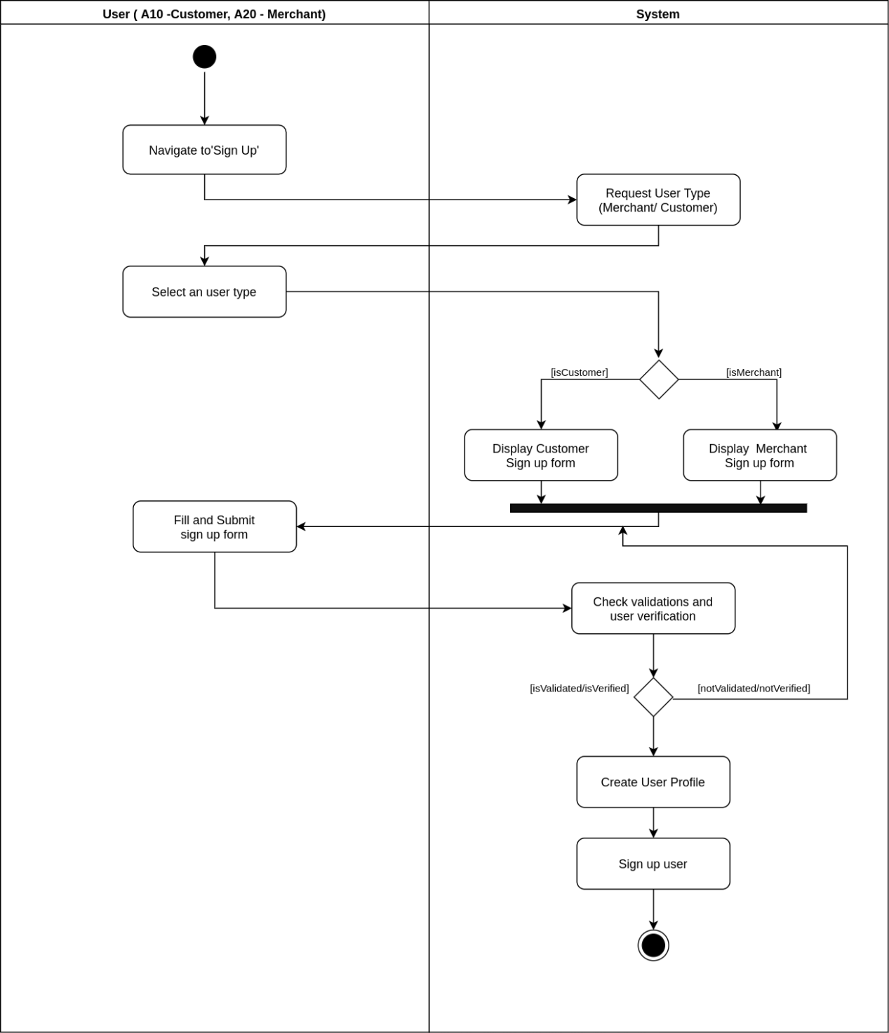

Figure 3.15 Activity diagram for sign up to the system

### 3.3.2 Activity diagram for log in to the system

Figure 3.16 illustrates the activity diagram for log in to the system. The activity is done by customer, merchant and system administrator.

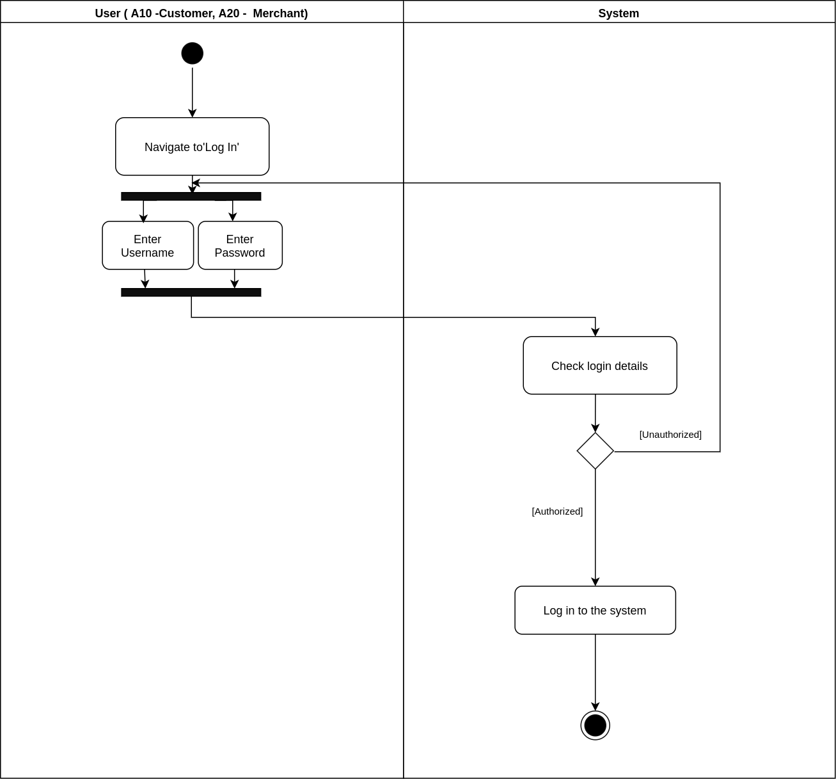

Figure 3.16 Activity diagram for log in to the system

### 3.3.3 Activity diagram for update Merchant’s user profile

Figure 3.17 illustrates the activity diagram for update Merchant’s user profile. The activity is done by merchant. Both merchant and customer can update their user profiles. Merchant’s profile update includes identity verification with a photograph of NIC/DL. Without proper identity verification, merchant is not allowed to create a business profile.

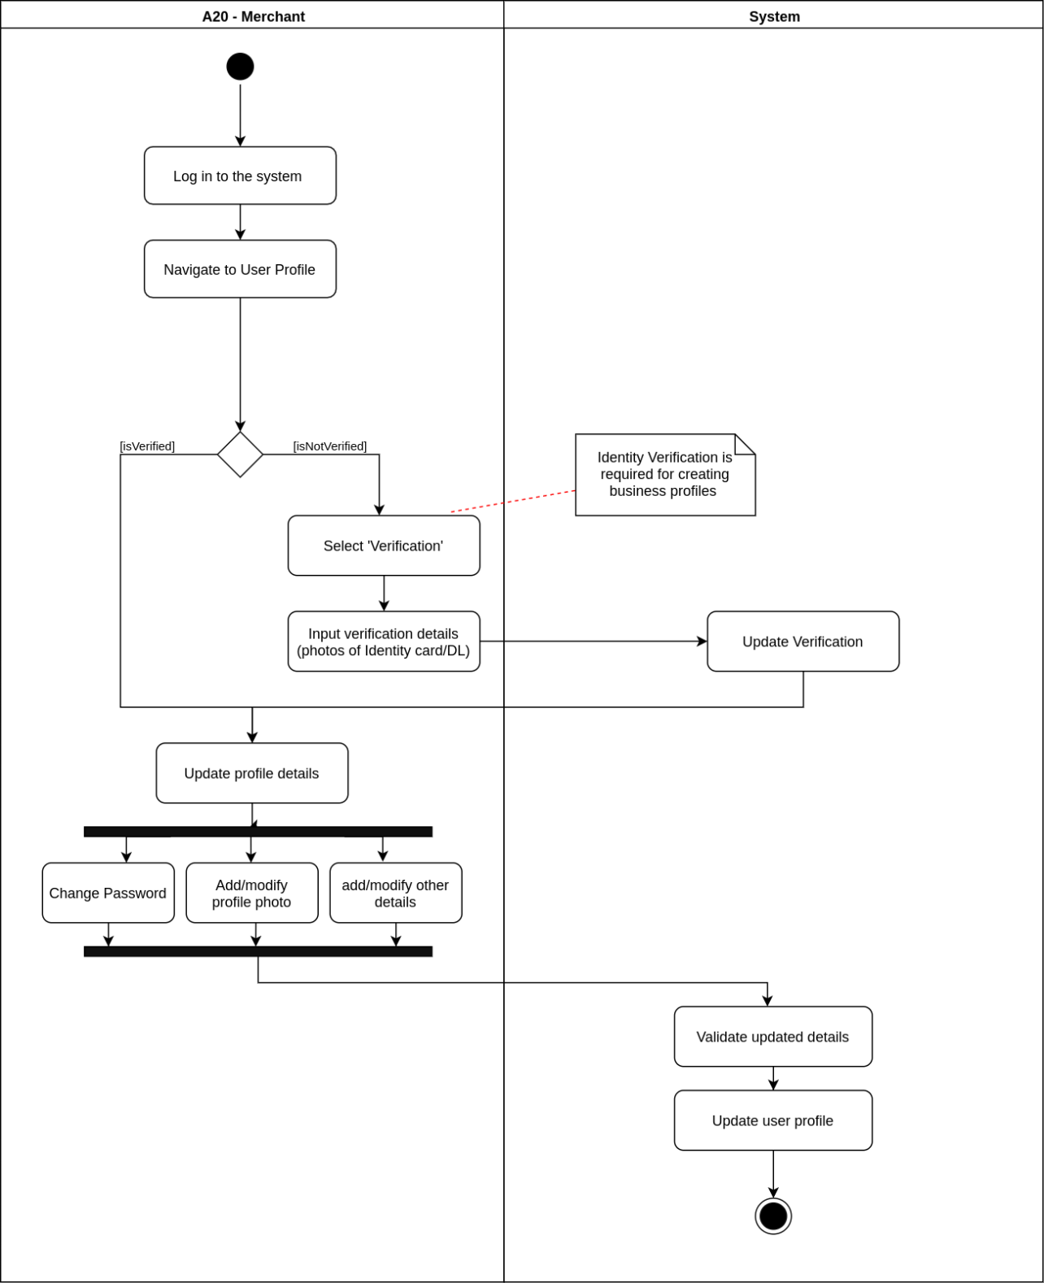

Figure 3.17 Activity diagram for update Merchant’s user profile

### 3.3.4 Activity diagram for generate event plan for available event category

Figure 3.18 illustrates the activity diagram for generate event plan for an available event category in the system. The activity is done by customer. An event has two types: open and closed, and it has several categories. An event plan will be generated accordingly.

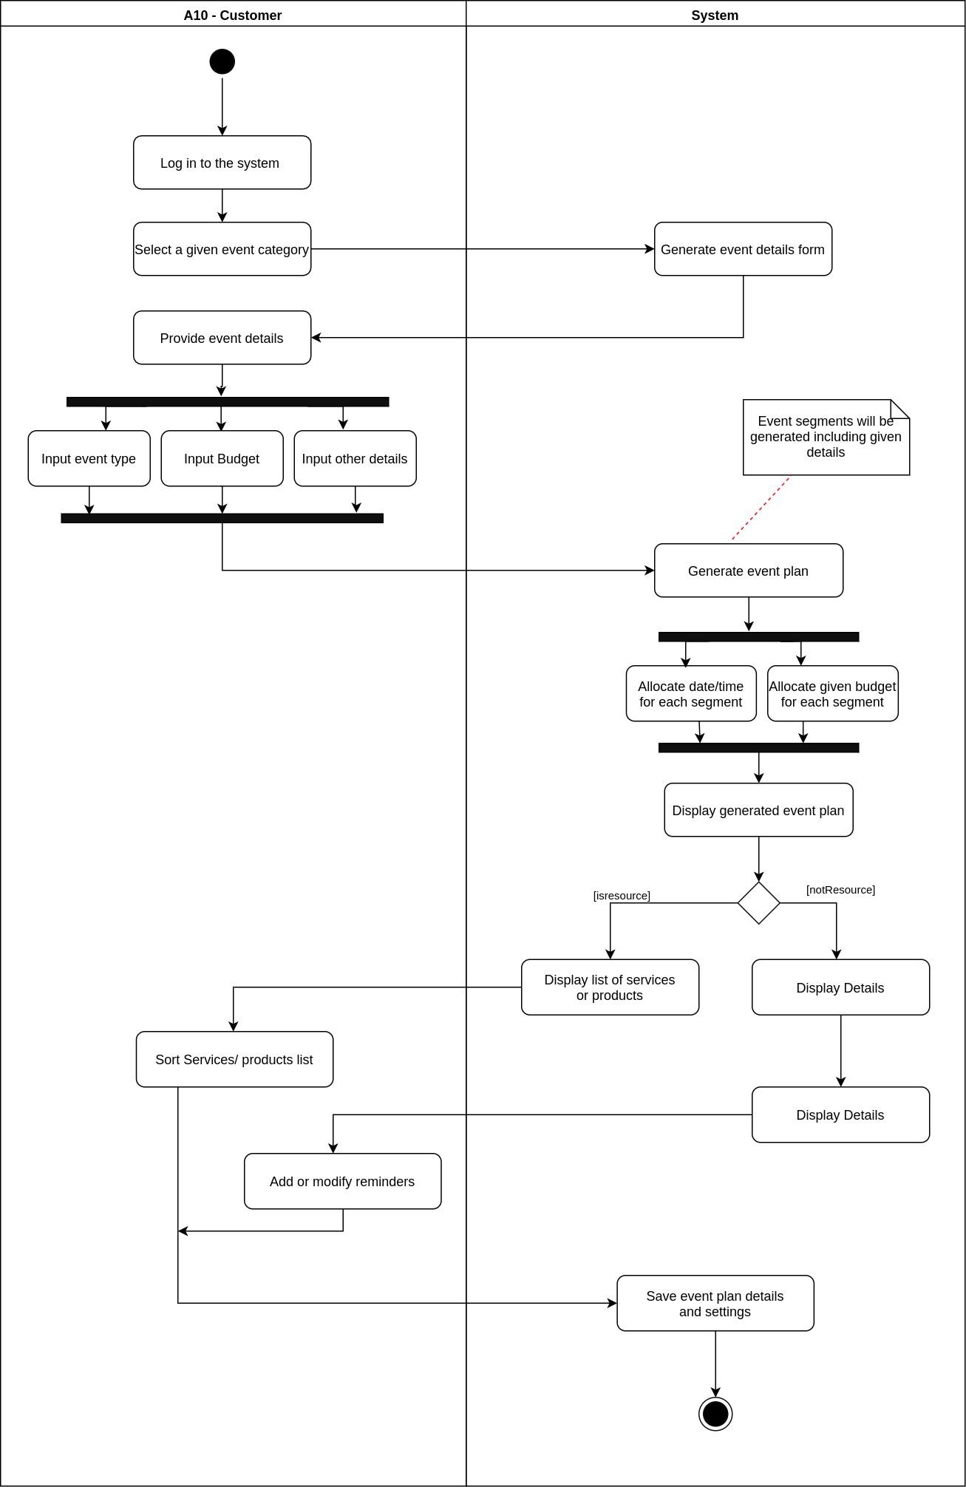

Figure 3.18 Activity diagram for generate event plan for available event category

### 3.3.5 Activity diagram for and generate event plan for new event category

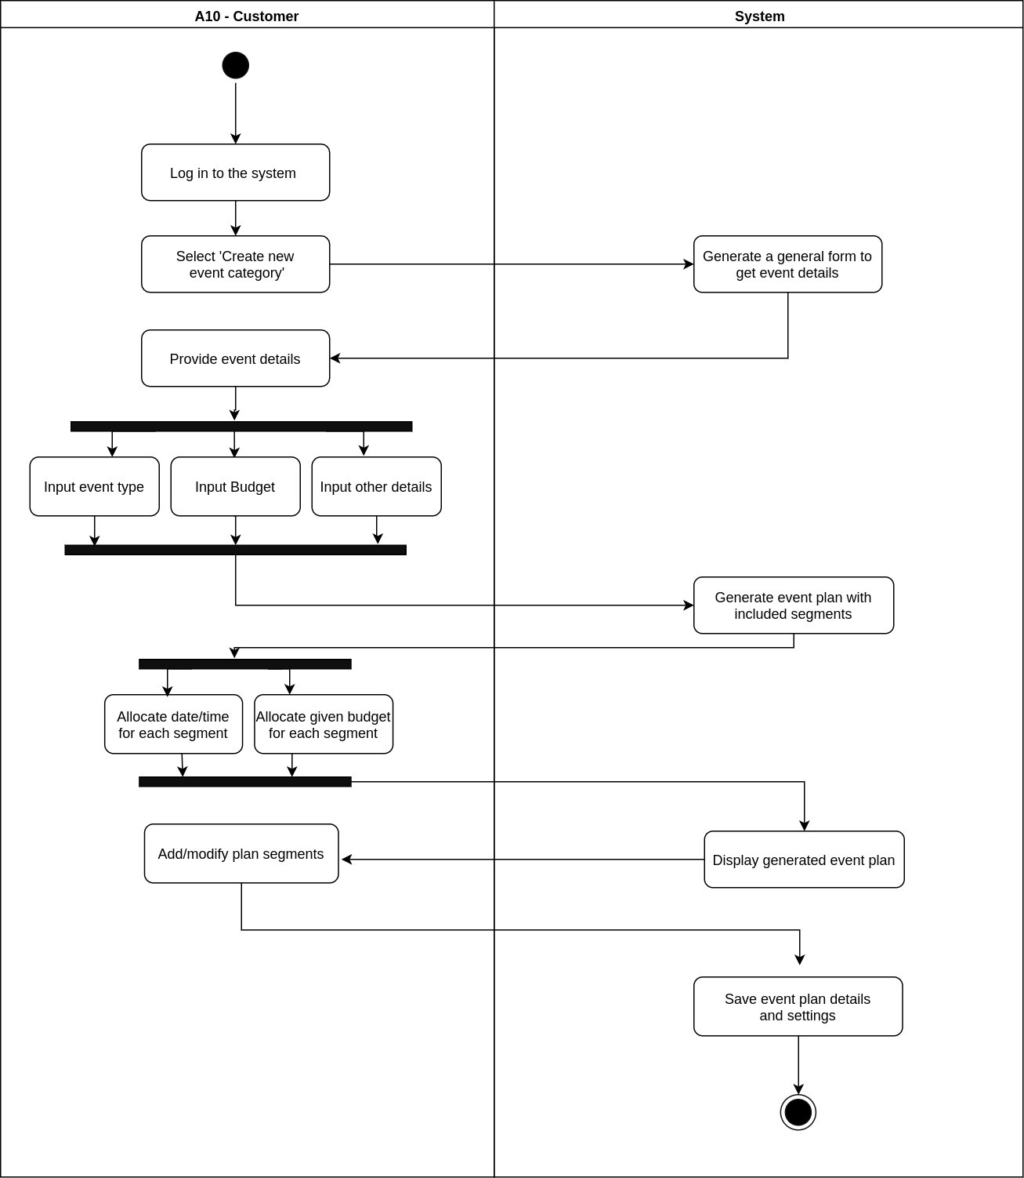Figure 3.19 illustrates the activity diagram for generate event plan for new event category in the system. The activity is done by customer. A new event category can be created, and a basic plan can be generated after providing relevant details.

Figure 3.19 Activity diagram for and generate event plan for new event category

### 3.3.6 Activity diagram for creating business profile

Figure 3.20 illustrates the activity diagram for creating business profile. The activity is done by merchant. Merchant’s identity verification is required. Products or services can be added to the merchant’s business profile.

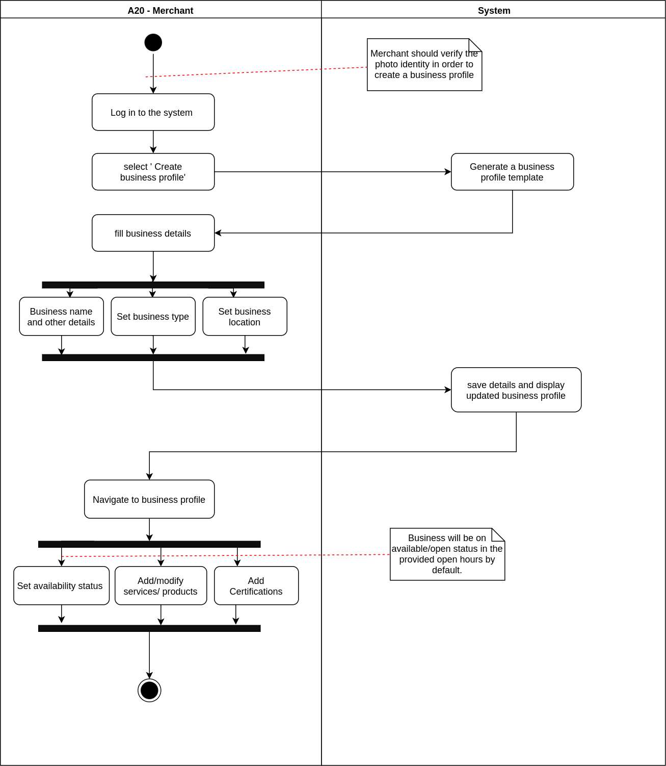

Figure 3.20 Activity diagram for creating business profile

### 3.3.7 Activity diagram for add and modify products and services

Figure 3.21 illustrates the activity diagram for add and modify products and services to the merchant’s business profile. The activity is done by merchant.

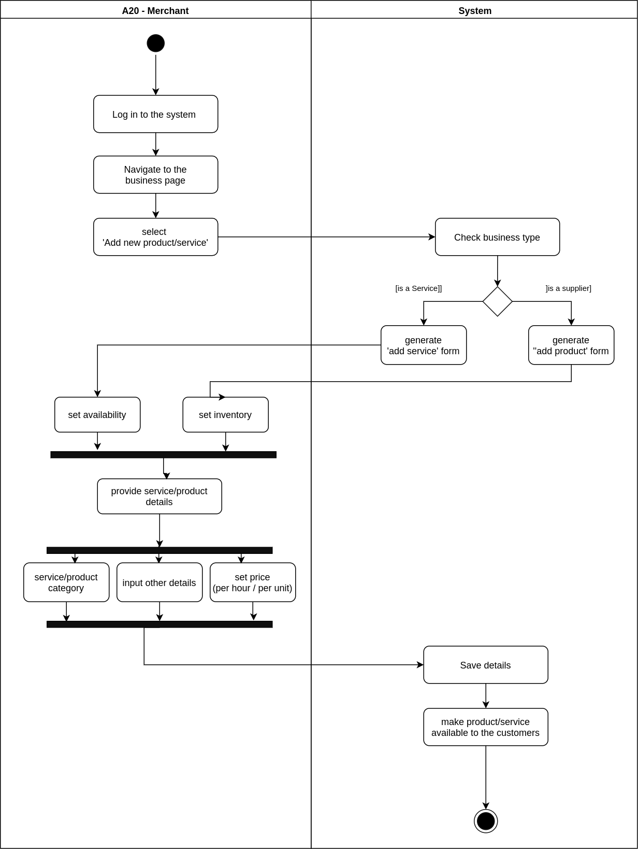

Figure 3.21 Activity diagram for add and modify products and services

### 3.3.8 Activity diagram for search and filter products and services

Figure 3.22 illustrates the activity diagram for search and filter services or products. The activity is done by customer. They can either search for product or service or generate a suggested product/ service list under relevant event segment.

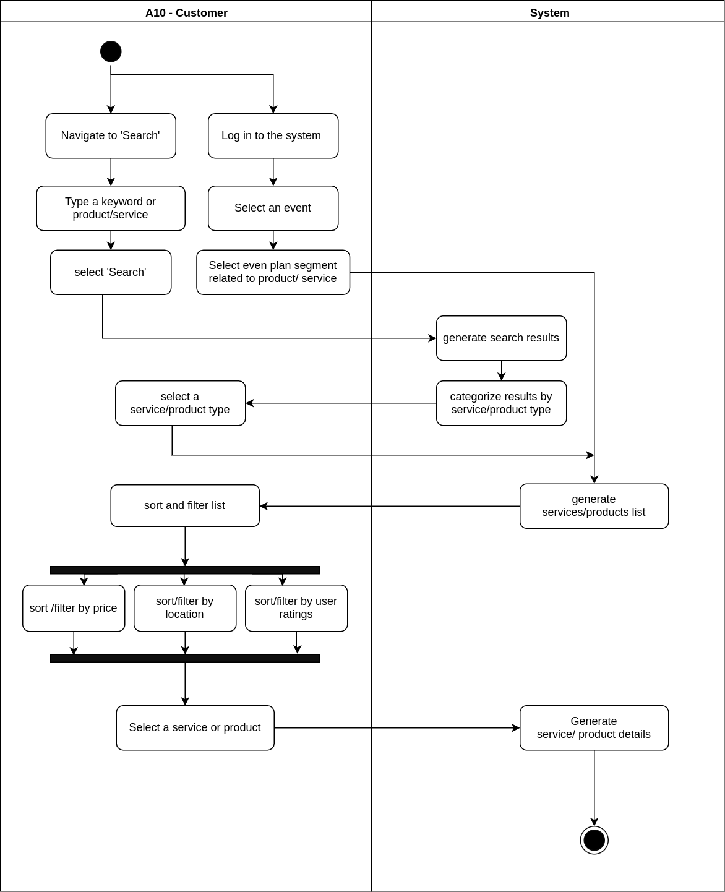

Figure 3.22 Activity diagram for search and filter products and services

### 3.3.9 Activity diagram for place a booking for a service

Figure 3.23 illustrates the activity diagram for place a booking for a service. The activity is done by customer. An initial booking fee will be charged through the system.

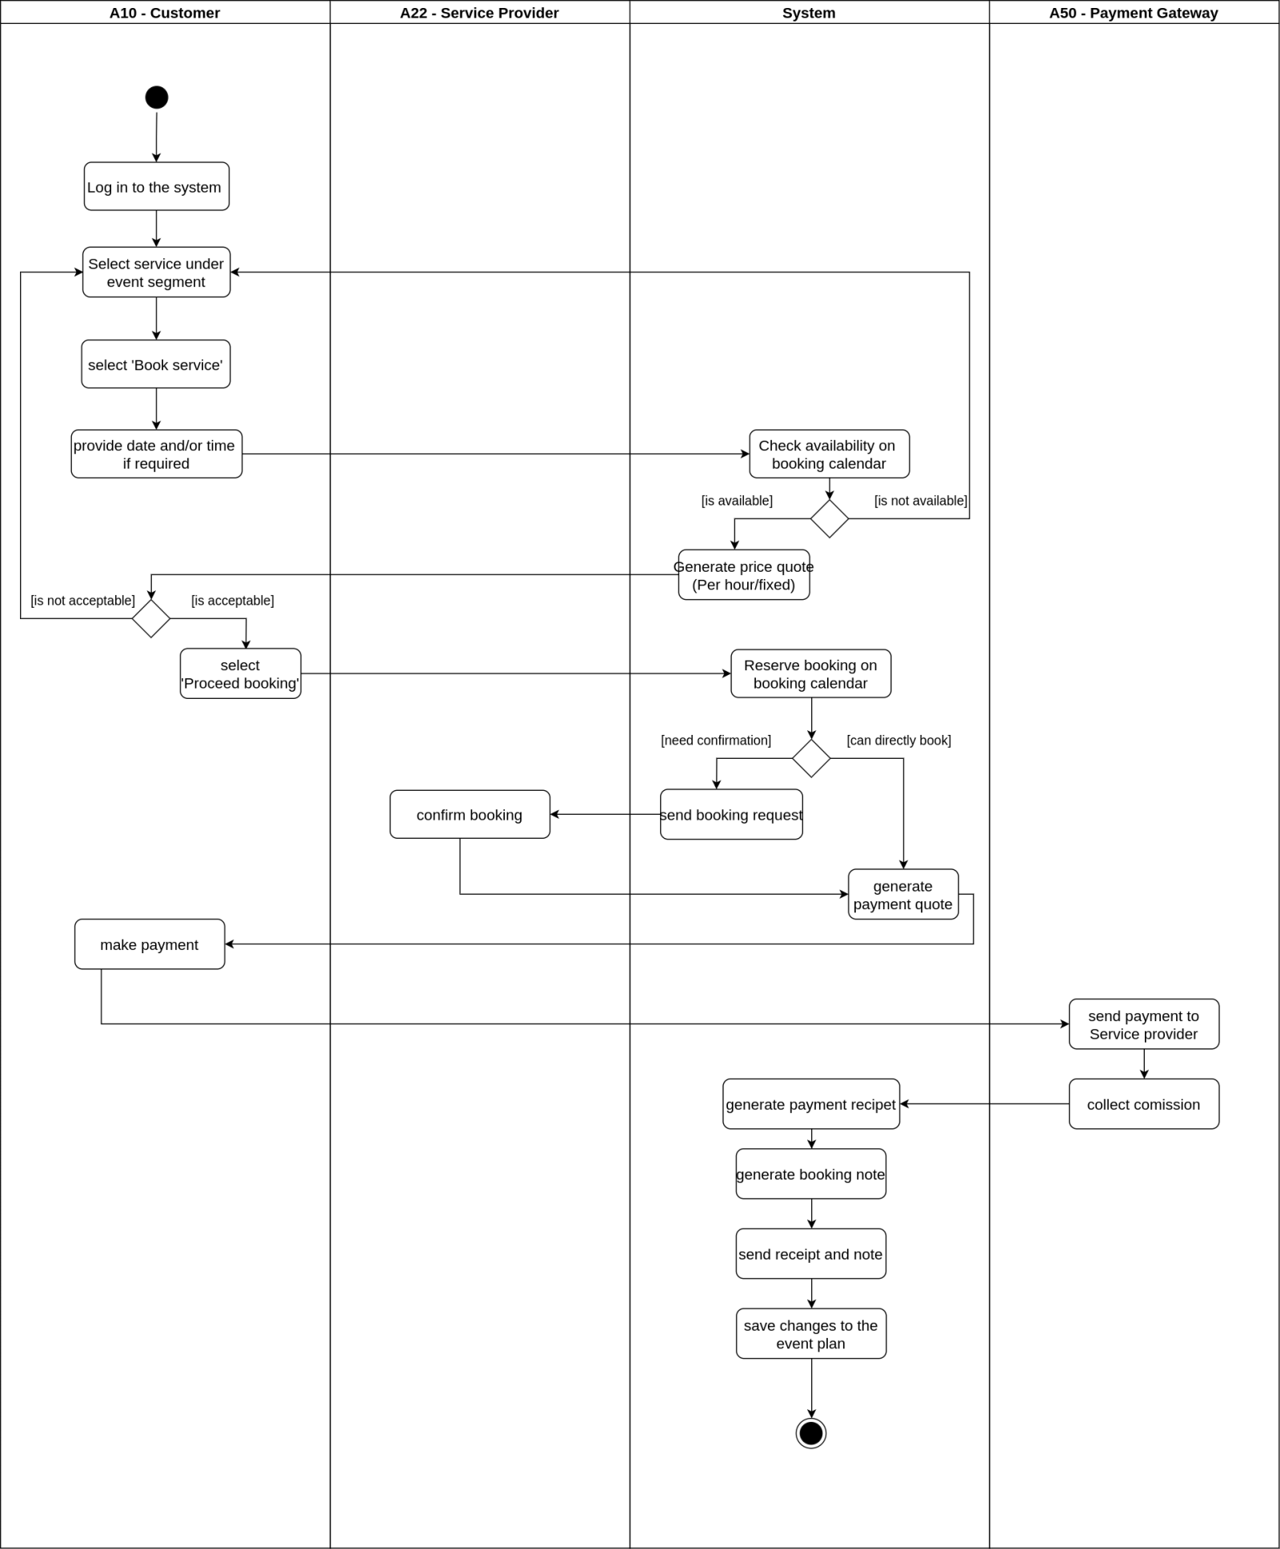

Figure 3.23 Activity diagram for place a booking for a service

### 3.3.10 Activity diagram for place a visit appointment for a venue service

Figure 3.24 illustrates the activity diagram for placing a visit appointment for a venue. The activity is done by customer. A visit appointment prior to the booking can be only requested for services belongs to ‘Venue’ category.

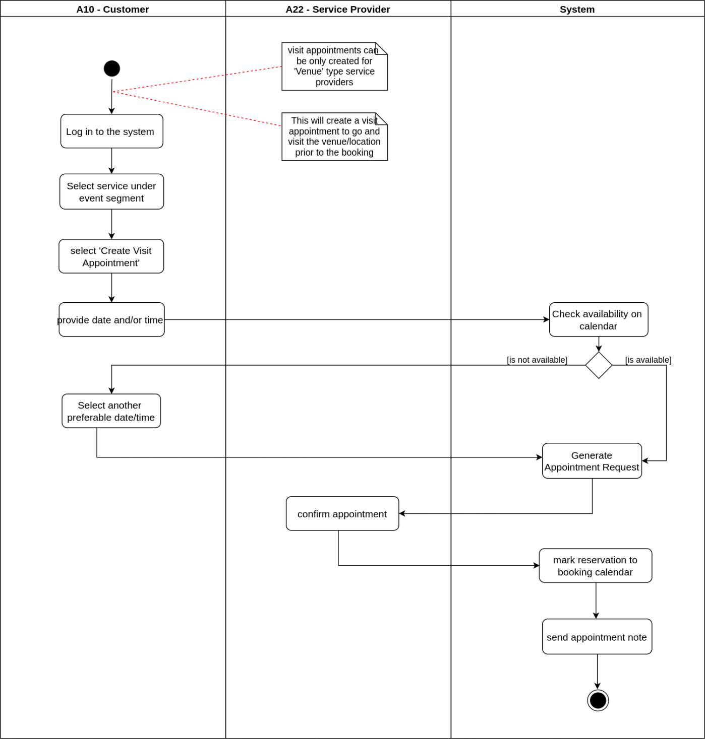

Figure 3.24 Activity diagram for place a visit appointment for a venue service

### 3.3.11 Activity diagram for place an order for a required product

Figure 3.25 illustrates the activity diagram for purchase and order products. The activity is done by customer. Ordering and payment can be processed through system. Product delivery is explicit from the system.

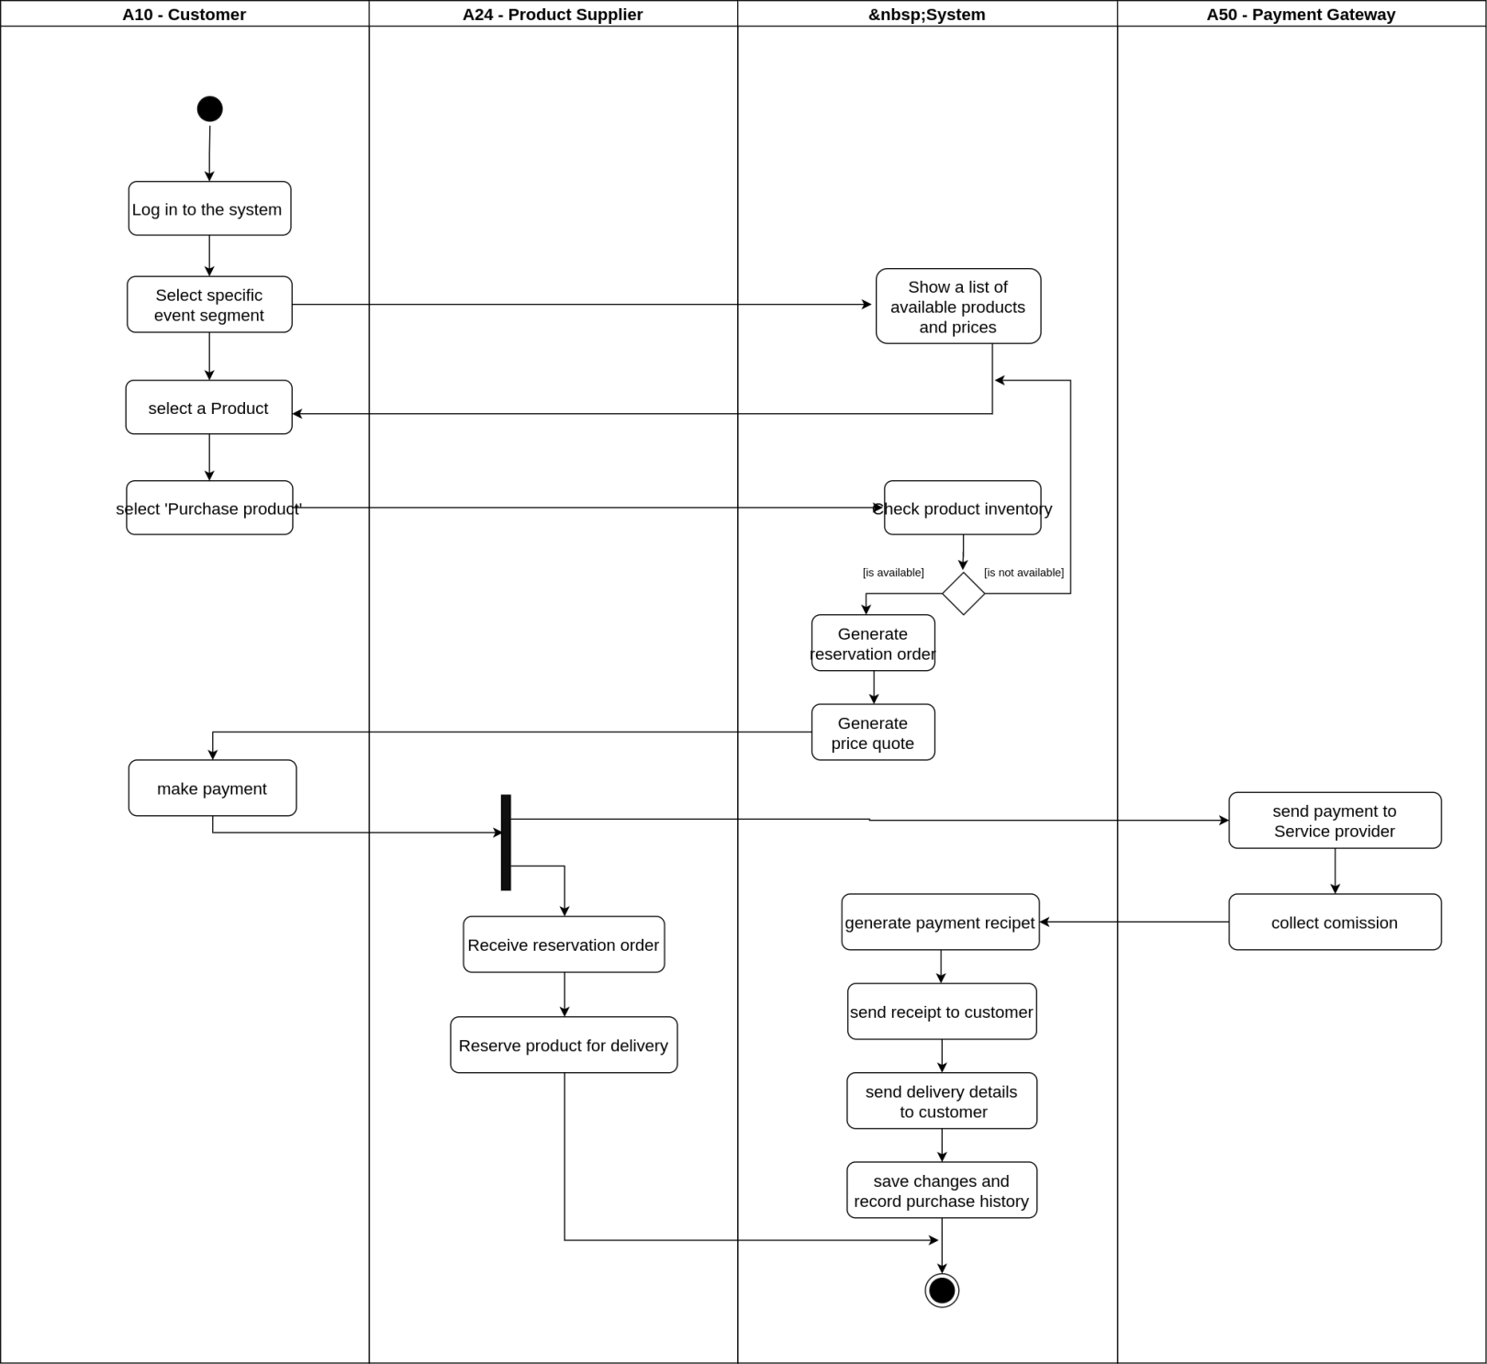

### 3.3.12 Activity diagram for send invitations to invitees (closed type events)

Figure 3.25 Activity diagram for place an order for a required product

Figure 3.26 illustrates the activity diagram for sending invitations for the selected guests for ‘closed type’ events. The activity is done by customer. RSVP details are recorded.

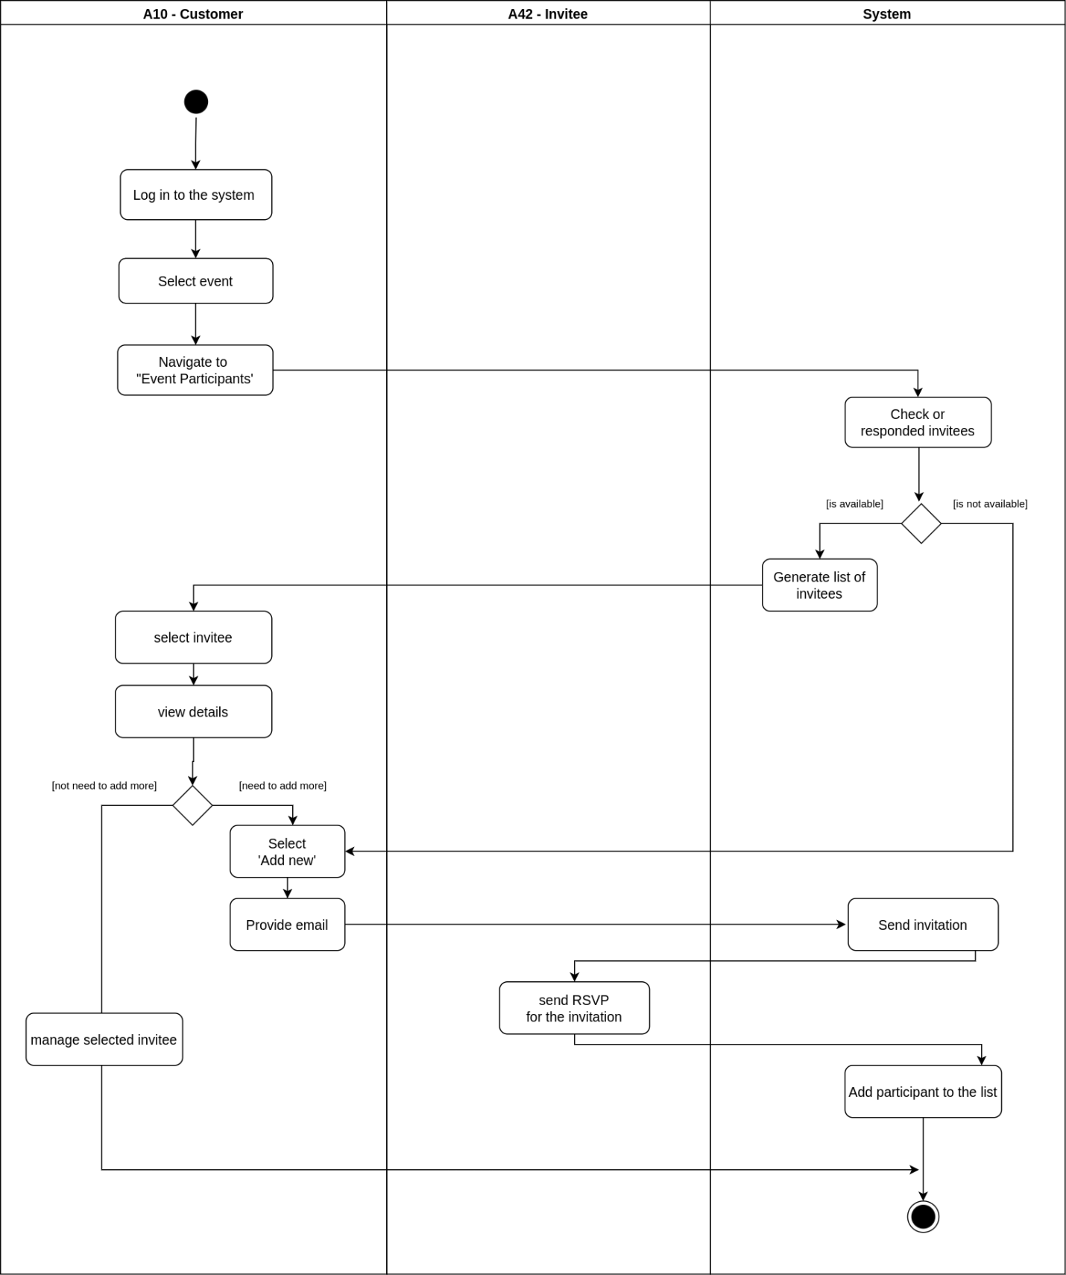

Figure 3.26 Activity diagram for send invitations to invitees (closed type events)

### 3.3.13 Activity diagram for get participants registered (open type events)

Figure 3.27 illustrates the activity diagram for getting participants registered to an event using a registration form. The activity is triggered by customer. A generic event registration form can be crated and send through the system.

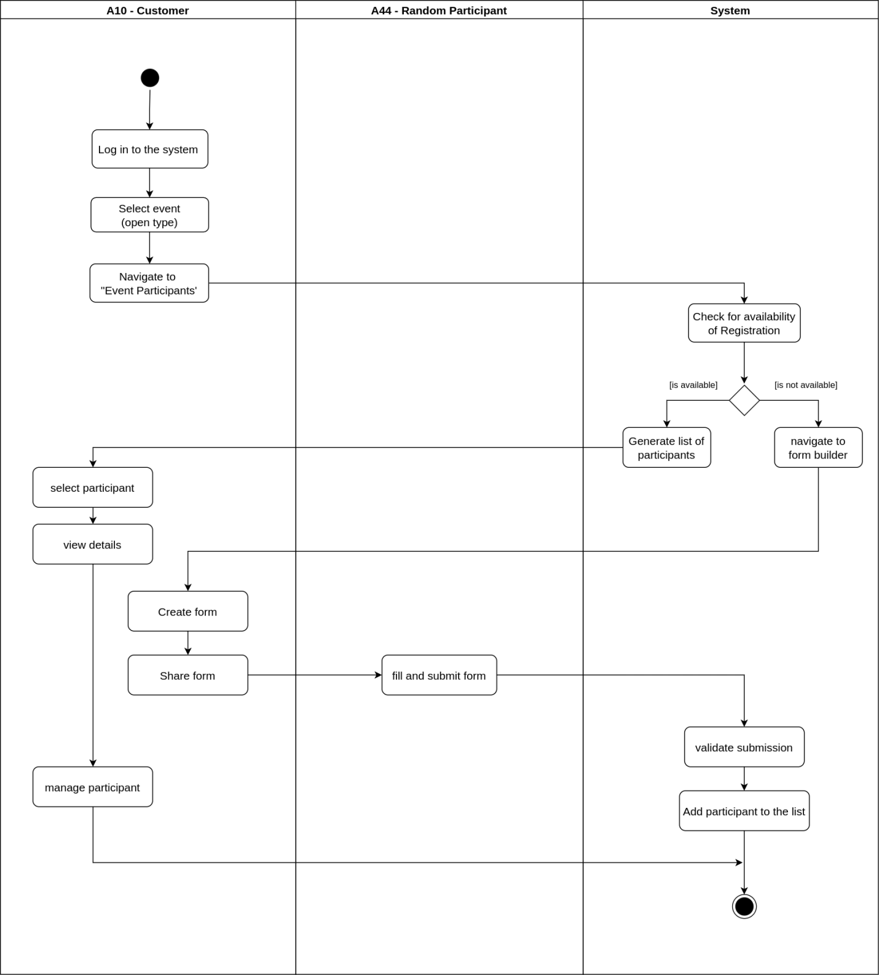

Figure 3.27 Activity diagram for get participants registered (open type events)

### 3.3.14 Activity diagram for generating reports

Figure 3.28 illustrates the activity diagram for generating reports. The activity is done by merchant and the system administrator.

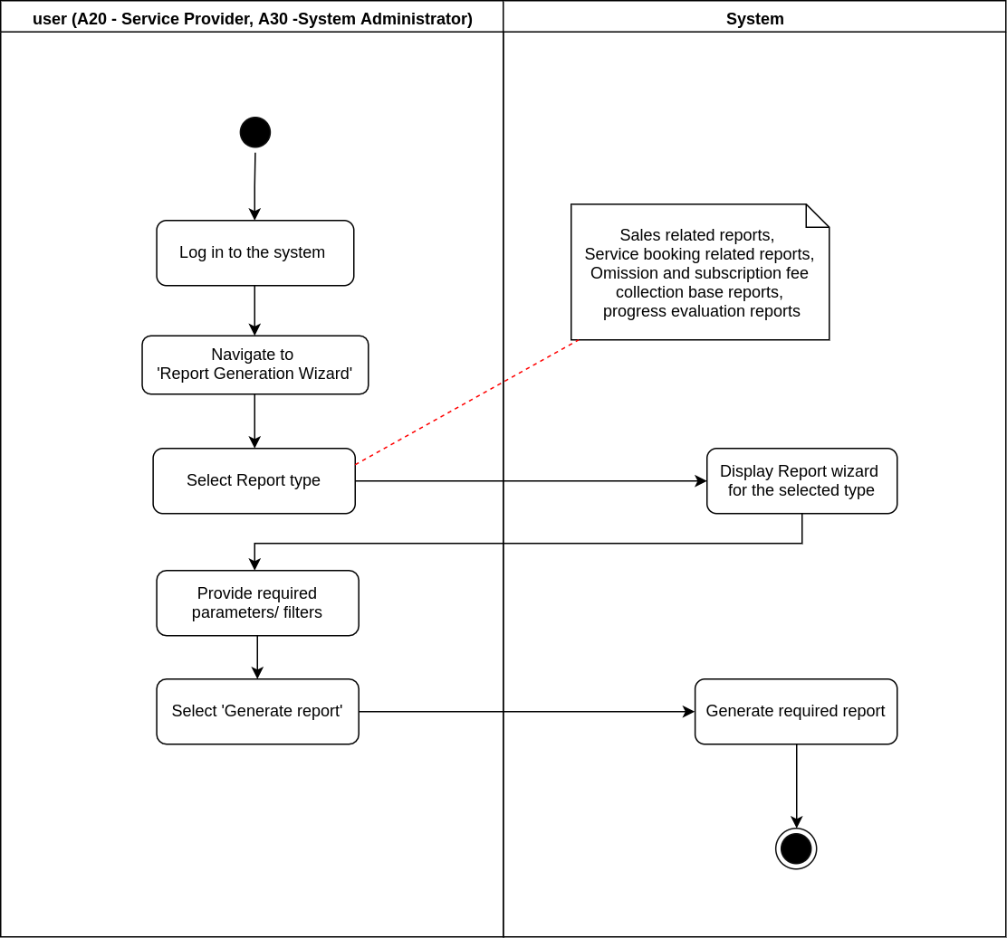

Figure 3.28 Activity diagram for generating reports

### 3.3.15 Activity diagram for collect commission by admin

Figure 3.29 illustrates the activity diagram for collecting commissions and subscription fee paid by the merchants. The activity is done by system administrator.

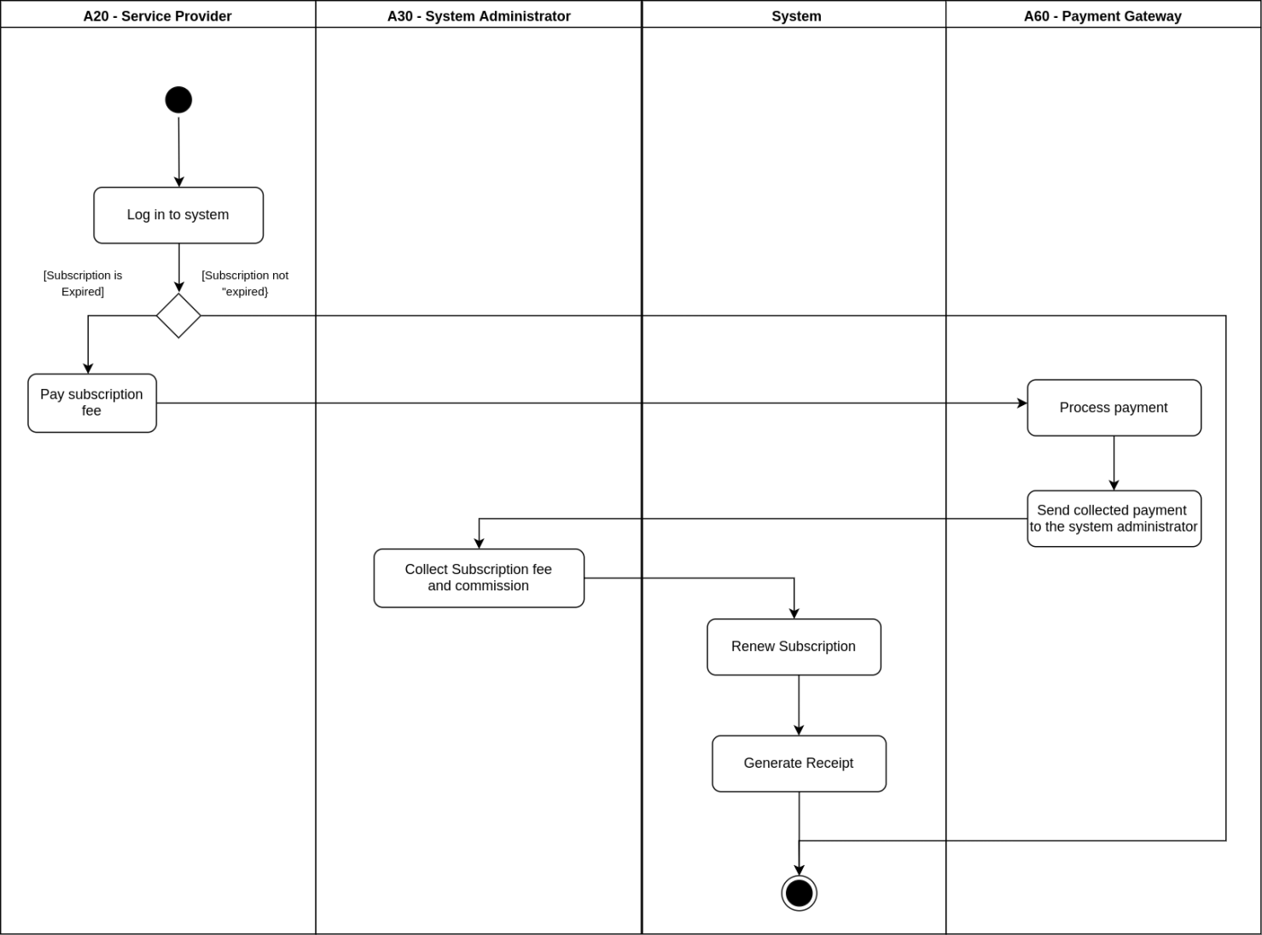

Figure 3.29 Activity diagram for collect commission by admin

### 3.3.16 Activity diagram for manage users by admin

Figure 3.30 illustrates the activity diagram for managing system users. Users are consisting of both customers and merchants. The activity is done by system administrator.

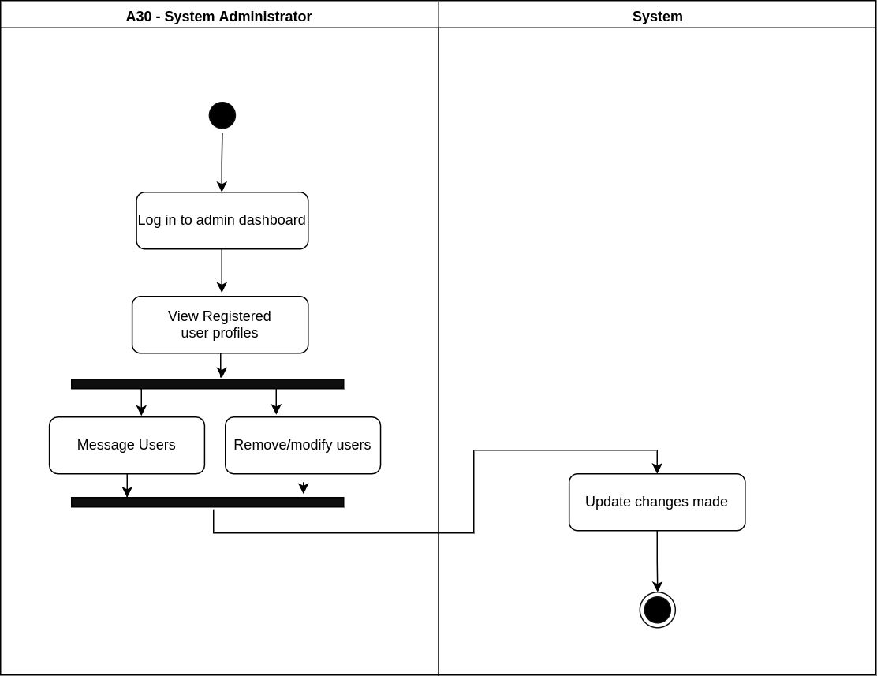

Figure 3.30 Activity diagram for manage users by admin

### 3.3.17 Activity diagram for chat with chatbot

Figure 3.31 illustrates the activity diagram for chat with chatbot, a feature which will be developed as a non-functional requirement. Customers can have a convenient chat with chatbot for easy event planning with less complexity.

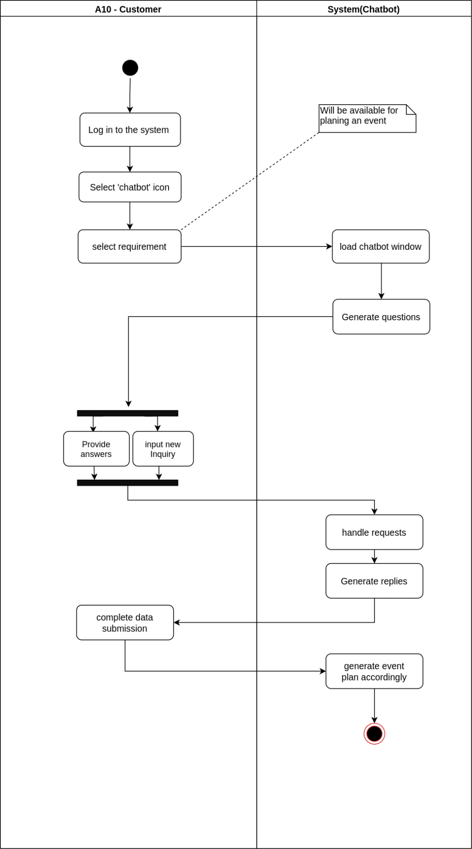

Figure 3.31 Activity diagram for chat with chatbot

# 3.4 Sequence Diagrams for the Proposed System

Sequence diagrams show how the system interacts with the actors in a use case functionality. Each actor is represented with a horizontal lifeline and the data transactions are drawn from one lifeline to another or within one lifeline. Following sequence diagrams describe some of the main use cases which are a bit difficult to understand with only having use case descriptions.

### 3.4.1 Sequence diagram for sign up to the system

Figure 3.32 illustrates the sequence diagram for sign up to the system.

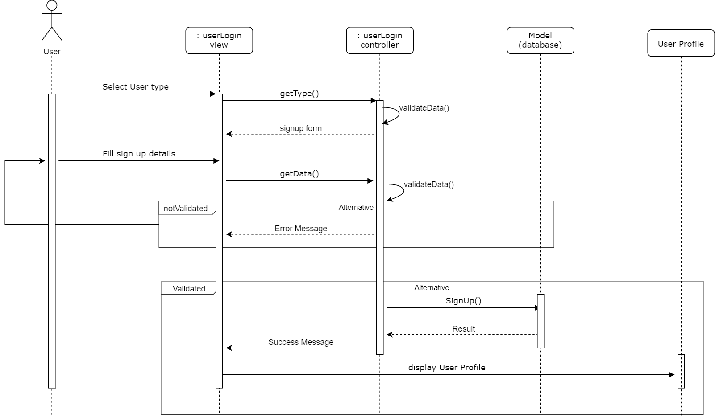

Figure 3.32 Sequence diagram for sign up to the system

### 3.4.2 Sequence diagram for log in to the system

Figure 3.33 illustrates the sequence diagram for log in to the system.

### 3.4.4 Sequence diagram for create business profile

Figure 3.33 Sequence diagram for log in to the system

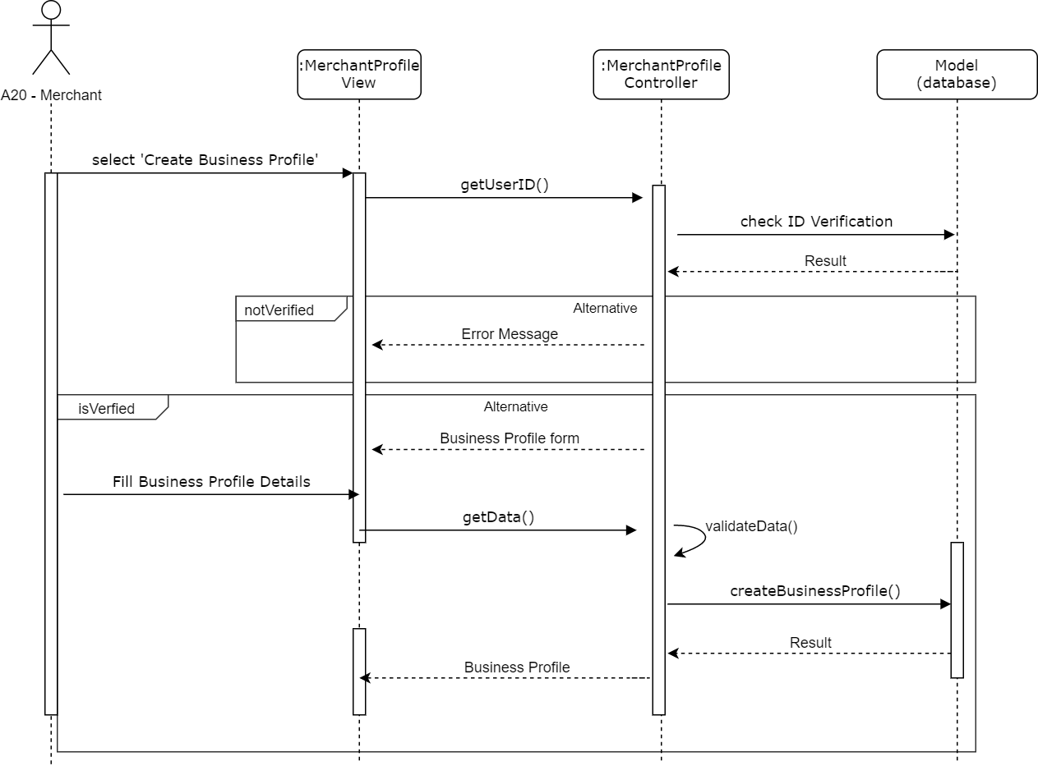   
Figure 3.34 illustrates the sequence diagram for creating the business profile by the merchant.

Figure 3.34 Sequence diagram for create business profile

### 3.4.5 Sequence diagram for create event plan

Figure 3.35 illustrates the sequence diagram for creating an event plan by customer.

### 3.4.6 Sequence diagram for place a booking for a service

Figure 3.35 Sequence diagram for create event plan

Figure 3.36 illustrates the sequence diagram for placing a booking for a service.

### 3.4.7 Sequence diagram for place a visit appointment for venue service

Figure 3.36 Sequence diagram for place a booking for a service

Figure 3.37 illustrates the sequence diagram for placing a visit appointment for a venue service prior to the booking.

### 3.4.8 Sequence diagram for order a product

Figure 3.37 Sequence diagram for place a visit appointment for venue service

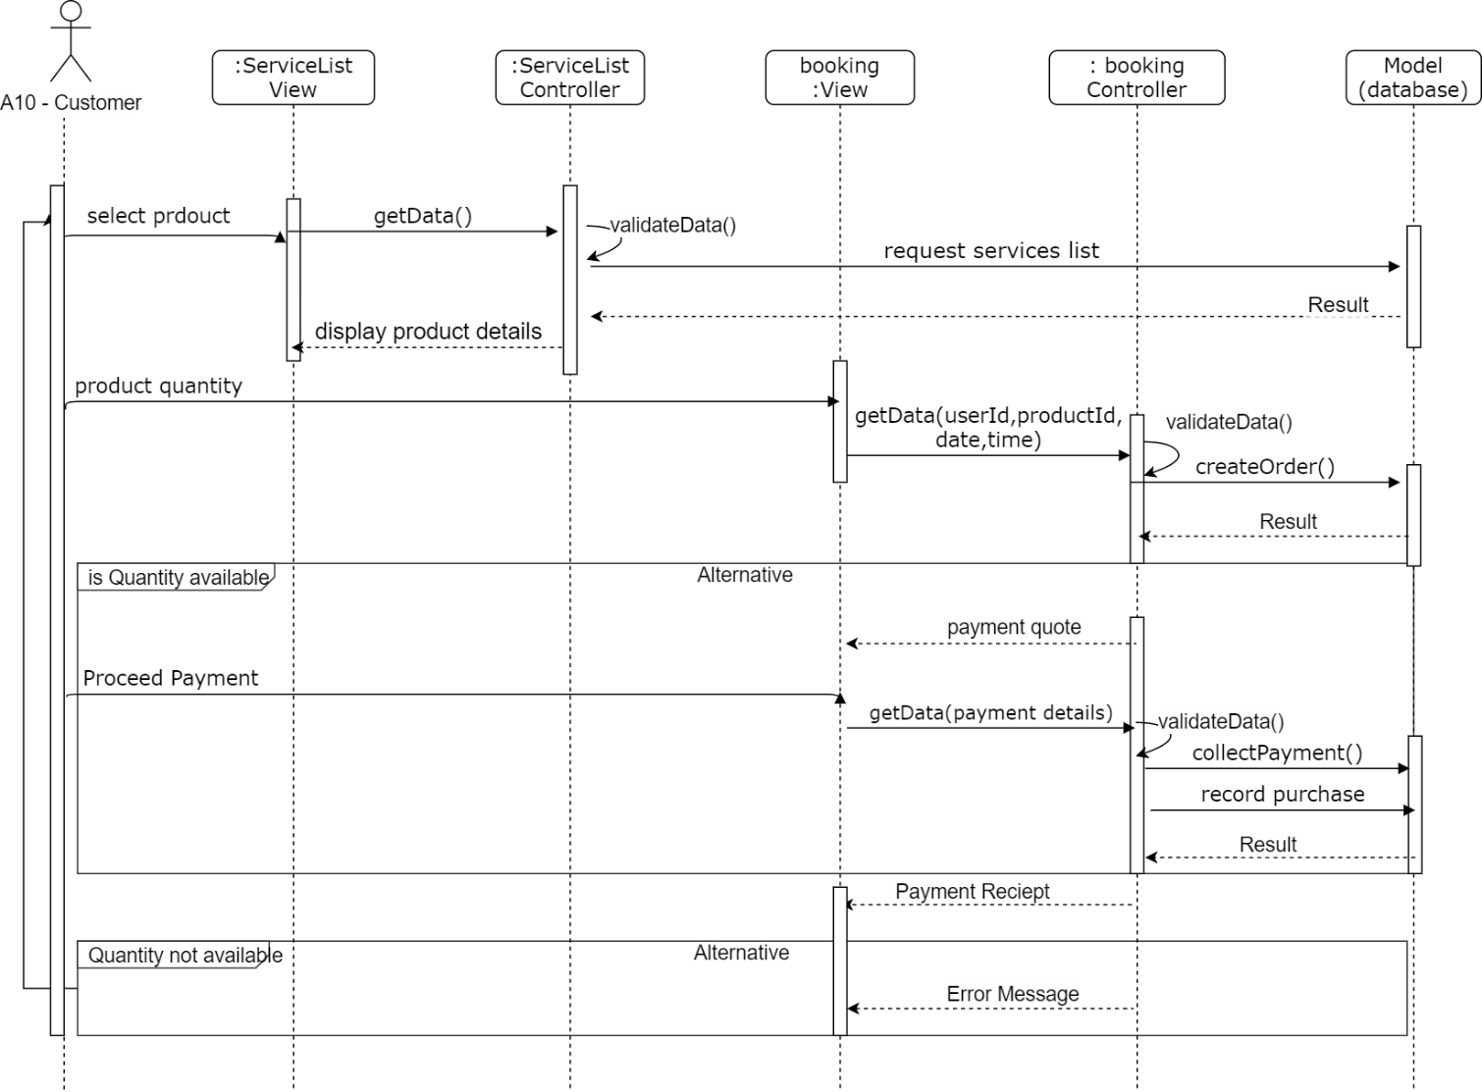Figure 3.38 illustrates the sequence diagram for order and purchase a required product for the event.

Figure 3.38 Sequence diagram for order a product

# 3.5 Class Diagram for Proposed System

Class diagram in figure 3.39 describes the structure of a proposed system by showing the system’s classes and their attributes(properties), behaviors(methods) and the relationships among the classes. Attributes and methods are clearly identified as private and public, and static attributes, methods are also included. System includes object-oriented programming concepts as abstraction, inheritance and encapsulation.

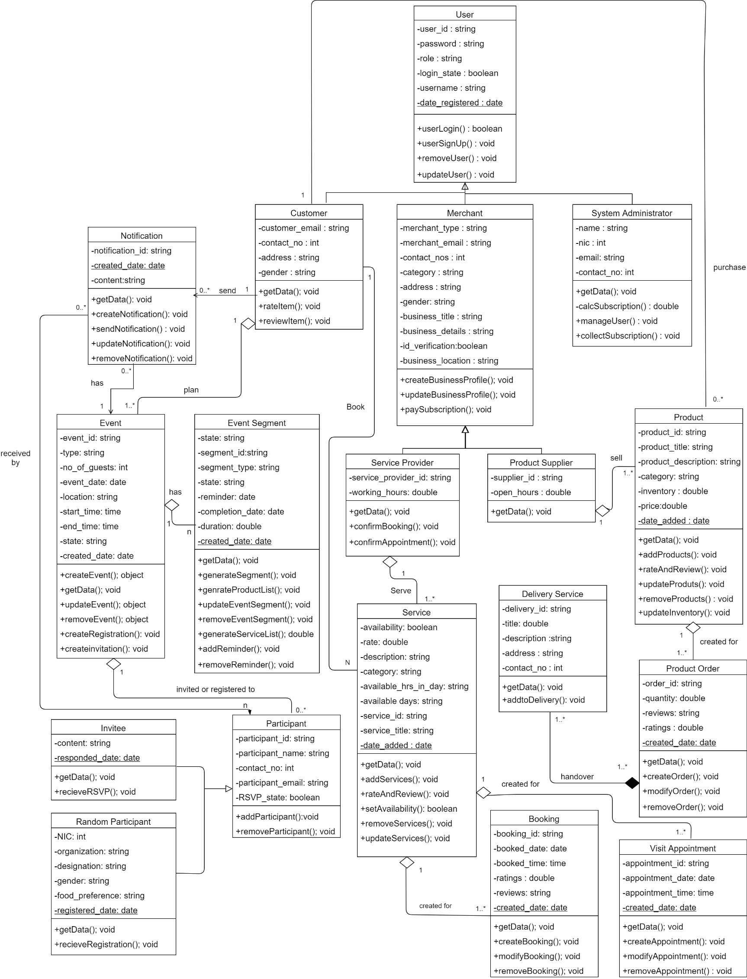

Figure 3.39 Class Diagram for the proposed system

# 3.6 Database Design

### 3.6.1 Entity – Relationship model

The entity relationship diagram shown below in figure 3.40 describe the relationship between entities of the system including their degrees and dependencies.

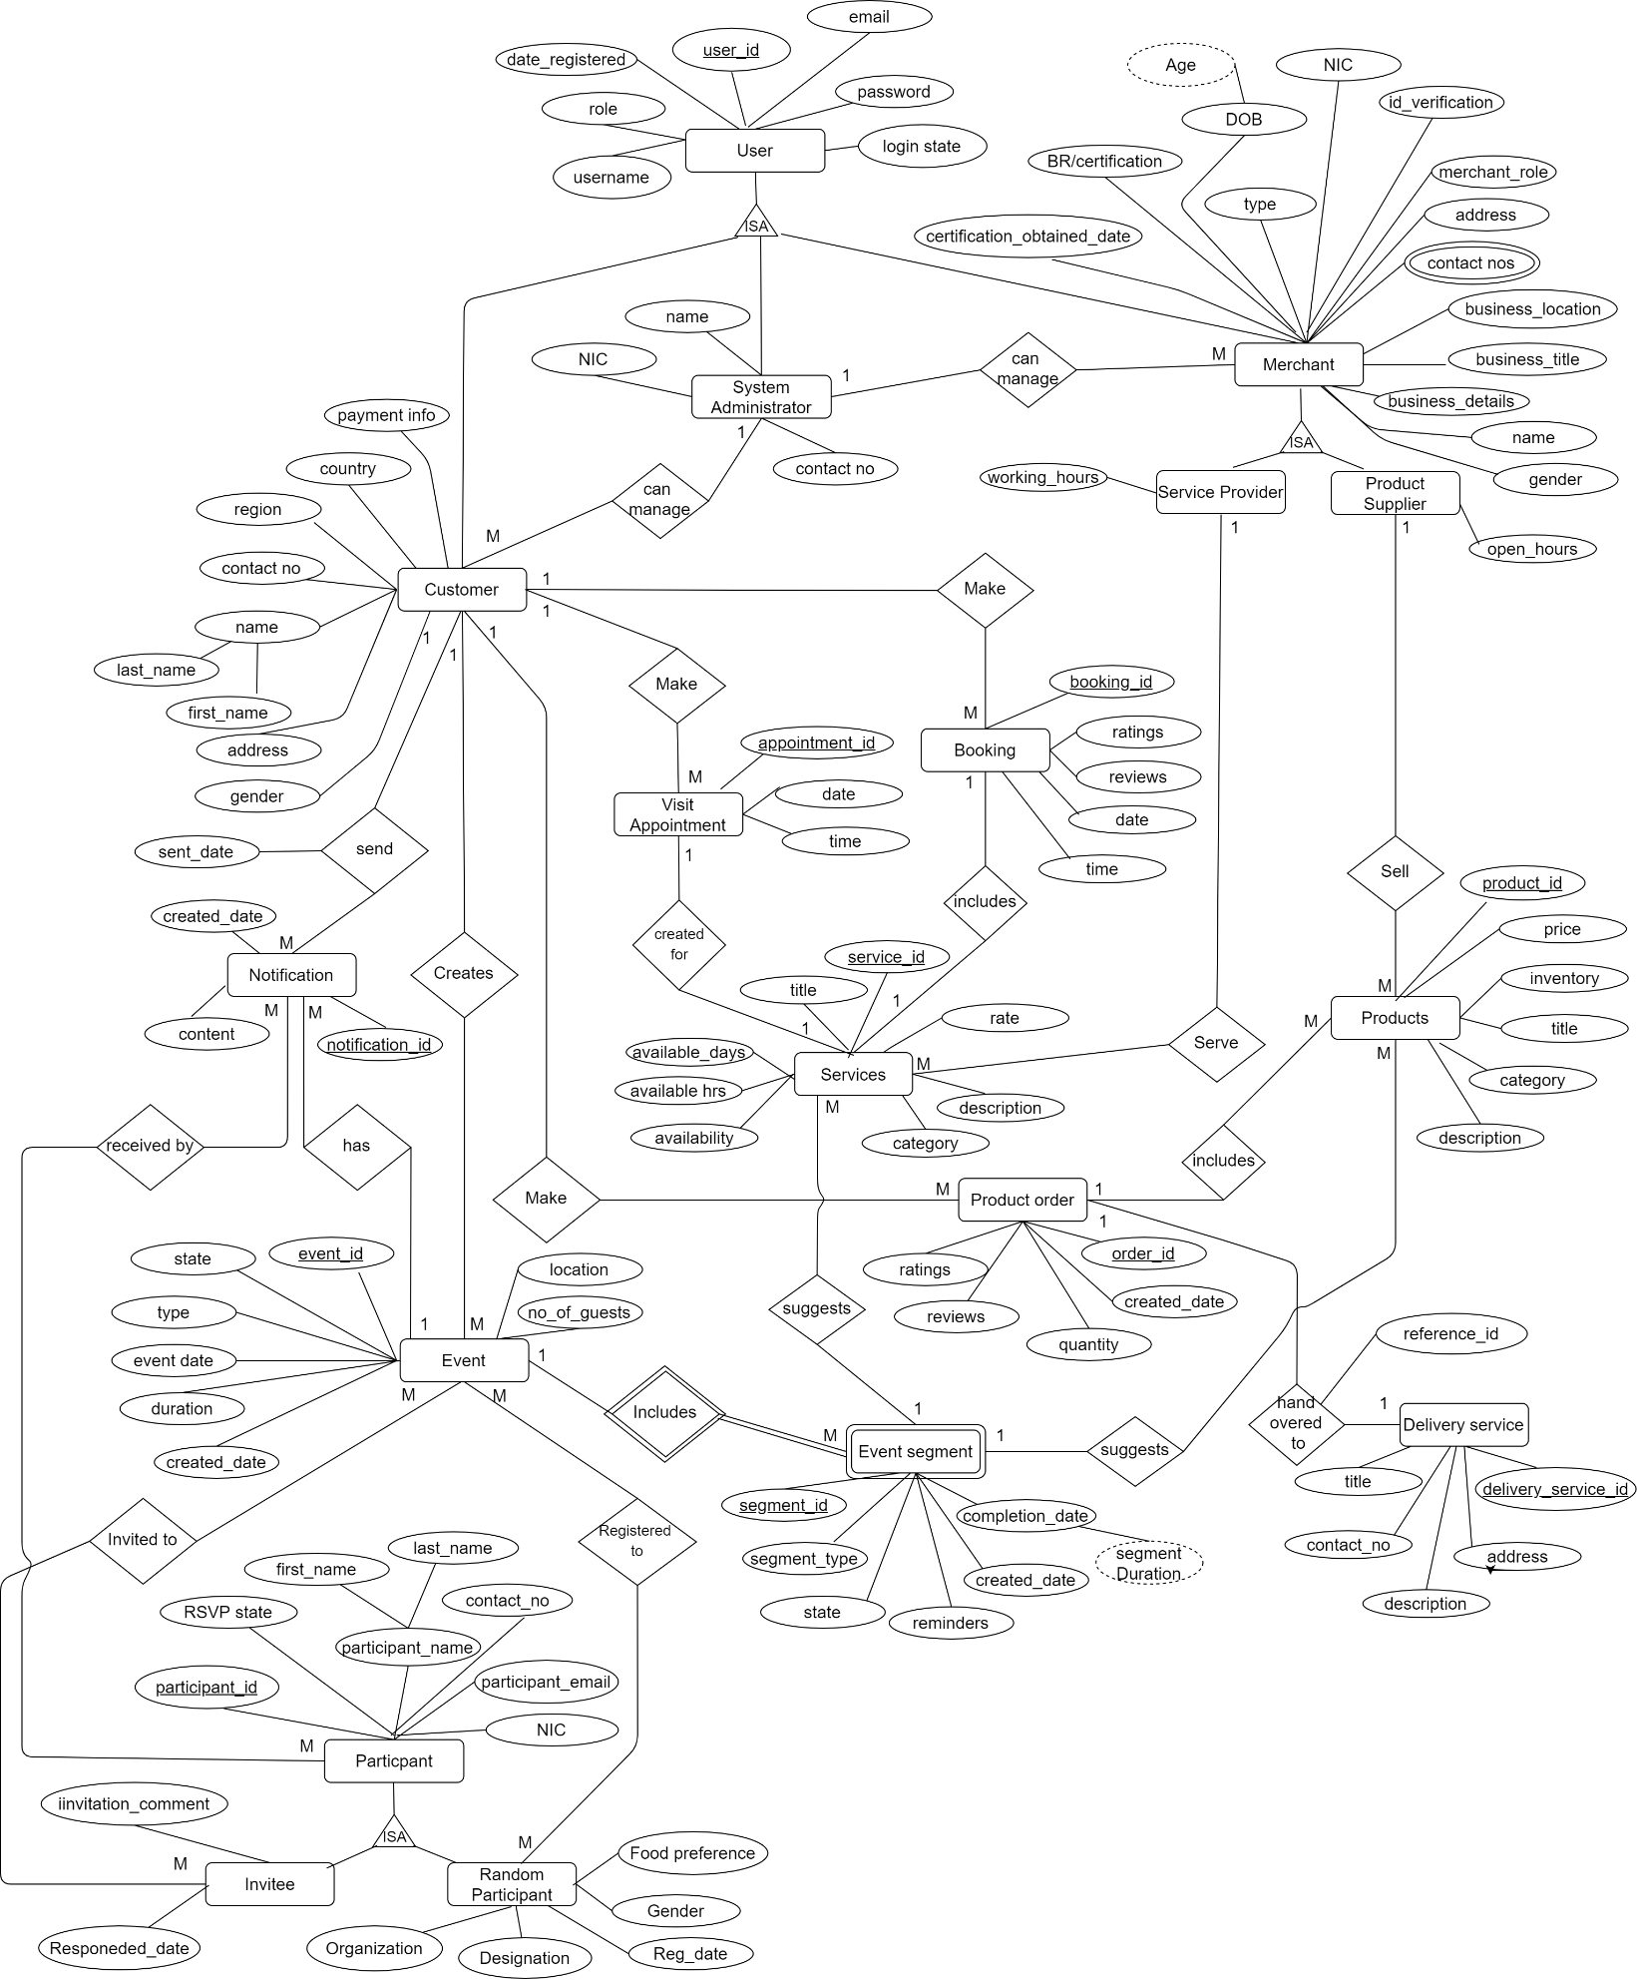

Figure 3.40 Entity Relationship diagram for the proposed system

### 3.6.2 Normalized database diagram

Database relationship diagram shown in figure 3.41 illustrates the proposed data tables in the system their keys and the relationship between the data tables in the database.

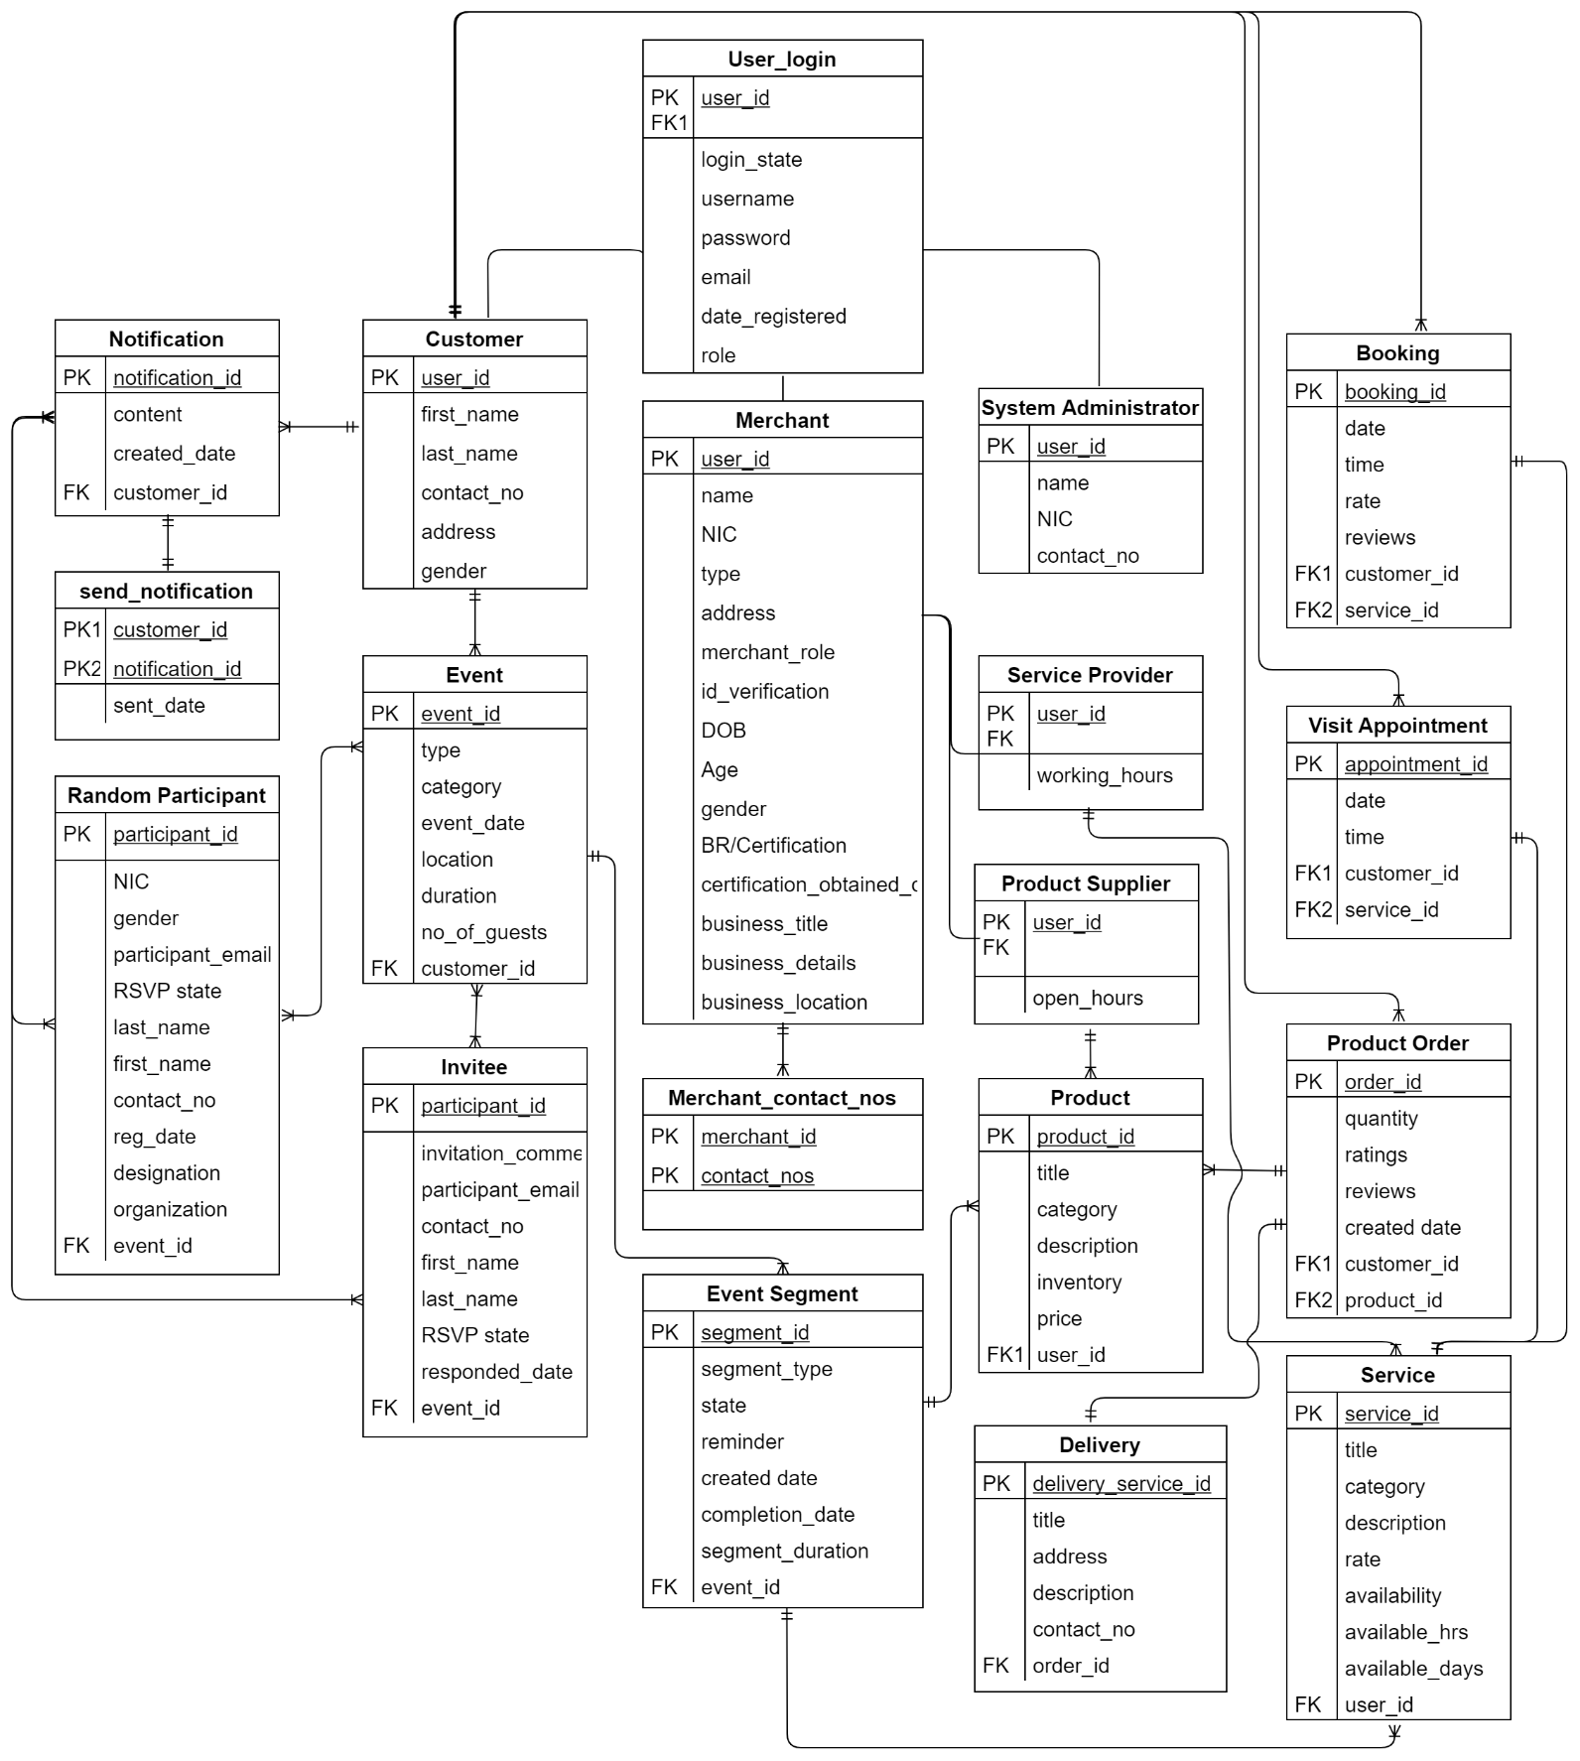

Figure 3.41 Normalized database design for the proposed system

# 3.7 GUI Design

Graphical User Interface (GUI) is one of the key components when developing the system as it is important for the interactive and convenient use of customers and merchants within the system. The system designer must be concerned on developing user-friendly GUI which is able to calm and cool the mind of user as this is a system that expected to use by the user in day to day life. User friendly GUI is the one of the major non-functional requirements of this system. The main design consideration related with GUI’s (Graphical User Interface) are listed below where these factors are considered in the system GUI designs.

* Attractive and user-friendly user interfaces.
* Easy to navigate forward and backward and keeping the flow of the actions.
* Give good error messages with relevant information to recover from the error occurred.
* Prevent errors as much as possible and use client-side validations to give feedback.
* Provide feedback of all the actions even if succeeded or not.
* More weight on process automation approach and reducing complexity through abstraction by designing smart interfaces.
* Try to implement and provide accessibility features for users with different requirements.

### 3.7.1 Welcome page GUI

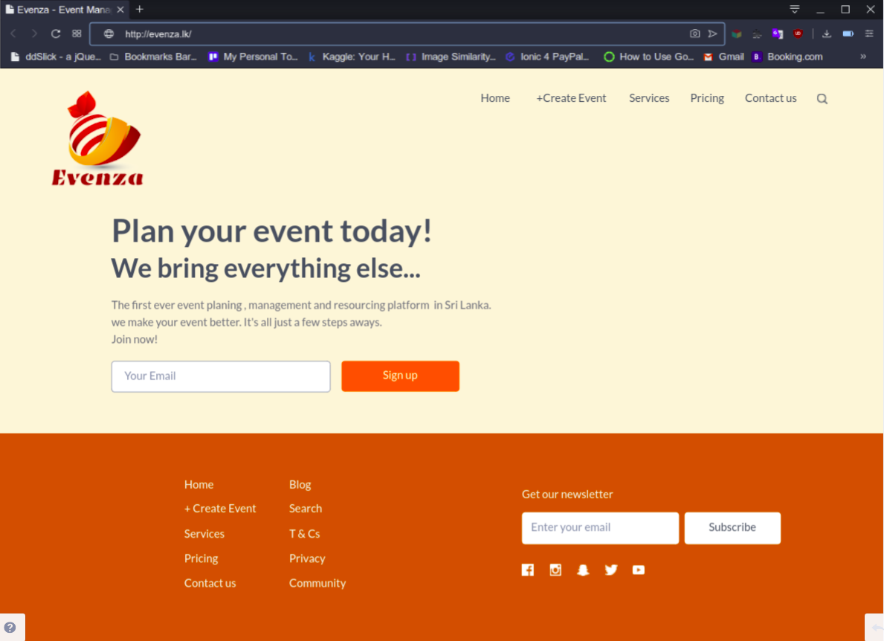

Figure 3.42 Welcome page GUI

**3.7.2 System Sign in GUI**

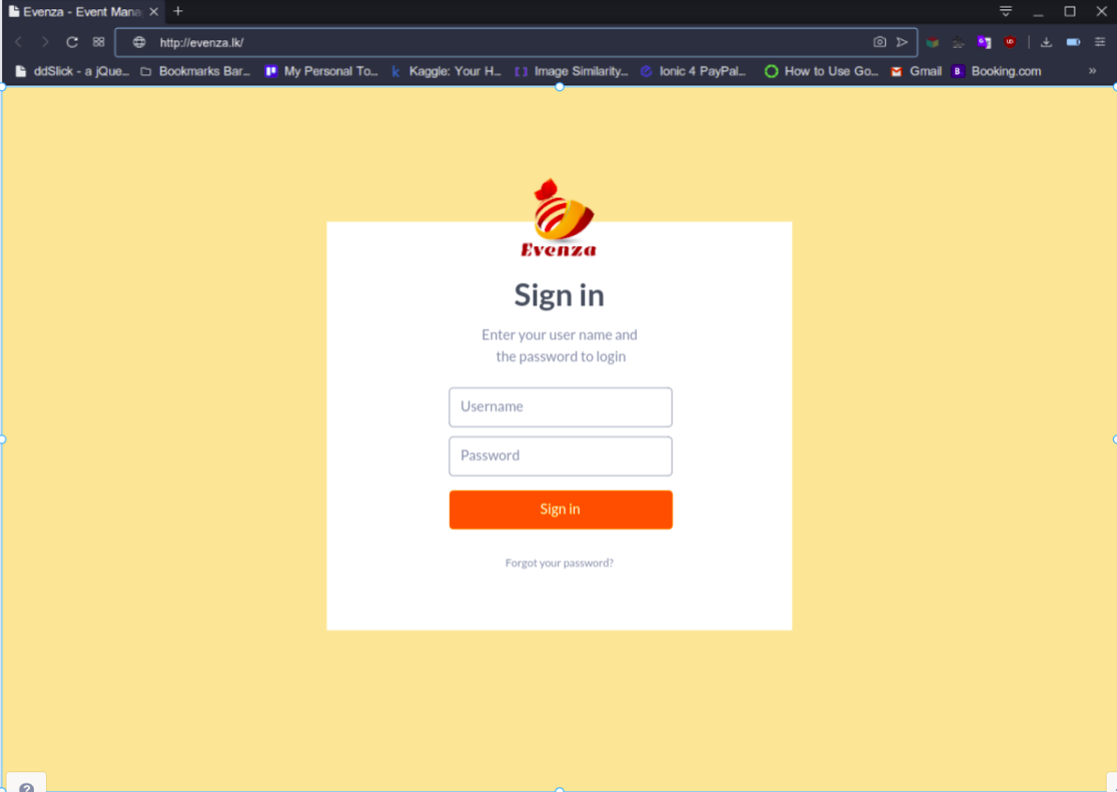

Figure 3.43 System Sign in GUI

### 3.7.3 System Sign up GUIs (Merchant’s sign up)

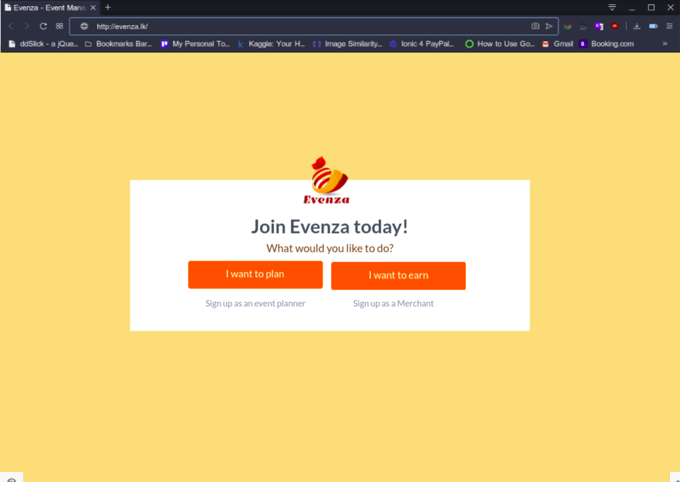

Figure 3.44 System Sign up GUIs (Merchant’s sign up) 01

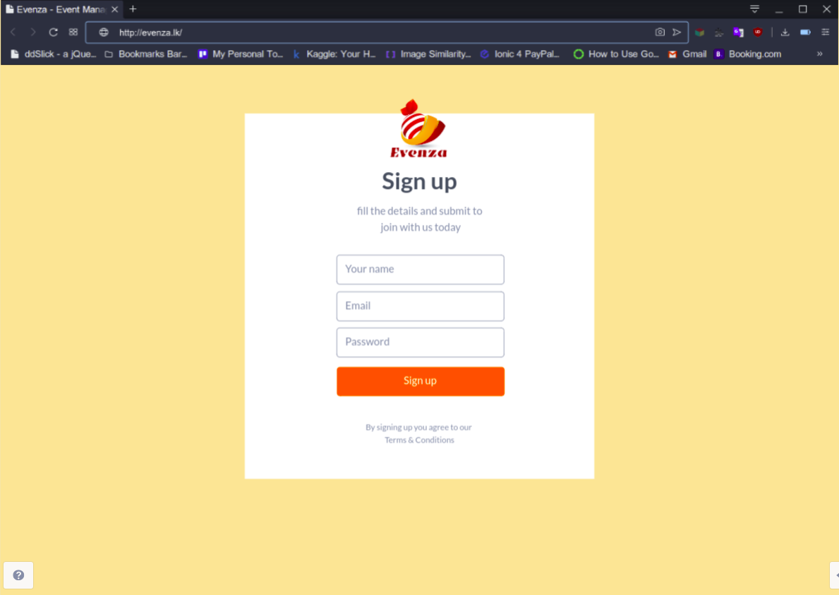

Figure 3.45 System Sign up GUIs (Merchant’s sign up) - 02

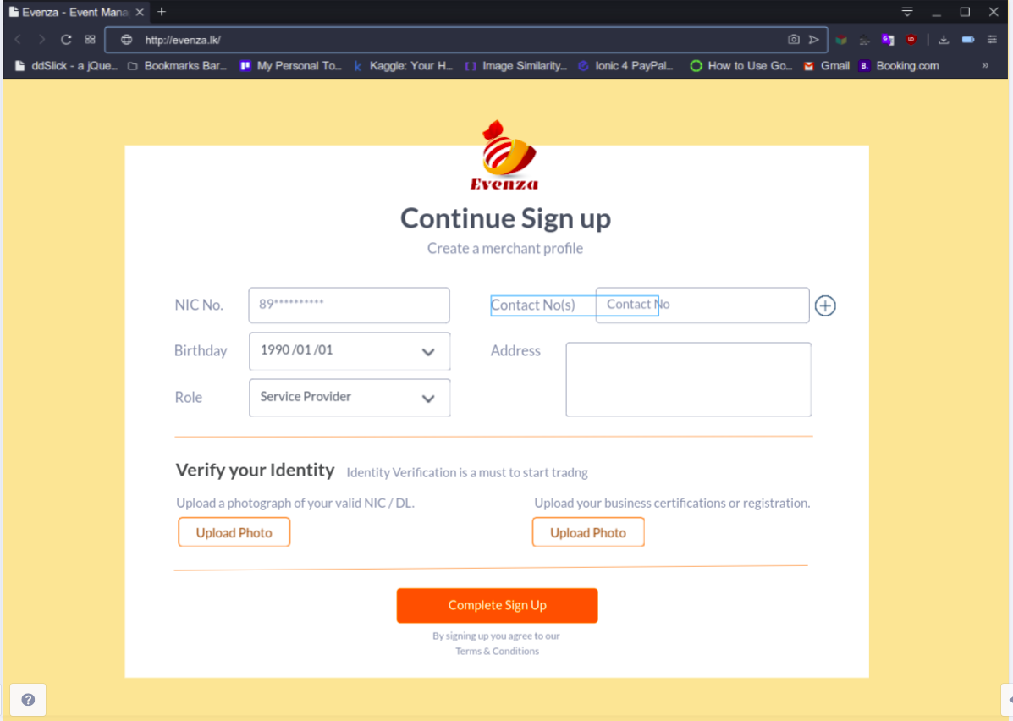

Figure 3.46 System Sign up GUIs (Merchant’s sign up) - 03

**3.7.4 GUI of user dashboard**

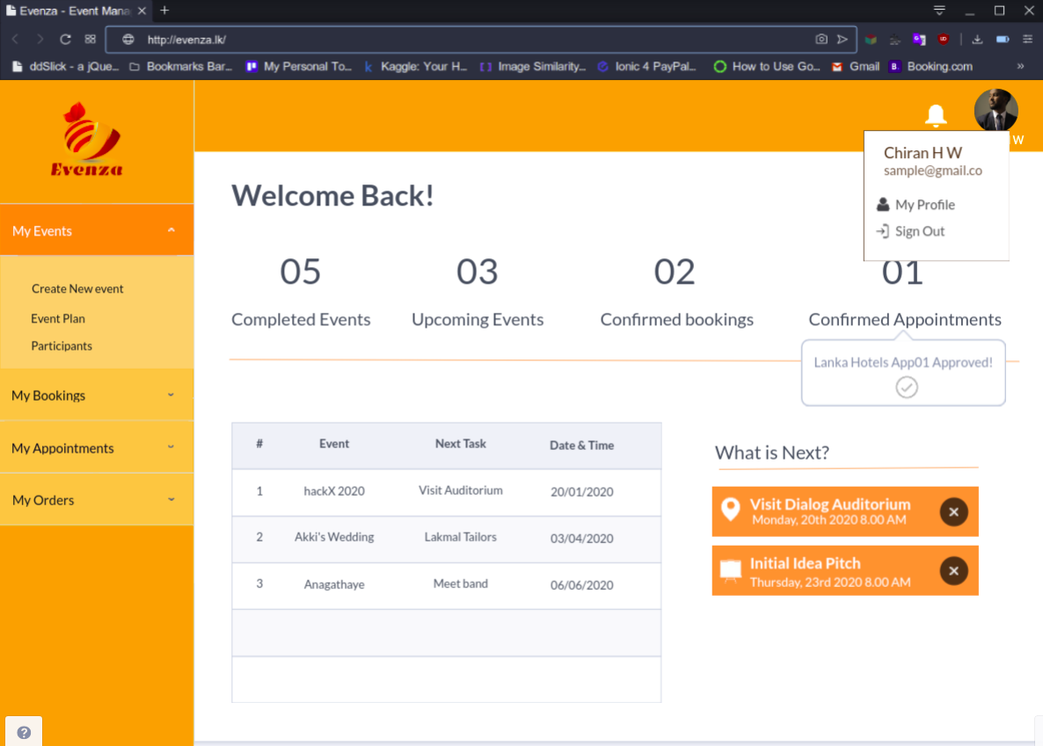

Figure 3.47 GUI of user dashboard

### 3.7.5 GUI of events overview

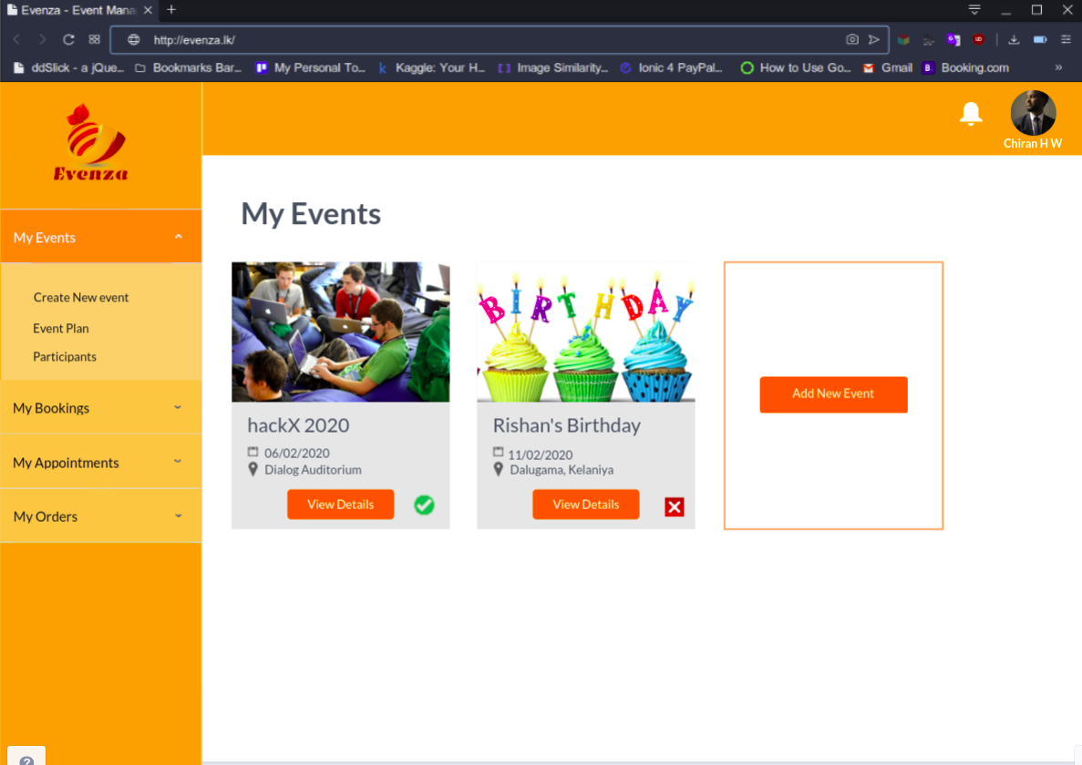

Figure 3.48 GUI of events overview

### 3.7.6 GUIs for creating an event plan

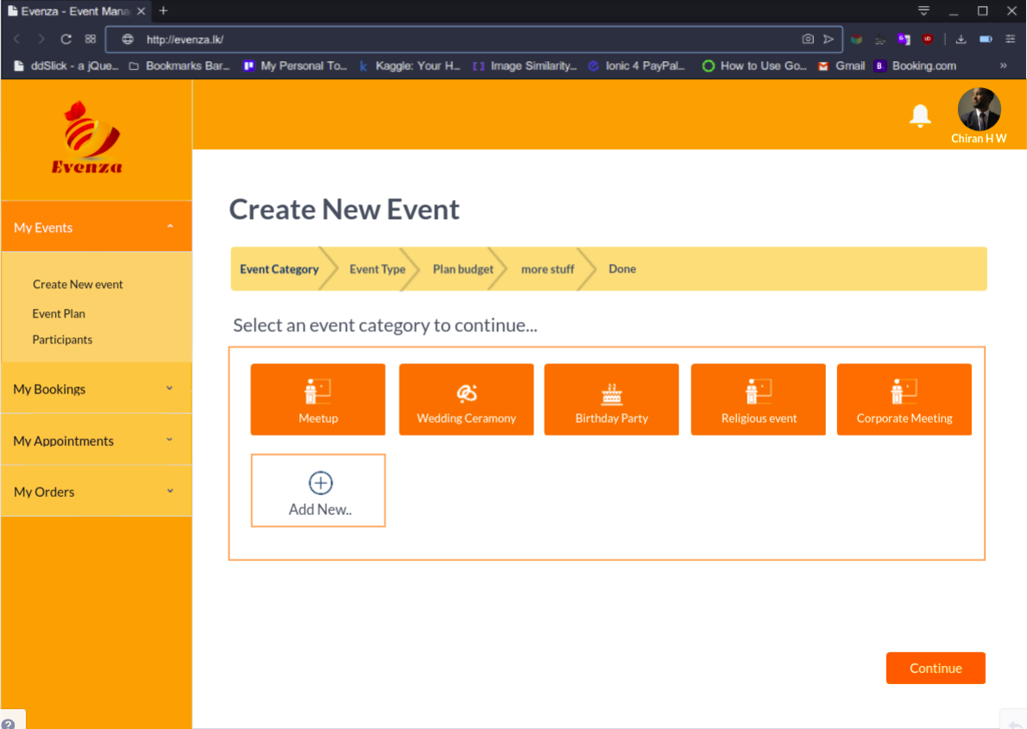

Figure 3.49 GUIs for creating an event plan 01

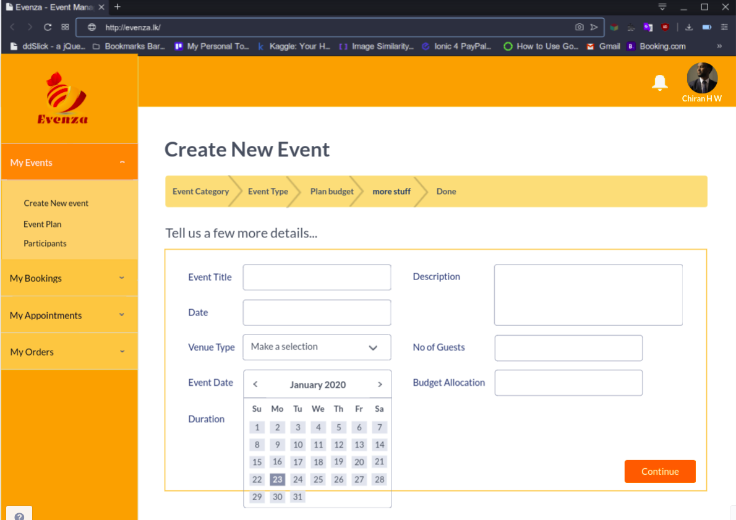

Figure 3.50 GUIs for creating an event plan 02

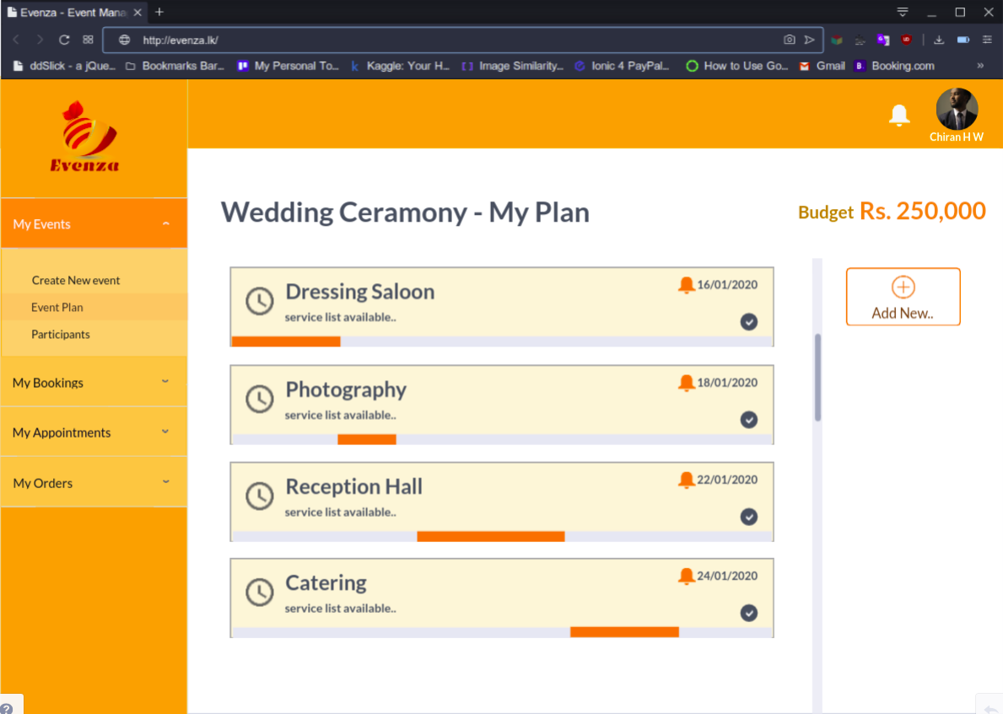

Figure 3.51 GUIs for creating an event plan 03

Total budget is allocated into separate plan segments. Reminders are set to each milestone. Customer can adjust and modify plan segments according to their requirements.

### 3.7.7 GUI of Merchant’s business profile

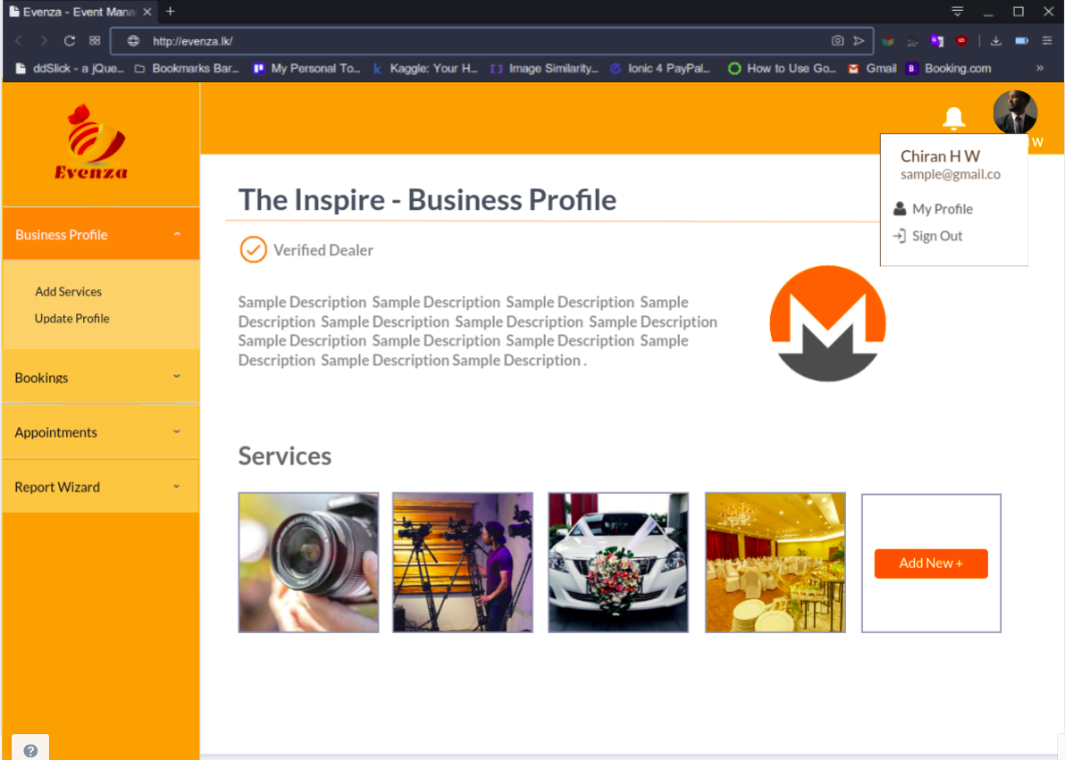

Figure 3.52 GUI of Merchant’s business profile

### 3.7.8 GUI of adding services to the business profile

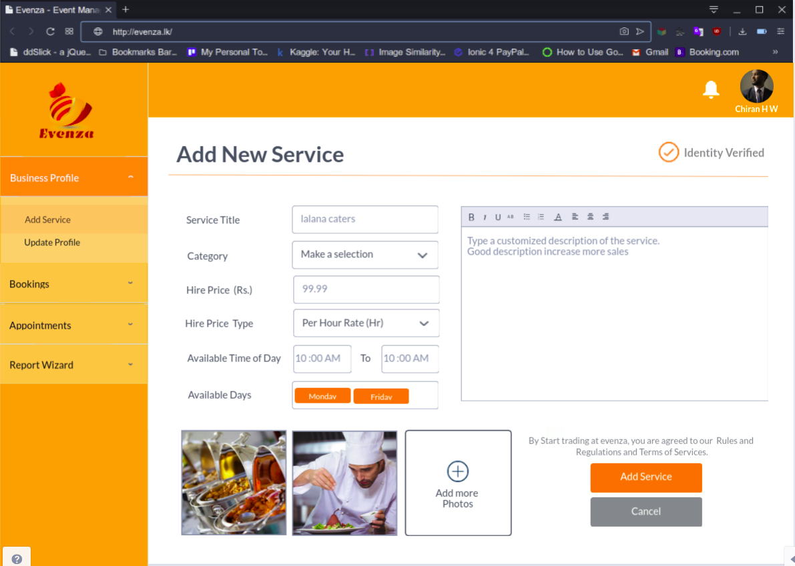

Figure 3.53 GUI of adding services to the business profile

### 3.7.9 GUI of adding products to the business profile by a product supplier

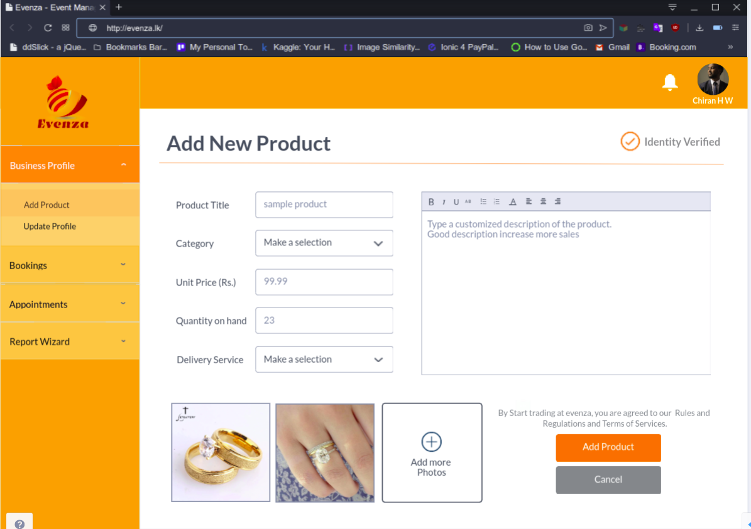

Figure 3.54 GUI of adding products to the business profile by a product supplier

### 3.7.10 GUI of Service overview and booking

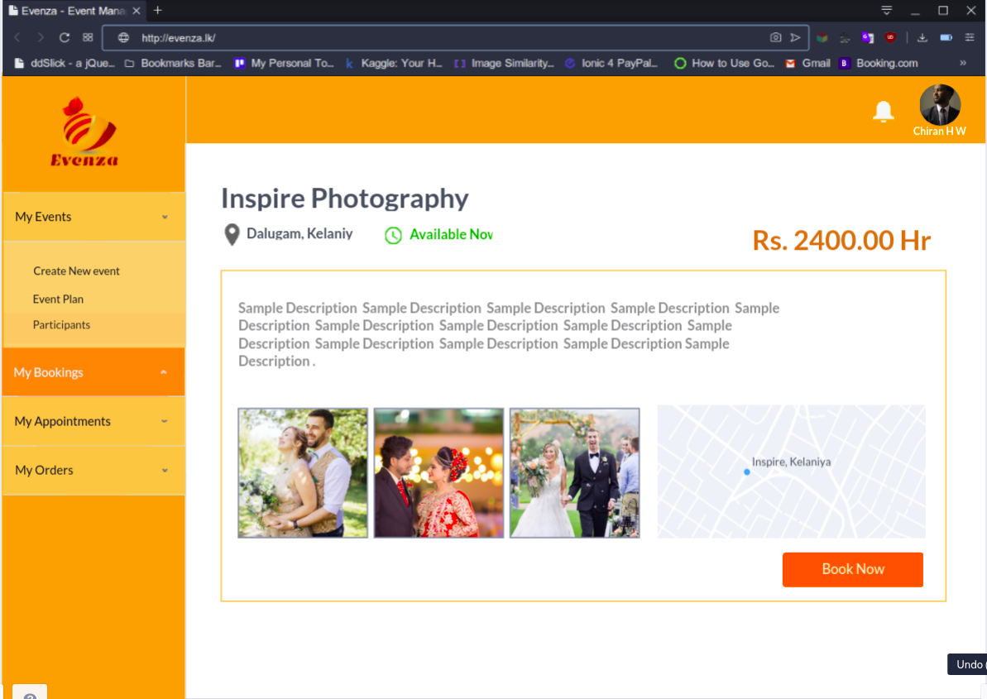

Figure 3.55 GUI of Service overview and booking

### 3.7.11 GUI of payment page

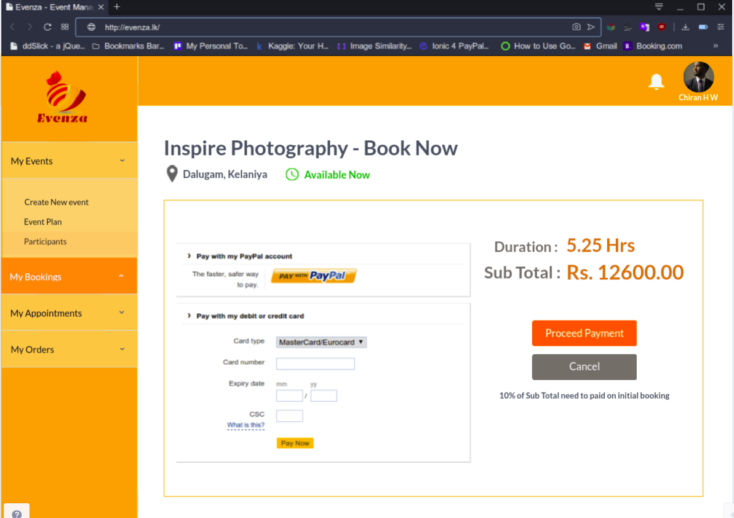

Figure 3.56 GUI of payment page

### 3.7.12 GUI of managing closed type event invitees

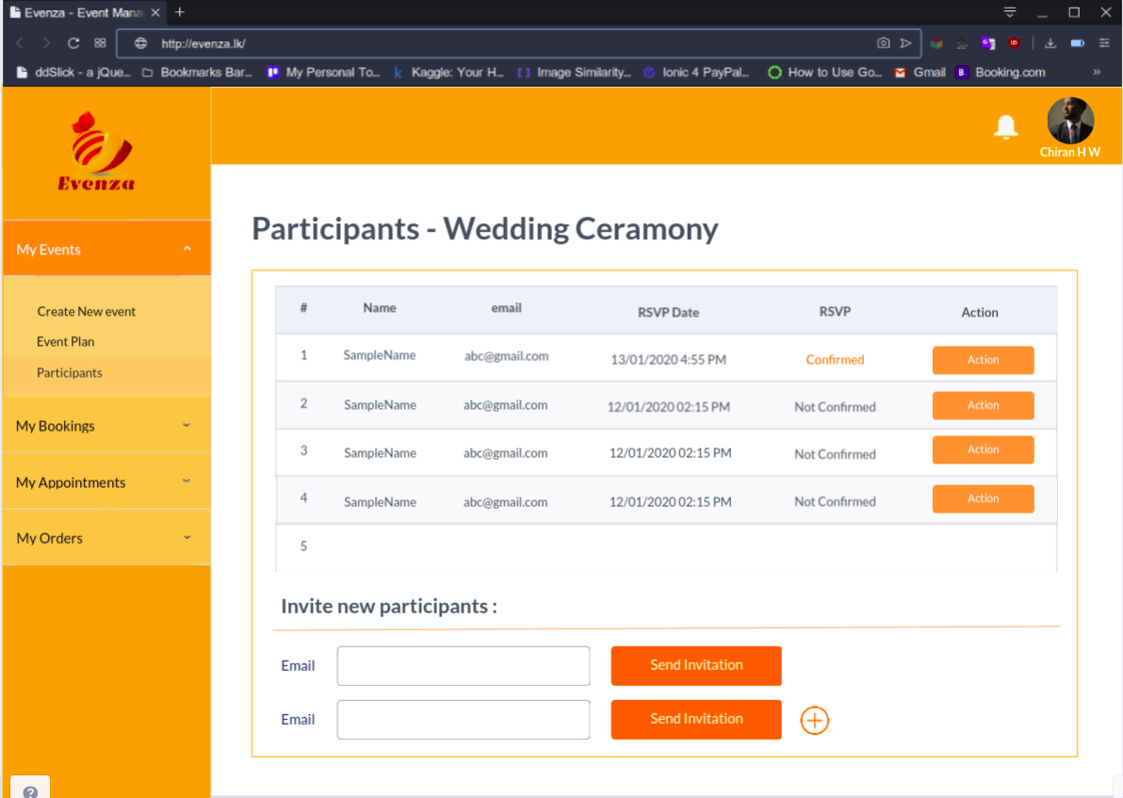

Figure 3.57 GUI of managing closed type event invitees

### 3.7.13 GUI of creating registration form for open type event participants

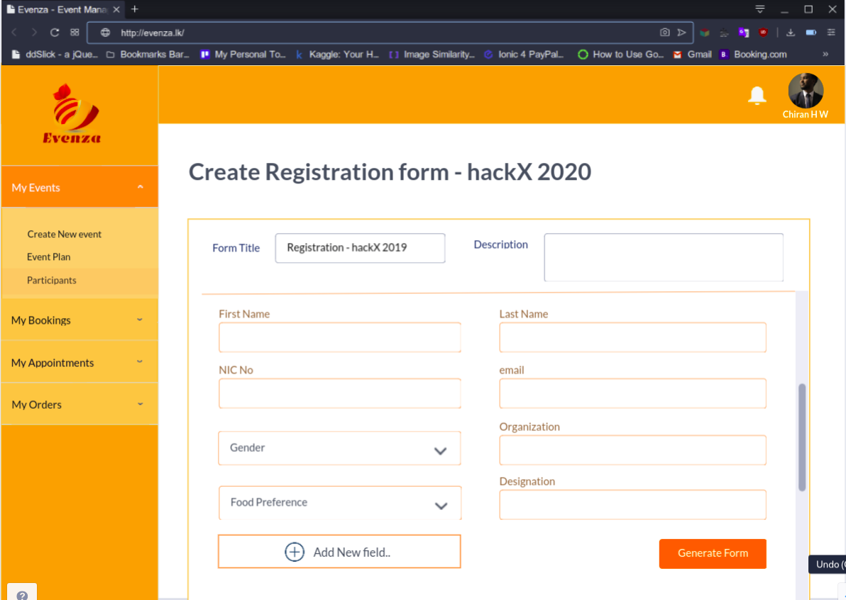

Figure 3.58 GUI of creating registration form for open type event participants

### 3.7.14 GUI of generating reports

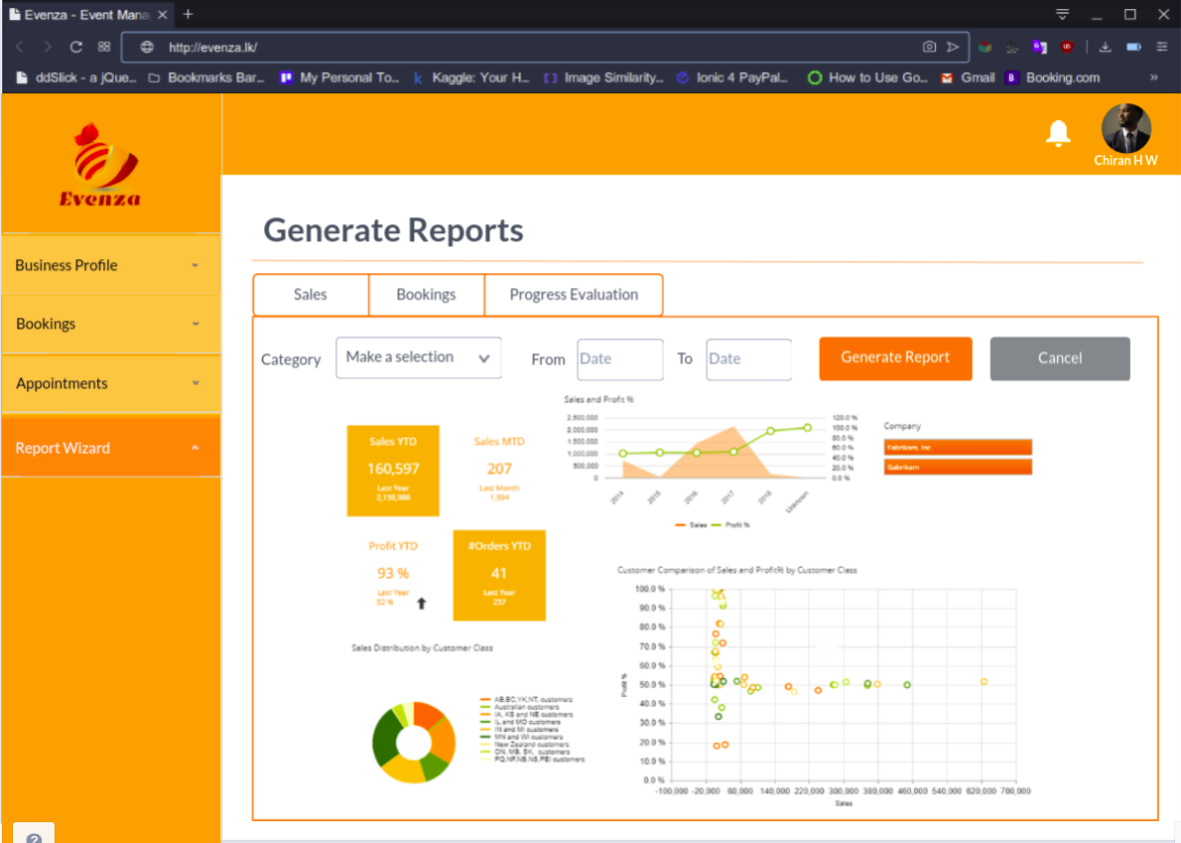

Figure 3.59 GUI of generating reports

### 3.7.15 GUI of Bookings overview of a customer

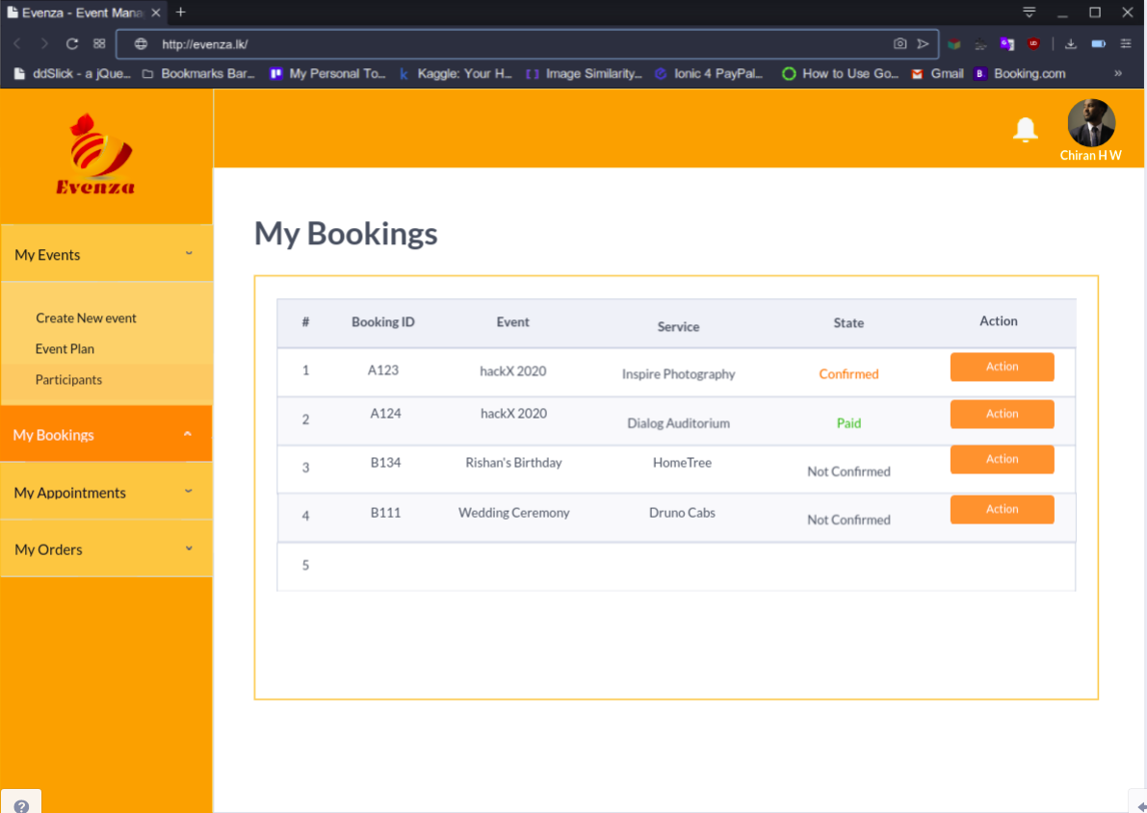

Figure 3.60 GUI of Bookings overview of a customer

### 3.7.16 GUIs of mobile interface - Getting started page

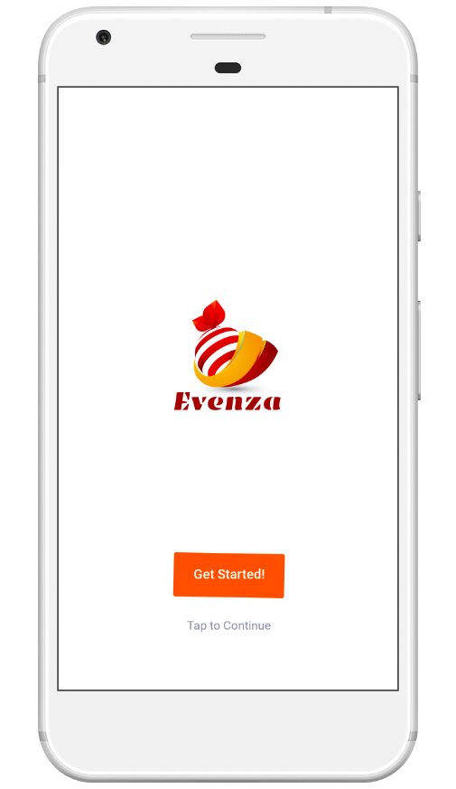

### 3.7.17 GUIs of mobile interface - Service list

Figure 3.61 GUIs of mobile interface - Getting started page

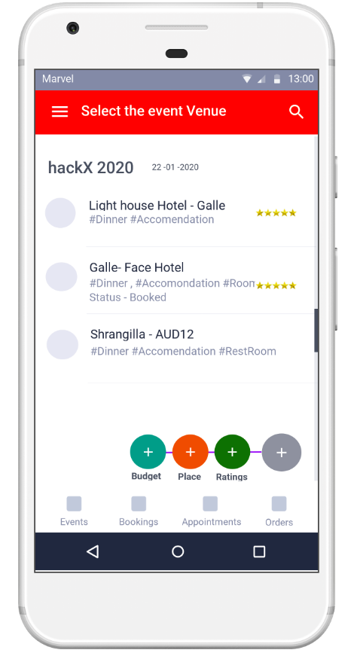

Figure 3.62 GUIs of mobile interface - Service list

### 3.7.18 GUIs of mobile interface - sidebar navigation

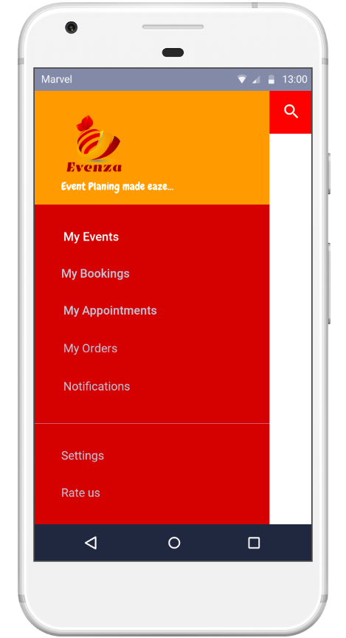

### 3.7.19 GUIs of mobile interface - chat with chatbot

Figure 3.63 GUIs of mobile interface - sidebar navigation

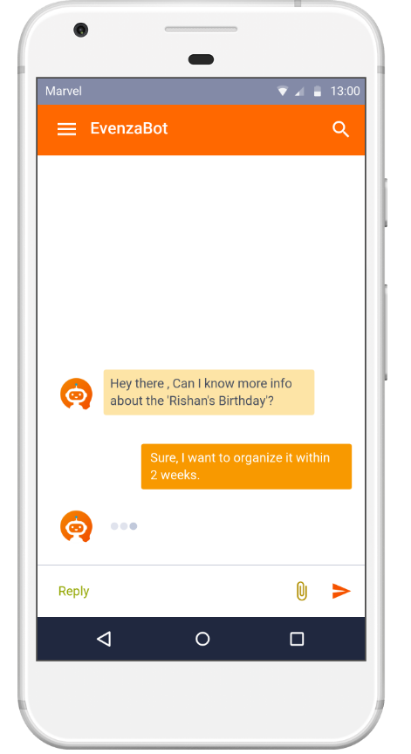

Figure 3.64 GUIs of mobile interface - chat with chatbot

### 3.7.20 GUIs of mobile interface - Receive Notifications

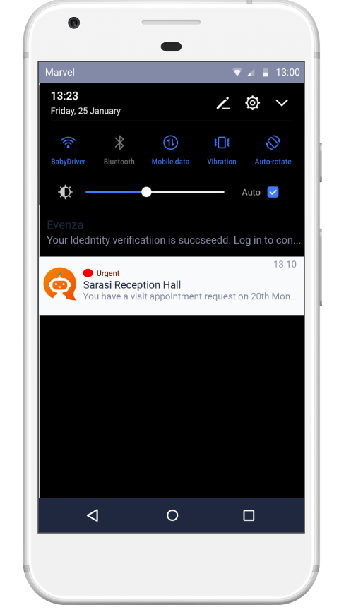

Figure 3.65 GUIs of mobile interface - Receive Notifications

# 3.8 System Reports

The system provides different types of managerial reports and transactional documents aiming enabling sales predicting and forecasting for service providers and product suppliers(merchants), easy organization and management of payment collections for system administrator and convenient transactions through system for customers with providing relevant receipts and notes. Some reports are listed below.

Managerial Reports are generated as:

* + Sales
  + Service bookings
  + Event budgeting
  + Commission and subscription fee collections
  + Forecasting for sales / service hiring
  + Progress evaluation reports

Transactional documents are generated as:

* + Payment quote
  + Payment receipt
  + Booking note
  + Appointment reservation note
  + Event invitation

# 3.9 Summery

This chapter depicted the system design where it showed how the functionality of the system is achieved with refer to several diagrams. This was depicted through objected oriented approach within designing its classes, their attributes and behaviors. Furthermore, the database design and the interactive graphical user interfaces were presented.

CHAPTER 4

## 4 CONCLUTION

This chapter evaluates the attempt taken in the project to deliver the system analysis and designing approaches and provides a conclusion of the project. This includes degree of objectives met within the designing and development of the system, limitations and drawbacks, and future modifications planned to be made, improvements and extensions possible.

# 4.1 Limitations and Drawbacks

With the time and resources available “Evenza” has some limitations and drawbacks in its system with the current completion state of system design.

The event related service suppliers, event organizers, planners and small-scale service providers who owns SME (Small and medium scale) bushiness whom were met for requirement gathering, were lack of knowledge on IT solutions and they are more interested in manual process than computerizing. Many bookings are made manually on personal contacts and recommendations. The booking history is recorded manually even they could get aid of available booking and scheduling platforms. Therefore, it took considerable time and effort to gather all the actual business processes together and understand the interrelationships. However still there are some gray area to be discovered.

Another drawback was the different platforms which are already used by different service providers for manage service bookings. Once the booking is made for the particular venue or the service on a specific date, the service providers are required to manually update their availability status in the calendars as it is not possible to communicate between different platforms they use, developed on different technologies.

Due to the technical capabilities required on machine learning and social media data mining techniques, system is unable provide a complete accurate and human like functioning chatbot service for event planning at first stage. Limitation of time for development also act as a barrier. Developing A community-based platform to connect generic parties in the system, takes more time and, more researches to be made for an accurate and universally implementable system.

# 4.2 Future Modification, Improvements and Extensions

There are several further modifications to the system design, which will enhance the quality of the system in terms of usability, reliability and accessibility.

* Integrate web data mining techniques for recommendations.
* Integrate recommendation features and machine learning based forecasting.
* Introduce a community social network to the system for event publishing and sharing purposes.
* Provide more accessibility features with smart interactive interfaces.

# 4.3 Summary

In this chapter, the author has described about the degree of objectives met after implementing the project, limitations and drawbacks, and further development of the project.

## REFERENCES

<https://creately.com/diagram-type/use-case>

<https://creately.com/blog/diagrams/activity-diagram-tutorial/>

<https://www.visual-paradigm.com/training/>

<https://blockevent.tk>

<https://eventray.com/features>

<http://www.siritha.com>

<http://www.thebanquetcompany.com>  
  
<http://eventplannersrilanka.com>